**Design Memorandum No. 52**

**LIBBY DAM-LAKE KOOCANUSA PROJECT MASTER PLAN**

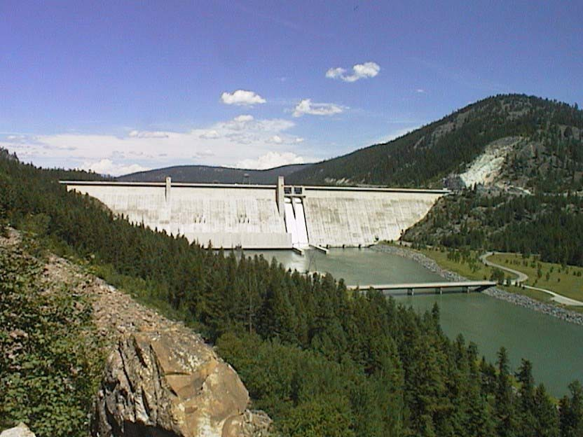

**SEPTEMBER 1997**

### VALIDATION

The Libby Dam-Lake Koocanusa Project Master Plan, Design Memorandum No. 52 prepared by Engineering Division, has been coordinated with all pertinent elements of Seattle District, including Operations Division and Real Estate Division.

September 1997.

Phillip M. O’Dell, P.E. Chief, Engineering Division

Brian R. Applebury, P.E Chief, Operations Division

Joseph C. Duncan

Chief, Real Estate Division

It is recommended that the Libby Dam-Lake Koocanusa Project Master Plan be adopted as a guide to the orderly use, development and management of the natural and manmade resources of the Libby Dam-Lake Koocanusa project administered by the Seattle District,

U. S. Army Corps of Engineers. The land classification and hazardous waters zones, and resource objectives developed by the project will provide for sound resource use, development, and management consistent with authorized project purposes and based on determination of highest and best use.

Approved:

James M. Rigsby

Colonel, Corps of Engineers District Engineer

### ACKNOWLEDGMENTS

Study Management and Coordination - Terri A. Taylor (fiscal year 1997) and Forest Brooks (fiscal year 1996).

Environmental Resources - Kenneth R. Brunner, Jeffrey C. Laufle, David G. Rice Landscape Architecture and Design - Terri A. Taylor

Recreation/Planning- Bonnie J. Ecker, Robert M. Rawson Real Estate-Cindy L. Luciano, Steven D. Mortenson

Review Team Members: Pamela J. Yorozu (leader), Jeffrey F. Dillon, Patrick C. McGrane, Mike C. McNeely, Lawr V. Salo, and Micheal P. Shea.

The following Libby Dam Operations Division personnel are acknowledged for their generous contribution to the development of the master plan: Richard T. Wernham and Mark J. Andreasen.

If you would like further information, please contact: Chief, Planning Branch

U.S. Army Corps of Engineers Seattle District

Post Office Box 3755

Seattle, Washington 98124-3755

Commercial Telephone: (206) 764-3600

## EXECUTIVE SUMMARY

The Libby Dam-Lake Koocanusa Master Plan will guide and direct the orderly use, development, and management of the land and water resources of the Libby Dam-Lake Koocanusa project administered by the Seattle District, U.S. Army Corps of Engineers. It is a vital tool for the responsible stewardship of these resources for the benefit of present and future generations, and promotes the awareness of environmental values and the need for protection, conservation and restoration. It is also a tool for enhancement of natural, cultural and man-made resources. This master plan identifies and assigns the resource management practices being considered and implemented, and when approved will provide the groundwork for the development and implementation of the project’s operational management plan (OMP) to achieve the resource objectives outlined in this master plan.

Project lands administered by the Corps of Engineers have been classified to provide for sound resource use, development, and management practices consistent with authorized project purposes and based on determination of highest and best use.

Prescribed land allocation and classification include Operations: Project Operations (151 acres); Operations: Recreation-Intensive Use (149 acres); Operations: Environmental Sensitive Areas (57 acres); Operations: Multiple Resource Management (1473 acres); Operations: Easement Lands (56 acres), and Mitigation: Mitigation (76 acres).

Lands and associated facilities and structures required for operation and maintenance of the project in accordance with authorized project purposes are classified and will be managed for Project Operations. These areas, totaling 151 acres, include Libby Dam and appurtenant structures, administrative complex, project operations storage area, downstream structures, rail spur, Fisher River quarry, and the left abutment slope**.**

Existing visitor accommodations administered by the Corps of Engineers and classified as Recreation total 149 acres and include Souse Gulch day use area, visitor center area, and left abutment visitor orientation area. Minor improvements and site alterations to improve the quality and functionality of the facilities and to increase resource management efficiency are identified. Development of three additional areas classified as Recreation located downstream of Libby Dam have been implemented and criteria for further development prescribed. Proposed site improvements at Alexander Creek, Blackwell Flats, and Dunn Creek Flats will provide needed minimal sanitary facilities and minor site improvements for fishing access and small boat launching on the Kootenai River, plus associated camping and picnicking facilities.

There are three areas comprising a total of 57 acres that are designated as Environmental Sensitive Areas. Two are associated with bald eagles, a threatened species, and one with the yellow lady’s slipper plant which is considered a sensitive species by the U. S. Forest Service.

Project lands comprising 1473 acres are managed for Multiple Resources. The left bank visitor area and the right bank visitor area, which total 64 acres, are classified as: Recreation (low density). A total of 1064 acres are classified as Multiple Resource Management: Wildlife. The 48-acre Tobacco River Land is classified as Multiple Resource Management: Inactive/Future Recreation Area and 297 acres contained in multiple locations are classified as Multiple Resource Management: Inactive.

The 76-acre Murray Springs Fish Hatchery near Eureka, Montana, was acquired specifically for mitigation of fishery losses associated with construction of Libby Dam. The land allocation and land classification for this site is Mitigation: Mitigation.

The master plan also recommends the following actions be taken to assure orderly use, development, and management of project resources: (1) periodic reevaluation of the identified Resource Objectives and updating of the master plan as appropriate; (2) federal financing of future overnight and day use visitor accommodations; (3) development and implementation of a project sign plan that is responsive to public needs; (4) preparation of a series of feature design memorandums for recommended project operations and future overnight and day use visitor accommodations development; and (5) preparation of the required resource management reports and documents identified in the master plan appendices.

## TABLE OF CONTENTS

### SECTION 1-INTRODUCTION

* 1. PURPOSE 1-1
  2. SCOPE 1-1
  3. PLAN FORMULATION 1-2
  4. RESOURCE OBJECTIVES 1-3

SECTION 2-PROJECT DESCRIPTION

* 1. AUTHORIZATION 2-1
  2. LOCATION AND PURPOSE 2-1
  3. ENVIRONMENTAL COMPLIANCE AND ENVIRONMENTAL REVIEW GUIDE FOR OPERATIONS (ERGO) ASSESSMENTS 2-2
  4. PERTINENT DATA 2-3
  5. PROJECT SETTING 2-4
  6. PROJECT LANDS ADMINISTERD BY THE CORPS 2-4
  7. DISPOSAL LANDS 2-5
  8. ACCESS 2-5
  9. RESERVOIR REGULATION 2-6
  10. CLIMATE 2-6
  11. GEOLOGY AND SOILS 2-6
  12. VEGETATION AND WILDLIFE 2-8
  13. KOOTENAI RIVER-LAKE KOOCANUSA FISHERY 2-11
  14. FORESTRY 2-12
  15. HUNTING 2-12
  16. CULTURAL RESOURCES 2-13
  17. NATIVE AMERICANS 2-13

SECTION 3-FACTORS INFLUENCING RESOURCE USE, DEVELOPMENT, AND MANAGEMENT

* 1. GENERAL 3-1
  2. PROJECT VISITATION TRENDS 3-1
  3. AREAS OF INFLUENCE 3-2
  4. SOCIOECONOMIC CHARACTERISTICS 3-5
  5. RELATED RECREATION AREAS 3-7
  6. THREATENED/ENDANGERED SPECIES 3-14
  7. CULTURAL RESOURCES MANAGEMENT 3-14
  8. NATIVE AMERICAN CONCERNS 3-16
  9. AMERICANS WITH DISABILITIES ACT 3-16
  10. PUBLIC COORDINATION OF MASTER PLAN 3-17

SECTION 4-LAND ALLOCATION AND CLASSIFICATION

* 1. GENERAL 4-1
  2. LAND CLASSIFICATION 4-1
  3. RESTRICTED WATER USE ZONES 4-3

SECTION 5-OPERATIONS: PROJECT OPERATIONS

* 1. GENERAL 5-1
  2. LIBBY DAM AND APPURTENANT STRUCTURES 5-1
  3. PROJECT OPERATIONS AND STORAGE 5-5
  4. RAIL SPUR 5-7
  5. FISHER RIVER QUARRY 5-10
  6. LEFT ABUTMENT SLOPE 5-10

SECTION 6-OPERATIONS: RECREATION

* 1. GENERAL 6-1
  2. SOUSE GULCH DAY USE AREA 6-1
  3. VISITOR CENTER AREA 6-7
  4. LEFT ABUTMENT VISITOR ORIENTATION AREA 6-10
  5. ALEXANDER CREEK RECREATION AREA 6-13
  6. BLACKWELL FLATS RECREATION AREA 6-15
  7. DUNN CREEK FLATS RECREATION AREA 6-18

SECTION 7-OPERATIONS: ENVIRONMENTAL SENSITIVE AREAS

* 1. GENERAL 7-1
  2. BALD EAGLE NESTING HABITAT 7-1
  3. ENDANGERED/THREATENED/SENSITIVE PLANTS 7-4

SECTION 8-OPERATIONS: MULTIPLE RESOURCE

* 1. GENERAL 8-1
  2. OPERATIONS: MULTIPLE RESOURCE MANAGEMENT: RECREATION-LOW DENSITY 8-1
  3. OPERATIONS: MULTIPLE RESOURCE MANAGEMENT: WILDLIFE MANAGEMENT 8-5
  4. OPERATIONS: MULTIPLE RESOURCE MANAGEMENT: INACTIVE AND/OR FUTURE RECREATION AREAS 8-15

SECTION 9-MITIGATION: MITIGATION

* 1. GENERAL 9-1
  2. MURRAY SPRINGS FISH HATCHERY 9-1

SECTION 10-DESIGN CRITERIA

* 1. GENERAL 10-1

|  |  |  |  |  |
| --- | --- | --- | --- | --- |
| * 1. ACCESSIBILITY STANDARDS   2. SITING   3. ACCESS AND CIRCULATION | | 10-2 | 10-2  10-4 | |
| 10.5 SITE PREPARATION | |  | 10-4 | |
| 10.6 LANDSCAPE RESTORATION | |  | 10-5 | |
| 10.7 LANDSCAPE ARCHITECTURAL | | FEATURES | 10-5 | |
| * 1. STRUCTURES   2. ELECTRICAL DISTRIBUTION | | 10-7 | 10-8 | |
| 10.10 | SIGNS 10-8 | | |  |
| 10.11 | WASTE COLLECTION TREATMENT SYSTEMS | | | 10-9 |

**SECTION 11-CONCLUSIONS AND RECOMMENDATIONS**

* 1. CONCLUSIONS 11-1
  2. RECOMMENDATIONS 11-1

### APPENDICES

A 3 October 1966 Memorandum of Understanding Pertaining to the Planning, Development, and Management of

Land and Water Resources for the Libby Dam Project Between the Corps of Engineers, Department of the

Army, and the Forest Service, Department of Agriculture A-1 B Action Plan for Construction of the Initial Recreation

Developments on Lake Koocanusa B-1

1. Biotic Inventory - Vegetation C-1
2. Biotic Inventory - Fish and Wildlife D-1
3. Libby Dam Master Plan Public Coordination E-1
4. Additional Visitation Data F-1
5. Conceptual Left Abutment Visitor Orientation Parking Pullout G-1
6. Previously Issued Design Memoranda (DM) H-1

## LIST OF PLATES, FIGURES, TABLES, AND PHOTOS

|  |  |  |
| --- | --- | --- |
| **Plates** |  |  |
| Plate 2-1Site Location | 2-15 |
| Plate 2-2Topography | 2-17 |
| Plate 4-1Project Land Classification |  | 4-5 |
| Plate 4-2Land Classification | 4-7 |  |

Plate 8-1Multiple Resource Management: Wildlife Management Lands 8-19

#### Figures

Figure 1-1 Study Framework 1-5

Figure 2-1 Vicinity Map 2-2

Figure 3-1 Visitation Areas of Influence 3-5

Figure 3-2 U.S. Forest Service Recreation Sites 3-11

Figure 3-10 Lake Koocanusa Recreation Areas 3-12

|  |  |  |
| --- | --- | --- |
| **Tables** |  | |
| Table 2-1 | Pertinent Data | 2-14 |
| Table 3-1 | Visitation by Market Area | 3-4 |
| Table 3-A | Visitation and Visitor Spending | F-1 |
| Table 3-B | Summary of Activity Participation | F-2 |

Table 4-1 Libby Dam-Lake Koocanusa Project Land Classification 4-4

Table 7-1 Dunn Creek Bald Eagle Nest History 7-3

#### Photos

|  |  |  |  |  |  |
| --- | --- | --- | --- | --- | --- |
| Photo 2-1 | Dirty Shame Fault |  | 2-7 |  |  |
| Photo 5-1 | Treaty Tower |  | 5-2 |  |
| Photo 5-2 | Road Along Dam Axis |  | 5-3 |  |
| Photo 5-3 | Project Operations Storage Area |  |  | 5-6 |
| Photo 5-4 | Rail Spur | 5-8 |  |  |
| Photo 5-5 | Fisher River Quarry |  | 5-9 |  |
| Photo 5-6 | Left Abutment Slope |  | 5-11 |  |
| Photo 6-1 | Souse Gulch and Visitor Center Area |  |  |  | 6-2 |
| Photo 6-2 | Souse Gulch | 6-3 |  |  |  |
| Photo 6-3 | Playground at South End of Souse Gulch |  |  |  | 6-4 |
| Photo 6-4 | Picnic Area at South End of Souse Gulch |  |  |  | 6-6 |

Photo 6-5 Boat Ramp and Floating Dock at South End of Souse Gulch 6-6

Photo 6-6 Visitor Center Area 6-8

Photo 6-7 Flag Plaza 6-9

Photo 6-8 Left Abutment Visitor Area 6-11

Photo 6-9 Alexander Creek Recreation Area 6-14

Photo 6-10 View of Alexander Creek Recreation Area 6-15

#### Photos (continued)

|  |  |  |
| --- | --- | --- |
| Photo 6-11 | Blackwell Flats Recreation Area Campsites | 6-16 |
| Photo 6-12 | Blackwell Flats Recreation Area | 6-17 |
| Photo 6-13 | View of Dunn Creek Flats Recreation Area | 6-19 |
| Photo 6-14 | Dunn Creek Flats Recreation Area | 6-21 |
| Photo 8-1 | Left Bank Visitor Area | 8-3 |
| Photo 8-2 | Right Bank Visitor Area | 8-4 |
| Photo 8-3 | Tobacco River Land | 8-16 |
| Photo 9-1 | Murray Springs Fish Hatchery | 9-2 |
| Photo 10-1 | Stone Curb Edging Along Trail | 10-5 |
| Photo 10-2 | Typical Concrete Features | 10-6 |
| Photo 10-3 | Typical Concrete and Timber Picnic Table | 10-6 |

Photo 10-4 Rustic Timber Fence 10-7

Photo 10-5 Rustic Information Kiosk 10-7

## SECTION 1-INTRODUCTION

### PURPOSE

The Libby Dam-Lake Koocanusa Project Master Plan (DM No. 52), hereafter referred to as the master plan, will guide and direct the future use, development and management of the natural resources, recreational, and cultural management programs of the Libby Dam-Lake Koocanusa Project (project) as administered within the United States by the Seattle District, U.S. Army Corps of Engineers. The original master plan for the Libby Dam-Lake Koocanusa Project (Design Memorandum No. 44) was issued in 1983. This master plan (DM No. 52) provides an update of project facilities and incorporates guidelines from the most recent Engineer Regulation (ER) 1130-2 550: Recreation Operations and Maintenance Polices (1996).

The master plan is a formal land use planning document which identifies and assigns the management practices being considered and implemented on Corps lands. It is the basic document guiding the Corps of Engineers’ responsibilities, pursuant to federal laws, to preserve, conserve, restore, maintain, manage, and develop lands, waters and related resources associated with Corps lands on and around Libby Dam and Lake Koocanusa. Subsequent planning, design, development and management decisions, including outgrants, will be consistent with the land use classification and resource objectives assigned and established in this master plan. This master plan is both flexible and conceptual by design and is subject to revision and updating as indicated by changing needs and conditions. An operational management plan (OMP) will be developed and implemented to achieve the objectives within the approved master plan. Detailed management and administration functions will translate the concepts of the master plan into operational terms in the OMP.

### SCOPE

Master plans are required for civil works projects and other fee-owned lands for which the Corps of Engineers has administrative responsibility for management of natural and man-made resources and includes consideration of scenic, cultural, recreational and biological values. Lands may be exempted from this requirement where there is no demonstrated need or opportunity to manage them. The primary purposes of power generation and flood control at Libby Dam, as well as the operation and maintenance of structures associated with these purposes, are outside the scope of this master plan. For example; reservoir levels, water releases for sturgeon and salmon, and management of lands exposed by reservoir draw downs are outside the scope of the master plan.

The goal of this master plan is to prescribe an overall land and water management plan, resource objectives, and associated design and management concepts, all of which

(1) focus on responses to regional and ecosystem needs, resource capabilities and suitabilities, and expressed public interest and desires consistent with Libby Dam’s

Libby Dam-Lake Koocanusa Project Corps of Engineers Master Plan-September 1997 Seattle District

authorized purposes; (2) contribute towards a high degree of recreation diversity within the region; (3) emphasize the particular qualities, characteristics, and potentials of the project; and (4) exhibit consistency and compatibility with national objectives and other state and regional goals and programs. The master plan is based on a thorough understanding of the operation of Libby Dam and its land and facility requirements.

Land classification and resource management prescriptions are formulated to be in harmony with these requirements.

In addition to the master plan, several other Corps reports guide the operation and management activities of the project. These include the Operational Management Plan (OMP), Operations and Maintenance Manual (O&M Manual), and Historic Properties Management Plan (HPMP). The Operation Management Plan (OMP) outlines in detail the specific operation and administrative requirements for natural resources and park management, consistent with the approved master plan. The Operations and Maintenance Manual directs operation of the powerhouse and dam. The Historic Properties Management Plan provides detailed management requirements for cultural resources.

### PLAN FORMULATION

The Master Plan has been formulated in accordance with the study framework depicted on Figure 1-1. This plan formulation process was developed in the Northwestern Division as a means to improve the quality and usefulness of master plans and to reduce the long-term cost of the Corps' master planning program. Current master planning philosophy within the Corps is reflected in this plan formulation. Major outputs of the plan formulation process include the following:

* + 1. Establishment of general Resource Objective’s (RO’s) for the project in accordance with the intent of Engineering Regulation (ER) 1130-2-550 (Chapter 3) and Engineering Pamphlet (EP) 1130-2-550 (Chapter 3).
    2. Assignment of land classification and restricted water use zones to project lands in accordance with the intent of Engineering Regulation (ER) 1130-2-550 (Chapter 3) and Engineering Pamphlet (EP) 1130-2-550 (Chapter 3).
    3. Establishment of resource objectives for specific project sites for which land classification has been assigned in accordance with the intent of Engineering Regulation (ER) 1130-2-550 (Chapter 3) and Engineering Pamphlet (EP) 1130-2-

550 (Chapter 3).

* + 1. Identification of development and management measures which will contribute to achievement of land use classification-specific RO's (Sections 5, 6, 7, 8, and 9).

Libby Dam-Lake Koocanusa Project Corps of Engineers Master Plan-September 1997 Seattle District

* + 1. Identification of major constraints to future project resource use, development, and management (Sections 5, 6, 7, 8, and 9).
    2. Specification of design criteria to be considered in subsequent design phases of plan implementation (Section 10).
    3. Prioritization of recommendations for subsequent aspects of

planning for use, development, and management of project resources (Section 11).

### RESOURCE OBJECTIVES

Resource objectives provide the overall framework which guide the use of project resources administered by the Corps at a project. They are clearly written statements specific to the Libby Dam-Lake Koocanusa project and to individual project areas which specify attainable options for resource development and management. These resource objectives have been developed through study and analysis of three broad components: regional needs, expressed public desires, and resource capabilities and potentials. They are also consistent with authorized project purposes and federal laws and directives.

Project-wide resource objectives applicable to the project lands administered by the Corps, consisting of a primary objective and eight secondary objectives, are presented below. They have been formulated to guide and direct the overall project resource management program. Resource objectives which correspond to specific project sites are presented in Sections 5, 6, 7, 8, and 9.

* + 1. Primary Resource Objective. Manage and conserve the natural resources consistent with ecosystem management principles, including developed public use areas, to ensure their continued availability for the present and future generations and to provide for public use within a safe environment.
    2. Secondary Resource Objectives:
       1. Public Use of Project Lands. Provide for public use of project lands on a year-round basis at locations and in a manner that will minimize conflicts between user groups and operational requirements.
       2. Capital Expenditures. Improve the quality of existing day use and overnight camping areas and develop future recreation areas on a cost effective basis considering (1) existing and projected use levels, (2) investment and maintenance costs, and (3) opportunity to provide for a wide range of public need.
       3. Environmental Quality. Maintain project lands for sustained public use of the natural resources up to their maximum attainable carrying capacities consistent with their aesthetic, historic, cultural, and biological values.

Libby Dam-Lake Koocanusa Project Corps of Engineers Master Plan-September 1997 Seattle District

* + - 1. Conservation and Management of Fish and Wildlife Resources. Encourage conservation and management of fish and wildlife resources in the project area for future generations in cooperation with appropriate federal, state, local, and citizen interests.
      2. Preservation of Cultural Resources. Provide for the protection and preservation of archeological and historical sites for the inspiration and benefit of the people.
      3. Interpretation. Broaden visitor understanding and appreciation of project resources through the expanded use of interpretive programming and facilities.
      4. Energy Conservation and Management Efficiency. Emphasize conservation of energy resources and seek means to increase management efficiency in all project resource management activities.
      5. Public Accessibility to Visitor Facilities. Insure that visitor facilities are usable by a wide segment of society, including the elderly and physically handicapped.

Libby Dam-Lake Koocanusa Project Corps of Engineers Master Plan-September 1997 Seattle District

#### Figure 1-1: Study Framework

Libby Dam-Lake Koocanusa Project Corps of Engineers Master Plan-September 1997 Seattle District

## SECTION 2-PROJECT DESCRIPTION

### AUTHORIZATION

Libby Dam, Kootenai River, Montana, was authorized by the Flood Control Act of May 17, 1950, 81st Congress (Public Law 516), in accordance with the plan set forth in House Document 531, 81st Congress, Second Session. Libby Dam was constructed in accordance with the treaty between the United States and Canada relating to international cooperation in water resources development of the Columbia River basin. The reservoir created by Libby Dam was designated Lake Koocanusa (a combination of the first syllables of the words Kootenai, Canada, and initials USA) by Public Law 91-625 dated December 31, 1970.

The initial authorization for Libby Dam identified the project as a 10 unit project.

Final design allowed for 8 units with a reregulating dam. Libby Dam’s initial construction was completed in 1975 with 4 units. In 1978, the U. S. District Court Montana enjoined the construction of Libby Dam Additional Units (units 5-8) and Reregulating Dam project (LAURD) because of lack of Congressional authorization and failure to provide a satisfactory Environmental Impact Statement. In fiscal year 1981, Congress appropriated funds to purchase equipment for units 5-8, but only allowed sufficient funds to complete installation of unit 5 in fiscal year 1982. In 1996, Water Resources Development Act 96 Sec 549 authorized that the Secretary shall “complete the construction and installation of generating units 6 through 8 at Libby Dam, Montana: and remove the partially constructed haul bridge over the Kootenai River, Montana” (the reregulation dam is not authorized). To date, Congress has made no appropriation of funds and none will be authorized without a number of preliminary steps including public review and comment, identification of impacts resulting from changes in operation, compliance with environmental laws, and economic feasibility and marketability studies.

The authority for public use development is derived from the Flood Control Act of 1944, Public Law 78-534, as amended. Overall planning, development, and management of the land and water resources of the project, which is located primarily within the Kootenai National Forest, is governed by the principles and policies of the August 13, 1964 Memorandum of Agreement by the Secretaries of the Army and Agriculture. This agreement, which superseded that executed by the Secretaries of War and Agriculture on December 16, 1946, also established procedures for the use of National Forest lands required for works of improvement related to these projects. An October 3, 1966 Memorandum of Understanding for the Libby Dam project between the Chief of Engineers and the Chief of the Forest Service (Appendix A) implemented the principles and policies of the 13 August 1964 Memorandum of Agreement. A May 5, 1975 amendment to the Memorandum of Understanding (Appendix B) provided for the Corps of Engineers to assume financial responsibility for the planning, design, and construction of initial recreation facilities for that part of the project which is within the Kootenai National Forest and for U.S. Forest Service (USFS) responsibility for the operation, maintenance, and replacement of such facilities. The amendment also provides for

Libby Dam-Lake Koocanusa Project Corps of Engineers

Master Plan-September 1997 Seattle District

development and construction by the USFS of future recreation facilities and resources on USFS administered lands. The Corps of Engineers is responsible for the development and administration of damsite visitors' facilities and the appurtenant works needed for public accommodations on Corps of Engineers administered lands.

**Figure 2-1: Vicinity Map**

### LOCATION AND PURPOSE

Libby Dam is located at river mile 221.9 on the Kootenai River in Lincoln County, Montana, 40 miles south of Gateway, Montana, the international boundary between the United States and Canada (see Figure 2-1). The dam is approximately 48 air miles west of Kalispel, Montana; 11 air miles east of the town of Libby, Montana; and 221.9 river miles upstream from the confluence of the Kootenai River with the Columbia River.

The Libby Dam-Lake Koocanusa project was constructed by the Seattle District,

U.S. Army Corps of Engineers. The project provides for storage for local flood control protection in Montana and Idaho downstream from Libby Dam; mainstem flood control in the lower Columbia River; and hydroelectric power generation at Libby Dam and downstream plants through storage release. Libby Dam is operated as a unit of the comprehensive system for improvement of the Columbia River basin for flood control,

Libby Dam-Lake Koocanusa Project Corps of Engineers

Master Plan-September 1997 Seattle District

navigation, hydroelectric power, and other purposes, including irrigation and recreation. Specific project operations are under the direction of the Northwestern Division, Reservoir Control Center (RCC) in Portland, Oregon. The RCC maintains frequent contact with local and state interests concerning project regulation as it may affect local activities and with the Bonneville Power Administration to help meet federal system electric power needs. The Columbia River Treaty (with Canada) allowed for the construction of Libby Dam which backs water 42 miles into British Columbia. B.C. Hydro administers the Canadian portion of Lake Koocanusa.

### ENVIRONMENTAL COMPLIANCE AND ENVIRONMENTAL REVIEW GUIDE FOR OPERATIONS (ERGO) ASSESSMENTS

The Corps of Engineers is required to carry out Civil Works Projects in consistency with many environmental laws, executive orders, and regulations. Primary among these is the National Environmental Policy Act (NEPA) of 1969. This law requires federal agencies to study and consider the environmental impacts of their proposed actions.

Consideration of the environmental impact of a Corps project begins in the planning stages, and continues through design, construction, and operation of the project. Libby Dam was under construction when NEPA was passed so a ‘construction’ Environmental Impact Statement (EIS) was prepared and filed in 1972. Subsequently, supplements to this basic EIS, which were prepared in 1976 and 1978, addressed project features and impacts more broadly, including recreation, and natural and cultural resources. As a land use management document, the master plan is subject to a number of environmental laws including NEPA.

In order to establish a formal procedure for meeting all environmental compliance requirements, the Corps developed the Environmental Review Guide for Operations (ERGO) Assessment. ERGO assessments are prepared by an interdisciplinary team which identifies project compliance deficiencies and prepares a plan for correcting those deficiencies. An ERGO assessment is prepared for each civil works project by the District Office every five years. In addition, the project reviews compliance issues once a year. ERGO Assessments were reviewed as part of the master plan process.

### PERTINENT DATA

Construction of the project was initiated in 1966, with initial-construction completed in 1977. The project became operational for flood control in 1972, and first power came on line in 1975. Libby Dam is a straight axis, concrete gravity, gate controlled dam, 370 feet high and 2,887 feet long (top length). The powerhouse currently has an installed capacity of 600,000 kilowatts from five hydroelectric generating units.

Lake Koocanusa is 90 miles long; 48 miles are located in the United States and 42 miles are located in the Canadian province of British Columbia. Lake Koocanusa has a useable storage capacity of 4,979,468 acre-feet. Pertinent project data are shown in Table 2-1. Consult the Libby Dam Project Operation and Maintenance Manual for

Libby Dam-Lake Koocanusa Project Corps of Engineers

Master Plan-September 1997 Seattle District

additional project data. For a list of previously issued Design Memoranda, see Appendix H.

For more information on the Libby Dam-Lake Koocanusa Project, visit the internet website [http://www.nws.usace.army.mil/opdiv/libby/libby1.htm.](http://www.nws.usace.army.mil/opdiv/libby/libby1.htm) Topics included are: 1) A Virtual Tour of Libby Dam, 2) Recreation, 3) Fish and Wildlife, 4) Local Information, and 5) Where We Are and How to Locate Us.

### PROJECT SETTING

Libby Dam is located in the Kootenai River Valley of northwest Montana within the Kootenai National Forest. The area is characterized by high, rugged, forested northwest- trending mountain ranges separated by narrow linear valleys. The reservoir enhances the natural attraction by creating an expanse of clear, cool water against a coniferous forest background.

Lake Koocanusa, with numerous clear tributary streams, open views of rugged mountains, and continuous forest cover, offers rugged scenic beauty expressive of the western mountains. Above Rexford to the Canadian border, the reservoir is approximately 2 miles wide and the character of the shoreline changes to generally sloping, rolling terrain with extensive flat areas at or above pool level. Downstream from Rexford, Montana, Lake Koocanusa occupies a narrow gorge, averaging 1 mile in width, between steep, coniferous forest-covered mountains with flat benches at the mouths of tributary streams.

Downstream of Libby Dam the Kootenai River follows a free-flowing meandering course, dropping about 5 feet per mile. Nine miles west of the town of Libby, Montana, the river passes over scenic Kootenai Falls which forms a natural barrier to upstream migration of at least some fish species. The area downstream of Libby dam is characterized by relatively flat terraces which lie at intervals between the riverbanks and steep mountain slopes.

### PROJECT LANDS ADMINISTERED BY THE CORPS OF ENGINEERS

Lands totaling 1,962 acres are administered by the Corps of Engineers (see Plate 4- 1). These lands include 1040 acres associated with Libby Dam along both left and right banks of Lake Koocanusa immediately upstream of the dam and downstream of the dam bordering the Kootenai River. Also included in the Corps-administered lands are the 63- acre Fisher River quarry which borders the right bank of the Fisher River. Approximately 297 acres are currently in inactive status and a 48-acre tract of land along the Tobacco River is an Inactive/Future recreation site (see Section 8.4). Seventy-six acres of land which comprise the Murray Springs Fish Hatchery, located seven miles northwest of Eureka, Montana on Lake Koocanusa, are also administered by the Corps of Engineers (see Section 9).

Libby Dam-Lake Koocanusa Project Corps of Engineers

Master Plan-September 1997 Seattle District

A total of 56.38 acres of project land is classified as Easement Lands. These easement lands range in size and purpose and are located throughout the project; they will be managed in strict accordance with the terms and conditions of the easement estate acquired for the project. Detailed information about individual easements are available through the Real Estate office at the Seattle District. Easement lands are not identified on master plan plates.

In addition, 382 acres of land originally acquired in fee simple title for construction of the Libby Additional Units and Reregulating Dam (LAURD) project is administered by the Corps of Engineers as part of the Libby Dam-Lake Koocanusa project (see Section 8).

Plate 2-1 identifies the general location of wildlife lands acquired by the Corps of Engineers for the mitigation of lost critical winter habitat for big game, including deer, elk, moose, and Bighorn sheep, caused by construction of the project. Three mitigation units, totaling 2,443.81 acres, were acquired by the Corps of Engineers and deeded to the State of Montana in 1982. These three units are:

* DeRozier Creek Unit (7 miles north of Eureka, Montana) 1,417.00 acres
* West Kootenai Unit (5 miles northwest of Rexford, Montana) 920.12 acres
* Kootenai Falls Unit (6 miles west of Libby, Montana) 106.69 acres

The mitigation lands have been and continue to be developed, operated, and maintained by the Montana Department of Fish, Wildlife and Parks in accordance with the Memorandum of Understanding executed between the Corps of Engineers; the Department of Fish, Wildlife and Parks; and the U.S. Fish and Wildlife Service dated February 10, 1976.

### DISPOSAL LANDS

Approximately 95 acres of noncontiguous undeveloped project lands were reported as excess to the General Service Administration (GSA) in the 1983 Libby Dam-Lake Koocanusa Project Master Plan. These lands were located east of Montana State Highway (MSH) 37 and consisted of a 49-acre tract immediately north of the Bonneville Power Administration switchyard, and a 46-acre tract traversed by Dunn Creek. The 49- acre parcel was conveyed to a private individual in September 1986 and a quit claim deed was granted to a private individual for the 46-acre parcel in November 1987.

Libby Dam-Lake Koocanusa Project Corps of Engineers

Master Plan-September 1997 Seattle District

### ACCESS

Montana State Highway 37 and Forest Development Road 228 provide access to Libby Dam and Lake Koocanusa (see Plate 2-1). MSH 37 parallels the Kootenai River and Lake Koocanusa, providing access to lands acquired for the reregulating dam, the Fisher River quarry, Libby Dam lands on the left bank of the Kootenai River and Lake Koocanusa, and Murray Springs Fish Hatchery. Forest Development Road 228 provides access to project lands along the right bank of the Kootenai River and Lake Koocanusa.

### RESERVOIR REGULATION

Reservoir regulation attempts to meet flood control, power, fishery, and recreation needs. The normal fluctuation range for the reservoir is 172 feet between elevation 2,459 and 2,287. Lake Koocanusa is regulated to impound water during the annual spring runoff period, providing supplemental flows for endangered fish species downstream as required by the Endangered Species Act. If possible, the reservoir is filled to a normal full pool elevation of 2,459 feet National Geodetic Vertical Datum (NGVD). The reservoir is held as full as possible during the summer recreation season. Beginning in the fall, the water level is brought down producing valuable power benefits while providing space for the next year’s runoff. There is a January 1 maximum elevation of 2,411 feet NGVD for flood control, and further adjustments are made based on periodic inflow forecasts. The minimum pool elevation specified in the years with the largest predicted runoff is elevation 2,287 feet NGVD.

### CLIMATE

The climate of the Kootenai River basin is a combination of a modified west coast marine and continental climate. Maritime influences are strongest during winter, and snowfall results when relatively warm, moist air from the Pacific Ocean is cooled as it is lifted over mountains in the basin and mixes with colder air moving south from the Arctic. Continental influences are strongest in summer with convective-type showers during May and June followed by hot, dry weather until mid-September. At Libby, Montana, July is the warmest month with an average daily temperature of 66º F; the extreme maximum temperature of record is 109º F. January is the coldest month at Libby, with an average daily temperature of 22º F; the extreme minimum temperature recorded is -46º F. The mean annual temperature for the basin is approximately 41º F. Mean annual precipitation averages approximately 30 inches for the basin and generally increases with increasing altitude and varies from 17 inches at Rexford, Montana, to an estimated 60 inches on some of the higher mountains. Annual snowfall varies from about 40 inches in the lower valleys to an estimated 300 inches in some mountain areas. Most of the snow falls during the November-March period, but heavy snowstorms can occur as early as mid-September or as late as early May.

Libby Dam-Lake Koocanusa Project Corps of Engineers

Master Plan-September 1997 Seattle District

### GEOLOGY AND SOILS

* + 1. Geologic Setting. The drainage area of the Kootenai River lies in the Northern Rocky Mountain physiographic province, an uplifted, naturally dissected, and heavily glaciated area. Topography is primarily controlled by bedrock structure modified by glacial erosion and sedimentation. The project area is characterized by high, rugged, forested northwest-trending mountain ranges separated by narrow linear valleys. Bedrock of the Precambrian Belt Series underlies the entire area, composed principally of fine-grained metasedimentary quartzite, argillite, and impure limestone deposited as sand, silt, and clay in a broad and shallow basin. A relatively few igneous intrusive bodies are found scattered within the drainage basin.
    2. Soils and Topography. Stratified and unstratified glacial sediments composed of glacial till and other forms of drift and lacustrine deposits form the bulk of surficial soils in the project area. Variability of topsoil within the project area is great due to the mixing action of both glaciation and subsequent melt periods. The topsoil is composed of sandy, silty gravels and frequently contains cobbles and boulders. Intermixed with these materials are occasional silt and fine sand deposits.

Much of the land adjacent to and downstream of Libby Dam was used during dam construction for staging and stockpiling purposes. Consequently, the native soils were removed and leveled for convenient operation. Some areas were also excavated and used for waste areas of rock spalls, concrete slag, and other construction debris. These areas have since been covered and restored. However, excavation in these areas for future needs should be carried out with an awareness of the buried debris. Topography, which ranges from 2,100 feet NGVD near the Kootenai River to over 3,000 feet NGVD east of MSH 37, is shown on Plate 2-2.

* + 1. Geologic Hazards. The potential for rock instability in the left abutment area was recognized early in the planning phase of the project. Accordingly, two extensometers were installed above MSH 37 cut prior to beginning of construction of the dam and highway. In the 3 years following excavation of the cut, rock movements foretold the ultimate failure of part of the slope on the Dirty Shame (DS) +122 bedding fault. A rock slide occurred at the steep left abutment slope near the axis of Libby Dam above MSH 37 on January 31, 1971, requiring the removal in spring 1971 of an estimated 90,000 cubic yards of slide material and hazardous overhanging rock. The adjacent rock mass has been stabilized by installation of post-tensioned cable tendons and drilling of drain holes to inhibit buildup of hydrostatic pressure (see Photo 2-1). Buttress fill was placed along the left abutment upstream of the dam between MSH 37 and Lake Koocanusa to further reduce slope instability. A variety of monitoring equipment has been installed for surveillance of the potential slide mass west of

Libby Dam-Lake Koocanusa Project Corps of Engineers

Master Plan-September 1997 Seattle District

MSH 37, including wire and multirod vertical extensometers and multistage piezometers. Monitoring and evaluation are an ongoing activity at the project.

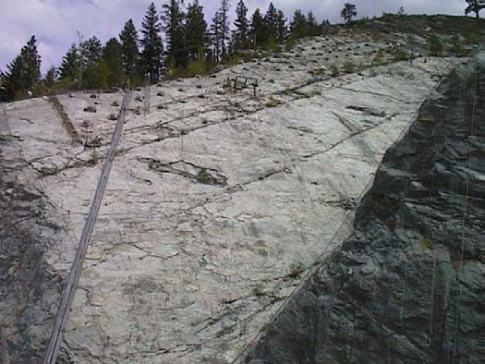

#### Photo 2-1: Dirty Shame Fault (part of left abutment slope) 2.12VEGETATION AND WILDLIFE

The Kootenai River basin in the vicinity of project lands is characterized primarily by coniferous forests. Vegetation along the river and tributary streams (called riparian) is primarily deciduous woodlands dominated by cottonwoods. Forested islands support a mixture of coniferous and deciduous trees. The Kootenai River flows south through the reach bordered by the project. Subsequently, the forested slopes above the river are predominantly east- and west-facing slopes, with relatively few south- and north-facing slopes. The aspect of slopes is a particularly important factor controlling vegetation associations in an area where the summers are hot and dry, which characterizes the project area. Thus, the south-facing slopes receive sun for a large portion of each day and are the hottest and driest slopes. They are typified by a sparse growth of ponderosa pine and relatively few understory plants. At the other extreme, north-facing slopes receive little to no direct sun and tend to be cooler and do not become as dry, typically receiving moisture from morning dew. Hence, vegetation is denser and more lush, usually showing a greater diversity of species. These slopes tend to be dominated by Douglas fir and western larch, with a large number of understory plants. The east and west facing slopes, then, tend to show a gradation of community makeup as it changes from ponderosa pine on south-facing slopes to Douglas fir and western larch on north- facing slopes. They include species common to both north- and south-facing slopes and usually have the greatest diversity of vegetation and animal species, though the west- facing slopes tend to be slightly drier than the east-facing slopes and are somewhat more open in structure and have a slightly lower diversity of species. Complete lists of common and scientific names of vegetation and wildlife species found on project lands are included as Appendices C and D, respectively.

Libby Dam-Lake Koocanusa Project Corps of Engineers

Master Plan-September 1997 Seattle District

* + 1. East and West Facing Slopes. In the project area these slopes consist primarily of Douglas fir and ponderosa pine with western larch interspersed. As the slopes grade toward south-facing, the pines increase and the firs and larch decrease in percentage until the slopes consist almost entirely of ponderosa pine. As the east and west facing slopes grade toward the north, the pines decrease and the firs and larches increase until pines are no longer found in the community. Therefore, the east and west facing slopes encompass a wide range of variability within the Douglas fir/ western larch/ponderosa pine association. Understory plants consist of ninebark, snowberry, kinnikinnick, Oregon grape, ocean spray, mock azalea, golden currant, rose, and serviceberry. Serviceberry is perhaps the most preferred of these shrub species by wildlife, but is also the least common plant in the area. Ninebark is probably the most abundant shrub on project lands, but appears to receive almost no use by wildlife, other than for nesting by small birds. Snowberry is almost as abundant as ninebark, and is favored by many species of birds for its fruit, and by deer and elk for its twigs and foliage. Deer and elk also eat the twigs and foliage of Oregon grape, ponderosa pine, and Douglas fir. White-tailed deer show a preference for kinnikinnick, the fruit of which is also eaten by blue grouse. Red squirrels are insectivorous during spring and summer, but turn to the seeds of Douglas fir and ponderosa pine during fall and winter. Black bears utilize these areas as well, feeding on berries, tubers, insects, small mammals, and honey. The higher elevations of the slopes are the preferred summer range of deer and elk, while the lower elevations provide fair winter habitat for big game. Although the understory vegetation is diverse, the overstory vegetation is strictly composed of coniferous trees, and the bird life is therefore representative of a coniferous forest, including such species as mountain chickadee, red-breasted nuthatch, northern flicker, American robin, and dark-eyed junco. Most of these species are insectivorous, but the nuthatch also eats the seeds of Douglas fir and ponderosa pine. Examples of east and west facing slopes are found in wildlife management areas A, B, C, D, and F (see Section 8).
    2. North-Facing Slopes. These slopes are devoid of ponderosa pine and are dominated by Douglas fir with western larch being a minor component in the overstory. Understory plants consist of the same species as found on the east- and west-facing slopes, though in different proportions. For instance, serviceberry and ocean spray are more numerous here than on the slightly drier slopes. Wildlife, too, is quite similar and differs in that the number of species of animals that utilize the north-facing slopes is slightly less than on the east and west facing slopes. Despite the greater abundance of serviceberry big game use is generally a little less on the north-facing slopes primarily because of the lack of sun that penetrates through to the forest floor (due to the denser overstory vegetation). In addition, these slopes in the project area tend to be relatively steep, which likely discourages use by big game to some degree. However, small species of mammals and birds do not appear to be any less abundant on north-facing slopes

Libby Dam-Lake Koocanusa Project Corps of Engineers

Master Plan-September 1997 Seattle District

than on other slopes. Examples of north-facing slopes are found in wildlife management areas B and D (see Section 8).

* + 1. South-Facing Slopes. These slopes consist almost entirely of ponderosa pine in the overstory and very small numbers of rose and ninebark in the understory. Ground cover is composed primarily of grasses and a few forbs. The only good example of a south-facing slope on project lands is at the southern end of wildlife management area D (see Section 8). The availability of grass on south-facing slopes makes them important elk grazing areas. However, the isolation and small size of the south-facing slope in area D makes it of only marginal importance for elk and deer. In addition, the absence of browse plants on this slope, with the exception of roses, also limits the use of this area by big game. Other wildlife use of this slope is also low due to the low diversity of vegetation and subsequent low availability of cover and food. Birds on south- facing slopes include mountain chickadee, red-breasted and white-breasted nuthatches, northern flicker, and American robin.
    2. Riparian Communities. Riparian communities are characterized as narrow belts of specialized vegetation (i.e., adapted to relatively wet conditions) lining the shorelines of streams. The controlling factor is the existence of a fairly stable zone of soil moisture which will support a greater density of vegetation than the adjacent flood plain and hillsides. The plants here must be able to withstand saturation of the soil as well as periodic flooding. These species include cottonwood, willow, red-osier dogwood, mountain alder, birch, serviceberry, ninebark, and rose. Riparian areas are important not only for the variety of food and cover they provide for wildlife, but also for their ready availability of water. Riparian areas provide an especially rich variety of foods including buds, twigs, catkins, seeds, and fruit. The fruit of red-osier dogwood is much preferred by wood ducks, ruffed grouse, grosbeaks, thrushes, and vireos. White-tailed deer and moose seek out the twigs and foliage of this dogwood, as well as willows, alder, and birch. Birch and alder catkins provide food for redpolls, pine siskins, black-capped chickadees, and fox sparrows. The buds and catkins of cottonwoods, alders, and birches are important food for ruffed grouse. Finally, beaver and porcupine eat the bark and wood of cottonwood, birch, and willow. Ospreys and bald eagles perch in trees of riparian areas, and Canada geese and other waterfowl nest among the grasses and/or dense vegetation growth associated with these habitats. Riparian communities are found in wildlife management areas E and F (see Section 8).
    3. Forested Island. There is one forested island within project lands. Moonshine Island, which belongs to the U.S. Forest Service, contains bottomland forest vegetation that is considered typical for the Kootenai River basin. It is a mixed coniferous and deciduous forest of Douglas fir, western larch, Engelmann spruce, western red cedar, cottonwood, and alder in the overstory. The understory consists of Rocky Mountain juniper, common juniper, birch, rose, ninebark,

Libby Dam-Lake Koocanusa Project Corps of Engineers

Master Plan-September 1997 Seattle District

snowberry, and Oregon grape. The vegetation of Moonshine Island contains a relatively diverse range of food and cover and supports a correspondingly wide range of wildlife species. Wildlife includes white-tailed and mule deer, great blue herons, beavers, red squirrels, great-horned owls, northern flickers, belted kingfishers, and several other species of small birds and mammals.

* + 1. Snags. Snags and fallen logs are present throughout the project lands. Snags are an integral part of the forest ecosystem, providing cavity nesting for a wide variety of birds and small mammals. Most cavity nesters are insectivorous and, thus play an important role in maintaining the health of the forest. Cavity nesters include ducks, woodpeckers, swallows, owls, chickadees, wrens, bluebirds, flycatchers, finches, flying squirrels opossums, raccoons, martens, bats, and chipmunks.
    2. Summary. None of the communities discussed above are independent. Each community needs to interact with its neighbor to be viable and healthy. For example, deer need the exposed higher elevations of slopes for their summer habitat but utilize the lowest areas, especially riparian areas, during the winter. The habitats between the summer and winter ranges are necessary to provide the deer with food and cover, as well as safe migration pathways. Few animals are completely tied to a specific community, but rather need the resources provided by a variety of communities to survive through all four seasons of the year. The interdependence of the vegetation communities of project lands and the wildlife they support is considered whenever manipulation of a particular area is proposed.

### KOOTENAI RIVER-LAKE KOOCANUSA FISHERY

The free-flowing Kootenai River prior to the construction of Libby Dam provided relatively good fishing for a fair number of fishermen. Mountain whitefish and rainbow and cutthroat trout were the primary species taken. The fishing was, however, seasonal due to the high turbid flows which normally characterized the river for about a 3-month period during spring runoff.

Construction of Libby Dam created two separate ecological environmentsa regulated river downstream from the dam and a fluctuating reservoir upstream from the dam each with its distinctive fishery.

The Kootenai River downstream of Libby Dam has developed into an excellent rainbow trout fishery with success rates comparable to the best State Blue Ribbon streams in Montana. Although fishing is frequently restricted by water level fluctuation caused by hydropower peaking at the dam, it has remained productive. Large Gerrard- strain rainbow trout, introduced to the Kootenai, can be caught below the dam where they feed on kokanee entrained through the penstocks. There are species of fish in the river

Libby Dam-Lake Koocanusa Project Corps of Engineers

Master Plan-September 1997 Seattle District

that are at risk, including westslope cutthroat, burbot, bull trout, and white sturgeon (see Section 3.6).

As mitigation for inundation of the Kootenai River, the Corps built a hatchery at Murray Springs near Eureka, in 1978-79. The Montana Department of Fish, Wildlife and Parks (MDFWP) operates the hatchery under a cooperative agreement with the Corps to stock Lake Koocanusa with westslope cutthroat and rainbow trout. Lake Koocanusa was heavily stocked with westslope cutthroat trout in the early years following impoundment. These fish, along with the ubiquitous rainbow trout, formed the backbone of what developed into an excellent fishery. They were supplanted by the kokanee, a landlocked form of the sockeye salmon, which was inadvertently stocked, apparently due to losses from an upstream Canadian fish hatchery. Kokanee are popular with anglers, but because of food limitations, individual fish size has been small at times. In 1986, the MDFWP began stocking Gerrard (Kamloops) rainbow trout, a fish-eating strain which grows quite large (up to 20 pounds or more), for two purposes. One purpose was to feed on kokanee, to control their numbers and let the survivors grow larger. The other purpose was for the trout to provide a trophy fishery themselves for those anglers willing to put in extra effort. Many kokanee, primarily age 0 and age 1 fish, are entrained each spring through the dam as high flows are provided for sturgeon spawning. Thus potentially large percentages of the kokanee population, and also its food, zooplankton, are lost each spring from the reservoir. Fishery management objectives continue to be evaluated and adjusted by MDFWP, in cooperation with the British Columbia Ministry of Environment. Bull trout and westslope cutthroat may be at risk in the drainage above the dam.

### FORESTRY

The forest resources located on the project are managed for sustained yield as well as for their wildlife, recreational, and aesthetic values. By exercising sound management practices these values and benefits will be maintained through the promotion of a healthy and diverse forest. Timber removal and disposal projects are based on construction and operational requirements; recreational development or management of recreation areas; and silvicultural prescriptions.

Disposal of forest products through a formal timber sale contract, in which bids are solicited, are developed by Real Estate elements based on information provided by the project. Minor sales, involving lots with an estimated value of $1000 or less, may be accomplished by the project manager under general guidance issued by the Real Estate Branch. Two or more formal bids will be obtained in writing, if possible. If only one bid can be obtained, the proposed sale will be posted for a period of ten days. Products may also be removed by project employees as firewood in accordance with the project's woodcutting permit.

Woody debris collects at the head of the dam it is not a major problem. The debris is collected on the upstream side of the dam through a system of trashracks on the selective

Libby Dam-Lake Koocanusa Project Corps of Engineers

Master Plan-September 1997 Seattle District

withdrawal system. In spring when the reservoir conditions are right the debris is collected and moved to the east bank of the reservoir where it is piled and burned.

### HUNTING

Hunting is permitted on project lands as long as it is outside of posted safety zones and all applicable state and federal laws and regulations are followed (Title 36 CFR 327.8). The possession of loaded firearms, ammunition, loaded projectile firing devices, bows and arrows, or explosive devices of any kind (including fireworks) is prohibited unless they are: 1) being used for hunting or fishing as permitted under Section 327.8, with devices being unloaded when transported to, from or between hunting sites; 2) in possession of a federal, state or local law enforcement officer; 3) being used at authorized shooting ranges; or 4) have written permission from the District Engineer (Title 36 CFR 327.13).

### CULTURAL RESOURCES

Seventeen known cultural resource sites located on project lands downstream from Libby Dam have been determined eligible for the National Register of Historic Places. These sites have been evaluated and are part of the Libby-Jennings Archeological District. About 300 cultural resource sites have been identified within the drawdown area of Lake Koocanusa. These comprise the middle Kootenai River Archeological District, which has been determined eligible for listing in the National Register of Historic Places.

Mitigation of cultural resource losses attributed to operations at Libby Dam-Lake Koocanusa Project are pursuant to Section 106 of the National Historic Preservation Act of 1966. Under a 1991 Programmatic Agreement with Bonneville Power Administration (BPA), the Corps will take the lead to address adverse effects to cultural resources in Lake Koocanusa as a result of power marketing operations. This effort is part of a 15- year program which will be coordinated by the Corps through a locally based Cultural Resources Cooperating Group. See Section 3.7 for additional cultural resource information.

### NATIVE AMERICANS

The Kootenai Indian people historically lived within the area of Libby project lands.

Today, the federally recognized treaty Indians group which claims the area of Libby project lands as part of their former territory includes the Confederated Salish Kootenai Tribes of the Flathead Reservation at Pablo, Montana. The Kootenai Tribe of Idaho and Canadian Kootenai bands have also periodically expressed interest in cultural resource sites at the Libby Dam-Lake Koocanusa Project.

Libby Dam-Lake Koocanusa Project Corps of Engineers

Master Plan-September 1997 Seattle District

**General**

Owner and Operator Seattle District, U.S. Army Corps of Engineers Date of Dam Construction 1966-19751

Stream Kootenai River, Montana, Idaho, and British Columbia State, Province Montana, Idaho, and British Columbia

County, State Lincoln, Montana

Drainage Area 8,985 square miles Reservoir

Name Lake Koocanusa

Length 90 miles (48 miles Montana, 42 miles British Columbia)

Maximum Depth 370 feet Shoreline 224 miles

Normal Full Pool Elevation 2,459 feet NGVD2 Minimum Pool Elevation 2,287 feet NGVD

Average Tailwater Elevation 2,120.5 feet NGVD (11,360 c.f.s.) Area at Normal Full Pool 46,456 acres

Gross Storage (El. 2,459’) 5,809,000 acre-feet3 Useable Storage 4,979,468 acre-feet Total Draw Down 172 feet

Dam and Spillway

Location River mile 221.94 Type Concrete gravity Length of Dam Crest 2,887 feet Width at Crest 41.5 feet

Width at Base 310 feet

Height Above Streambed 370 feet (elevation 2,459) Volume of Concrete 3,800,000 cubic yards

Spillway Type High head, two-bay, ogee-shaped crest Width 116 feet

Spill Design 146,000 cfs; capable of discharging 150,000 cfs @ max. regulated pool, elevation 2,459 feet. (10,000 year flood)

Flood Inflow Peak 282,000 cfs Flood Outflow Peak 206,000 cfs Powerhouse

Number of Generating Units 5 presently in operation, 8 ultimately Turbine Type Francis

Rated Horsepower 165,000

Rated Nameplate Capacity5 120,000 kilowatts per unit

Plant Capacity6 600,000 presently; 960,000 ultimately

1/Project construction 90% complete in 1975 with first power on-line. 2/ National Geodetic Vertical Datum.

3/An acre-foot of water covers one acre to a depth of 1 foot and is equivalent to 325,804 gallons. 4/Originally the river mile axis was 219.9. River miles have since been reassigned for the entire stream.

5/Each unit has a continuous overload capacity of 120,750 kilowatts (115 percent nameplate at 0.95 power factor). 6/All units are regularly run at 115% of nameplate rating, giving the plant a present capacity of 603,750 kilowatts and an ultimate capacity of 966,000 kilowatts.

**Table 2-1: Pertinent Data**

Libby Dam-Lake Koocanusa Project Corps of Engineers

Master Plan-September 1997 Seattle District

**front of Plate 2-1**

Libby Dam-Lake Koocanusa Project Corps of Engineers

Master Plan-September 1997 Seattle District

**back of Plate 2-1**

Libby Dam-Lake Koocanusa Project Corps of Engineers

Master Plan-September 1997 Seattle District

**front of page 2-2**

Libby Dam-Lake Koocanusa Project Corps of Engineers

Master Plan-September 1997 Seattle District

**back of Plate 2:2**

Libby Dam-Lake Koocanusa Project Corps of Engineers

Master Plan-September 1997 Seattle District

## SECTION 3-FACTORS INFLUENCING RESOURCE USE, DEVELOPMENT, AND MANAGEMENT

### GENERAL

A variety of social, economic, and institutional factors influence the options for future development, use and management of Libby Dam and Lake Koocanusa resources. These factors include visitation trends, areas of influence, socioeconomic characteristics, related recreation areas, endangered/threatened species, cultural resources management, accessibilty requirements, and public coordination.

### PROJECT VISITATION TRENDS

* + 1. Current Visitation. Recorded visitation at Libby Dam and on surrounding Corps lands since the project opened to the public in 1974 is displayed in Appendix F, Table 3-A. Statistics prior to 1987 are not entirely accurate due to inconsistent counting methods, how visitor numbers were reported (visitor hours versus recreation days), and the definitions of these two terms. Many factors have influenced visitation around Libby Dam, including the eruption of Mount St. Helens, gasoline prices, the existing state of the economy, methods used to report visitation, and the value of the Canadian dollar. Weather cycles, fishing success rates and the size of fish being caught, and general access to the reservoir are also contributing factors. Furthermore, Lake Koocanusa is between two highly developed recreation areas, Lake Pend Oreille in northern Idaho and Flathead Lake to the east in Montana. Both of these areas offer better transportation facilities (regular air service and major highways). Activity participation recorded from the recreation visitation surveys conducted in 1983, 1985, and 1992/93 is summarized in Appendix F, Table 3-B. Statistics included in Appendix F apply only to visitation on project lands and do not apply to visitation to Lake Koocanusa as a whole.
    2. Future Visitation Trends. Future trends are difficult to predict due to the unknown impact of increased regional tourism promotional programs, and the influence of public and agency management decisions for recreation use of Lake Koocanusa. In 1983, the state of Montana projected a 40 percent increase in total (resident and nonresident) recreation participation for 1980 to 1990 (Montana Department of Fish, Wildlife and Parks).

The 1984 proposed Kootenai National Forest Plan projected that there is a 50-year supply of recreation facilities with the existing developed recreation facilities within the forest, roughly 75 percent of which is located on Lake Koocanusa. A projected average annual rate of growth in recreation demand may be close to 1.5 percent over the next 50 years.

Libby Dam-Lake Koocanusa Project Corps of Engineers

Master Plan-September 1997 Seattle District

With its scenic beauty, high quality fishery, and the high percentage of publicly-owned land, northwestern Montana is a region with great recreational potential. With three exceptions, virtually all of the 117 miles of Lake Koocanusa’s shoreline in the United States is publicly owned. The potential for preserving the quality of the resources (water purity, fishery health and diversity, aesthetics, public access, etc.) is high. This becomes particularly important as other recreation resources in the region become privately developed and perhaps crowded and/or polluted.

In 1985, the U.S. Forest Service classified Lake Koocanusa as rural by definition from their Recreation Opportunity Spectrum system. This classification identifies the reservoir as a potential resource for accommodating a large amount of dispersed and concentrated use without reducing the site’s fundamental character. It is based on the proximity of roads, the existing evidence of man-made features, and the area’s natural setting. Current recreation sites will continue to be maintained with some modifications or additional features made.

The basic recreation activities on and around Lake Koocanusa are not expected to change in the near future. Fishing will most likely remain the greatest recreation activity. As other lakes closer to population centers become over used, and with an increase in boat service facilities, recreation boating could become a more popular activity on the reservoir.

There is potential for increased houseboating. While Lake Koocanusa would never have the intensity of use as many southwestern United States reservoirs do due to the climate, the length of the lake and the fishing resource could make it an attractive houseboating location. Such development would necessitate the Forest Service formulating a management policy for houseboats (carrying capacity of reservoir and sanitation facilities).

Continued drawdown of the reservoir could increase the use of off-road vehicles.

### AREAS OF INFLUENCE

Internal influences to bring visitors into the area can be attributed to improved signage and increased security in day use and overnight recreational areas. Signs erected at recreation areas have helped to identify overnight and day use facilities that were previously overlooked. Campground and area hosts help to curtail vandalism and provides the visitor with a greater sense of protection.

External influences towards visitation are typically due to the population increases in the Pacific Northwest—from northern Idaho and northeastern Washington, British Columbia and Alberta, Canada, as well as from the western Montana counties of

Libby Dam-Lake Koocanusa Project Corps of Engineers

Master Plan-September 1997 Seattle District

Lincoln and Flathead. The Montana tourism industry has greatly expanded their promotions of Montana as a destination state which continues to bring in new visitors. According to the Inland American Automobile Association, during 1996 Montana attracted 7.9 million tourists. This was 100,000 fewer than the previous year, but they spent $40 million more, or $1.28 million.

In referencing Table 3-1, those who recreate most frequently in facilities administered by the Corps of Engineers around Libby Dam and Lake Koocanusa continue to be from Lincoln County, Montana. This primary market accounts for up to 79 percent of the Montana visitors who can access the Libby Dam area within a relatively short time—two- to three-hour drive (180 miles one-way driving 60 miles per hour)— and also includes those passing by on Montana State Highway 37. Other areas of influence within this distance include Flathead, west Glacier, Lake, northern Missoula, Sanders and Mineral counties in Montana; Idaho counties of Boundary, Bonner, Kootenai, Benewah, Shoshone, northern Latah and northern Clearwater; counties of Pend Oreille, Spokane and Stevens in Washington; the extreme southeast corner of the Canadian province British Columbia and the extreme southwest corner of the province Alberta (see Figure 3-1). Since driving times increase when traveling the mountainous roads of northern Idaho and western Montana, visitors within the 180-mile range may not make the drive to Libby for just a day trip. Additionally, the primary market area doesn’t necessarily represent where the highest percentage of visitors come from, other than for Lincoln County.

Visitors from secondary and further market areas need to travel a few hours to reach the Libby area and would generally stay overnight since a single-day round trip would be too lengthy. Montana counties of east Glacier, Pondera, Teton, Lewis and Clark, Powell, southern Missoula, Granite and Ravalli; Idaho counties of Idaho and southern Latah and Clearwater; and Washington counties of Ferry and Lincoln are within a four- to five-hour drive from the Libby Dam area (300 miles one-way). Visitors from distances greater than 360 miles (six hour drive or longer) generally spend more than one night on-site. However, Libby Dam and Lake Koocanusa may not be a destination for these tourists, but function as a stopping point enroute to other areas in Montana, Idaho and Canada. Visitors from all market areas fluctuate seasonally and in response to tourism trends which can be influenced by economic and weather conditions, road conditions, and road construction.

Libby Dam-Lake Koocanusa Project Corps of Engineers

Master Plan-September 1997 Seattle District

|  |  |  |  |
| --- | --- | --- | --- |
| Market Area | 1983 | 1985 | 1992/93 |
| Montana | 52% | 60% | 57% |
| Lincoln County | 32% | 69% | 79% |
| Flathead County | 8% | 11% | 9% |
| Lewis & Clark Co. |  | -- | 5% |
| Missoula County |  | 4% | 3% |
| ounties not listed showed 2% or less in visitation.  Idaho 8% 10% 9% | | | |
| Bonner County |  | 51% | 6% |
| Boundary County |  | 16% | 41% |
| Kootenai County |  | 16% | 41% |
| Benewah County |  | 5% | -- |
| Jerome County |  | -- | 6% |
| Lemhi County  Shoshone Co. |  | --  4% | 6%  -- |
| ounties not listed showed 2% or less in visitation.  Washington 6% 10% 9% | | | |
| Spokane area |  | 43% | 39% |
| Other Eastern WA |  | 18% | 22% |
| Seattle area |  | 29% | 33% |
| Other Western WA Other undefined WA |  | 11%  -- | -- 6% |
| Canada | 7% | 7% | 8% |
| Alberta |  | 29% | 44% |
| British Columbia |  | 34% | 25% |
| Other Canada |  | 37% | 31% |
| All Other States | 27% | 13% | 16% |

#### Table 3-1. Visitation by Market Area.

Percentage of Visitors Surveyed

C

C

In 1980, the total population of Lincoln County, Montana was 17,752 persons, representing a 1.7 percent decrease from the 1970 census, and decreasing still in 1990 to 17,481. This could be attributed to the socioeconomic reasons listed in Section 3.04. On the opposite side, Flathead County’s population continues to increase from 39,460 in 1970 to 5l,966 in 1980 (31.7 percent) to 59,218 in 1990 (13.9 percent). Flathead County is host to the more metropolitan city of Kalispell, and is a jump-off point to Glacier National Park which is a popular national tourist attraction.

Libby Dam-Lake Koocanusa Project Corps of Engineers

Master Plan-September 1997 Seattle District

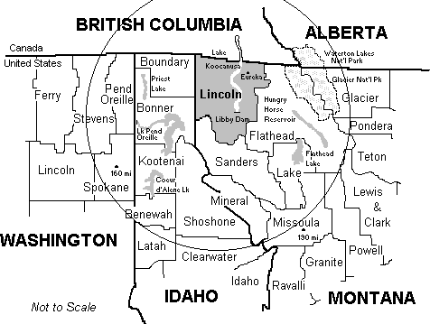

**Figure 3-1. Visitation Areas of Influence.**

### SOCIOECONOMIC CHARACTERISTICS

When Libby Dam was constructed the economy of the region, particularly the primary market area, was heavily dependent on its forests, with logging and lumber mills traditionally employing a large segment of the labor force. Farming, ranching, mining, and the tourist industry were also important to the region’s economy. Today, northwest Montana is experiencing social, economic and population changes. Collectively, these suggest the previous way of life, based on a timber culture, may become lost. Lifestyles may be substantially altered, as described below.

Libby Dam-Lake Koocanusa Project Corps of Engineers

Master Plan-September 1997 Seattle District

* Regional population showed a modest decline between 1970 and 1990. However, 1993 population estimations indicate a trend towards a substantial population increase.
* The timber basis of community economies is changing. With the total number of timber companies declining, uncertainty about the economic viability of the industry, and a declining total value of wood products sold, the trend is downward.
* Employment opportunities are declining because of the decreases in the mining industry and in timber activities.
* Agriculture is small but nonetheless a significant portion of the region’s economy. The total number of agricultural operations has decreased but the value of products sold has shown a steady upward trend, with livestock production accounting for a major contribution to this upward trend.
* Despite a downward trend in employment the total number of housing units has increased along with the average value of real estate, but the average number of persons per household has decreased.
* Population composition is changing in part because of an in-migration of new residents and an out-migration of established residents or their adult children. However, older residents are accounting for an increasingly larger portion of the total population in the region.
* The costs of social programs and services are steadily increasing.
* Multiple economic activities allow many small scale businesses to exist. In fact, residents emphasize the need to “piece together” a living. But the loss of even a small portion of total income from such businesses can have major consequences.
* Lincoln County, Montana is still a substantial and persistent unemployment area as described by the Census and Economic Information Center, Montana Department of Commerce. Unemployment in Lincoln County has averaged 13 percent since 1980. This is higher than the state and national average of 7 percent.
* Economic diversity is a significant goal of the region, given the changing nature of the timber industry and the current downward trend of the total value of wood products produced.
* Tourism, along with the natural resources and facilities affecting this industry, are perceived as important assets to the economic well being of the region.

Cited primarily from the *Executive Summary Social Assessment for the Kootenai National Forest,* July 31, 1995.

The town of Libby’s commercial developments are concentrated in the downtown area and along Highway 2. Businesses primarily serve the local permanent residents. Tourism- and recreation-related establishments are not abundant although ample commercial and office space are available for rent and for sale along Highway 2 where the highest traffic volumes occur.

From a study conducted in 1985 on recreation use on Lake Koocanusa1, users of Lake Koocanusa’s recreational facilities generally fall into two groups: the nonresident fishing campers without children who visit the reservoir for extended periods of time (one week to two months) who are generally attracted to full-service campgrounds; and the resident fishing/picnicking/swimmers with children who may come for the weekend and camp, or just for the day. It is probable that the majority of recreationists using

Libby Dam-Lake Koocanusa Project Corps of Engineers

Master Plan-September 1997 Seattle District

undeveloped campsites and boat launching sites on Lake Koocanusa are local or regional residents who are familiar with the network of local roads.

Businesses in Eureka on the north end of Lake Koocanusa are primarily retail.

Rexford, located west of Eureka, is primarily a bedroom community. Rexford Bench campground is the main recreational attraction. During the hunting and fishing seasons, Rexford enjoys substantial Canadian traffic through the area.

In both Eureka and Libby, tourism is viewed as a potentially significant and important element in developing the local economies. Residents and business persons believe their natural resources provide a potential foundation for the successful development of the area as a destination resort and vacation spot and would like to see tourism play a bigger role in the local economy1. In the 1985 study, according to the mayor of Rexford, his community seeks to respond to tourist and recreational needs as they arise, but not to actively promote tourist development, thereby preserving their community structure.

### RELATED RECREATION AREAS

Recreation areas and opportunities abound in the primary and secondary market areas. Major recreation areas include Glacier National Park in Montana; Waterton Lakes National Park in Alberta, Canada; Flathead Lake and Hungry Horse Reservoir in Montana; and Lake Pend Oreille, Priest Lake and Coeur d'Alene Lake in Idaho (see Figure 3-1). There are a number of wilderness and state recreation areas and parks to enjoy as well. Extensive National Forest lands and facilities within these markets include the Kootenai National Forest and parts of Lolo, St. Joe, Coeur d'Alene, Flathead, and Kaniksu National Forests. British Columbia Ministry of Forests lands include Cranbrook, Invermere and Kootenay Lake Forest Districts.

* + 1. High density recreation use. High density recreation is defined as day or overnight use in developed public use areas for intensive recreational activities by the visiting public. Facilities have been or will be provided to accommodate the recreation needs of visitors in concentrated numbers and such adjacent or associated lands without facilities as required for open space purposes to make a whole and desirable recreation unit. No hunting or agricultural uses are permitted on this land.

During early stages of planning for Libby Dam and Lake Koocanusa on the United States side, 22 sites were identified as potential recreation developments for administration under the U.S. Forest Service (see Figure 3-2). Today, nine high density developments offer visitors a wide choice of recreational opportunities (see Figure 3-3). Operation and maintenance is conducted by either the U.S. Forest Service (USFS), the Corps of Engineers (COE), or by a private operator. These sites include Rexford Bench, Mariner’s Haven, Peck Gulch,

Libby Dam-Lake Koocanusa Project Corps of Engineers

Master Plan-September 1997 Seattle District

Koocanusa Marina, Souse Gulch Day Use Area, McGillivray Campground, and Alexander Creek, Blackwell Flats, and Dunn Creek Flats Recreation Areas.

1. Rexford Bench, USFS. Located on the left bank of the lake near the town of Rexford. Facilities include a boat launching ramp usable to pool elevation 2,341 feet with a 50-space parking lot, swimming beach, twelve picnic units, 53 camping units with an additional 50-unit overflow area, accessible restrooms, trailer dump station, telephone, and trails.
2. Mariner’s Haven is privately operated. Located on the left bank of the lake one mile south of Rexford. It was developed in 1990 on both private and USFS lands under a special use permit. Facilities include a primitive boat ramp (usable to pool elevation 2,445 feet), a 40-slip marina, swimming beach, 62 trailer and tent sites with full hookups at 26 sites, showers, laundromat, trailer dump station, marine and auto fuel, and store.
3. Peck Gulch, USFS. Located on the left bank of Lake Koocanusa 26 miles north of Libby Dam. Facilities include a high-water boat launching ramp usable to elevation 2,400 feet and a low-water boat launching ramp usable to elevation 2,310 feet. There is also a 74-unit camping/day use area with picnic tables and firepits, handicapped access vault toilets, drinking water, trails, and associated parking for cars and trailers.
4. Koocanusa Marina (USA), a commercial development operating under a concession permit from the USFS. This marina and resort, located seven miles above Libby Dam on the left bank, is the most extensively developed recreational facility on the lake. It features a fully-developed campground with 55 full hookups and 23 non-hookup sites, showers, laundromat, restaurant and store, cabins, free boat launch ramp (usable to elevation 2,334 feet) with a 60-unit car/trailer parking lot which is also used as an overflow camping area, and a 30-slip marina complete with marine and auto fuel. It was jointly developed by the private sector, the USFS, and the Corps of Engineers.
5. McGillivray, USFS. Located on the right bank of Lake Koocanusa approximately five miles north of Libby Dam. Facilities include a 50-unit campground, swimming beach, play field, two group use areas provided with community kitchens, and a boat launching ramp usable to elevation 2,385 feet.
6. Souse Gulch Recreation Area, COE. This day use area is adjacent to Libby Dam on the right bank (west shore) and is hosted by a seasonal volunteer. Facilities include three picnic shelters with sinks, grills, electricity and running water, 28 picnic/grill sites, hiking trails, a paved boat launch ramp (usable to elevation 2,310 feet) and

Libby Dam-Lake Koocanusa Project Corps of Engineers

Master Plan-September 1997 Seattle District

moorage/waterskiing dock, playground, volleyball court and net, horseshoe pits, water, and heated restrooms. Information kiosks, visitor center and tours are provided at Libby Dam. Refer to Section 6 for additional information about the area.

1. Additional Corps of Engineer sites described in detail in Section 6 and located south of Libby Dam include Dunn Creek Flats Recreation Area, two miles on the left bank; Blackwell Flats Recreation Area, three miles on the right bank; and Alexander Creek Recreation Area, one mile on the right bank. These dispersed use sites offer primitive boat access to the river for trout fishing, camping sites, picnic tables and grills, and portable vault toilets. Drinking water is not available.
   * 1. Dispersed Recreation. Dispersed recreation is defined as day use or impromptu camping along or near forest roads and is characterized by low density use over broad expanses of land with minimal facilities. Several dispersed, low density recreation facilities have been completed since Libby Dam was constructed. These include Gateway, Tobacco Plains, Stone Hill, Rocky Gorge, Yarnell Islands, Canyon Creek, Baron Creek, Little North Fork Falls, Murray Springs Fish Hatchery, Libby Dam left abutment visitor area and Libby Dam right abutment visitor area. All areas are administered by the USFS with the exception of Murray Springs Fish Hatchery which is operated by the Montana Department of Fish, Wildlife and Parks under a cooperative agreement contract with the Corps of Engineers, and the Corps of Engineer’s left abutment and right abutment visitor areas located near Libby Dam.

Remaining sites originally identified in the June 1983 master plan may be considered for future recreational development by the USFS subject to a demonstrated need and availability of funding. Development along Lake Koocanusa includes approximately 60 miles of hiking trails, small vehicle turnouts and parking areas, flat areas suitable for camping, fishing access trails, and general cleanup and traffic control measures primarily for protection of the environment.

* + - 1. Gateway, USFS. Accessible only by boat and located on the left bank (east shore) of Lake Koocanusa just south of the Canadian border, and nine miles northeast of Eureka, Montana. Development includes four camping units and a pit toilet. Drinking water is not available.
      2. Tobacco Plains, USFS. Located south of Gateway on the left bank of Lake Koocanusa. Facilities include a two-lane boat launching ramp usable to pool elevation 2,433 feet, vault toilet, parking for 13 cars with trailers, and landscaping.

Libby Dam-Lake Koocanusa Project Corps of Engineers

Master Plan-September 1997 Seattle District

* + - 1. Stone Hill, located approximately four miles north of Peck Gulch along Highway 37, is operated by the USFS as a rock climbing site.
      2. Rocky Gorge, USFS. Located on the left bank of the lake 24 miles north of Libby Dam. Initial development began in 1988. A public boat launching ramp is usable to elevation 2,370 feet. Camping is permitted in the 120-unit car and trailer parking lot. A small number of picnic tables and firerings are provided along the edges of the parking area. Handicapped accessible pit toilets and water are available.
      3. Warland Flats, USFS. Located one mile north of Koocanusa Marina, offers a large open field for camping, a sandy beach and pit toilets.
      4. Yarnell Islands, USFS. These two small islands are located 3.5 miles north of Libby Dam and approximately a quarter-mile off the east shore of the lake. The islands are accessibly only by boat. Eight campsites, including tables, fireplaces, and connecting trails, have been provided. Drinking water and toilet facilities are not available.
      5. Canyon Creek, USFS. Located two miles north of Libby Dam on the left bank has numerous wooded camping sites along the shore. At full pool, a primitive boat ramp in a sheltered bay offers good access to the reservoir for small boats.
      6. Barron Creek, USFS. This area has been improved with vault toilets. The old Barron Creek road is used as a paved boat ramp and is serviceable to lake elevation 2,282.
      7. Little North Fork Falls, USFS. This area provides a parking lot and a quarter-mile hike to a scenic waterfall.
      8. Murray Springs Fish Hatchery above Rexford is a Corps of Engineers facility operated under lease to the Montana Department of Fish, Wildlife and Parks. Although this hatchery does not fall under the normal definition of dispersed use, it is open to the public with self-guided tours to accommodate a visitor’s curiosity. Restrooms are available during operating hours. This facility is described in detail in Section 9.

Libby Dam-Lake Koocanusa Project Corps of Engineers

Master Plan-September 1997 Seattle District

#### Figure 3-2: U.S. Forest Service Recreation Sites

Libby Dam-Lake Koocanusa Project Corps of Engineers

Master Plan-September 1997 Seattle District

#### Figure 3-3: Lake Koocanusa Recreation Areas

Libby Dam-Lake Koocanusa Project Corps of Engineers

Master Plan-September 1997 Seattle District

* + - 1. Left Abutment Visitor Area, COE. Located immediately below the dam. This site offers fishing access, wildlife viewing, picnicking and camping opportunities. See Section 8 for details.
      2. Right Abutment Visitor Area, COE. Located immediately below the dam, this site offers fishing access, project and wildlife viewing. See Section 8 for details.
    1. Canadian Recreation. On the Canadian side of Lake Koocanusa, recreation developments are administered by the British Columbia Provincial Parks (BC Parks), British Columbia Ministry of Forests (BCFS), and private commercial recreation providers.
       1. Newgate, BCFS. Located on the right bank (west shore) of Lake Koocanusa approximately one mile north of the Canadian border. This facility offers picnic tables, spring water, dispersed camping sites, pit toilets and a primitive boat ramp.
       2. Englishman Creek, BCFS. Located on the right bank about eleven miles north of the border. This area provides well water, dispersed camping sites, pit toilets, and a primitive boat ramp.
       3. Oestreich RV Park is privately operated. Located on the right bank of the lake about 15 miles north of the border. Services and facilities include campsites, a boat launching ramp, boat moorage slips and an activities facility.
       4. Koocanusa Marina (Canada) is privately operated. Also on the right bank of Lake Koocanusa this marina is approximately 18 miles north of the Canadian border. Facilities include campsites, a trailer dump station, a boat launching ramp and moorage slips, swimming beach, marina fuel, and a convenience store.
       5. Kikomun Creek Provincial Park, BC Parks. Located on the left bank (east shore) of the lake approximately 17 miles north of the Canadian border and six miles south of Jaffray, British Columbia. Facilities include 104 campsites, amphitheater, group camping area, three day use areas, three swimming beaches, trailer dump station, showers, hiking trails and wildlife viewing areas.
       6. Wardner Provincial Park, BC Parks. Located on the right bank of Lake Koocanusa about 35 miles north of the border. This is a day use area primarily for picnicking.

### THREATENED/ENDANGERED SPECIES

Libby Dam-Lake Koocanusa Project Corps of Engineers

Master Plan-September 1997 Seattle District

The only species known to be associated with project lands which is listed as threatened on the Federal List of Threatened and Endangered Wildlife and Plants is *Haliaeetus leucocephalis,* the bald eagle (see Section 7). Project lands provide numerous perches and nesting opportunities for the eagles, while Libby Dam maintains a regular flow of ice-free water throughout the winter months, making prey available for the eagles. Migrating eagles are present between October and April. Grizzly bears are also listed as endangered but are not found on project lands, though they range nearby. The Kootenai River population of white sturgeon, which lives downstream of Libby Dam, mainly below Kootenai Falls, was listed as endangered, without designation of critical habitat, in 1994. The reason for the listing was lack of recruitment of young fish to the adult population. Sturgeon spawning is being addressed through experimental spring flows from Libby Dam—an operational issue. A final recovery plan for sturgeon is anticipated by fall of 1997.

The US Fish and Wildlife Service has proposed listing the bull trout as a candidate species throughout their range, including the Kootenai drainage above and below Libby Dam. A final decision for listing has not been made yet. The Forest Service has also submitted a petition for listing westslope cutthroat trout but there has been no final decision. Burbot are of concern because of population declines in the Kootenai, but have not been the subject of any action to date under the Endangered Species Act. The yellow lady’s slipper (*Cypripedium parviflorum*) while not listed as endangered or threatened is considered a sensitive species by the U.S. Forest Service. The yellow lady’s slipper is found in a boggy area adjacent to the Souse Gulch Recreation area (see Section 7) .

No other threatened or endangered species are found on project lands, nor are any proposed species present in the area. There is no critical habitat designated anywhere in the project vicinity. The draft master plan was coordinated with the U.S. Fish and Wildlife Service during the public review period (see Appendix E).

### CULTURAL RESOURCES MANAGEMENT

* + 1. Libby Project Lands. Seventeen known cultural resource sites are located on Libby Dam lands between the dam and the mouth of the Fisher River. These include three historical sites and fourteen aboriginal prehistoric sites. These cultural resources are part of the Libby-Jennings Archeological District and have been determined eligible for listing on the National Register of Historic Places. Prior to any ground altering activity at the railroad spur project operations area (see Section 5), in the areas of Alexander Creek, Blackwell Flats, and Dunn Creek Flats (see Section 6), or Tobacco River Rails-to-Trails area (see Section 8), it will be necessary to make a “determination of effect” in consultation with the Montana Historic Preservation Officer, the Advisory Council on Historic Preservation, and the Confederated Salish-Kootenai Tribes of the Flathead Reservation. If unavoidable adverse effects to cultural resources are determined,

Libby Dam-Lake Koocanusa Project Corps of Engineers

Master Plan-September 1997 Seattle District

mitigation may be required, or the affected area avoided for development altogether.

* + 1. Lake Koocanusa. On October 3, 1966, the Corps of Engineers and the Forest Service executed a Memorandum of Understanding (MOU) which pertained to the planning, development, and management of land and water resources for Libby Dam and Lake Koocanusa. Under Article 14 of the MOU, Action Plan “O” (Cultural Resources) was established by the District Engineer and the Kootenai National Forest Supervisor on March 30, 1988, to identify responsibilities for cultural resources management. Action Plan “O” specified the Corps of Engineers will address adverse effects to cultural resources within the Lake Koocanusa drawdown area. Initially, this was done by development of a draft Cultural Resources Management Plan prepared and approved in 1987. In 1991, the Corps and Bonneville Power Administration (BPA) signed a cultural resources Programmatic Agreement with the Advisory Council on Historic Preservation for BPA's Intertie Development and Use Environmental Statement. Under the terms of the agreement, BPA will fund the Corps to accomplish required cultural resource studies and coordination. If this work is carried out according to the agreement, then both agencies achieve legal compliance with requirements of the National Historic Preservation Act. Accordingly, a revised Historic Properties Management Plan is needed, and will be prepared in fiscal year 1998.
    2. Response Requirements. The Corps of Engineers is legally responsible for enforcement of Archeological Resources Protection Act (P.L. 95-96) violations that occur on Libby Dam lands. Notifications to affected Indian tribes may be necessary. In addition, strict tribal notification requirements are specified for situations of inadvertent discovery of human remains in the Native American Graves Protection and Repatriation Act (P.L. 101-601), in addition to local law enforcement authorities. Response to these requirements will be planned for at the local project office and points-of-contacts will be designated for reporting such events within a 24-hour period.
    3. Environmental Review Guide for Operations (ERGO) Assessment Requirements for Cultural Resources. Archeological analysis and reporting responsibilities exist for the 1977-78 site testing and data recovery efforts related to the Libby Additional Units and Reregulating Dam (LAURD) Project. The most recent ERGO assessment has directed that former LAURD lands planned for real estate disposal will need to address the cultural resources effects.

Libby Dam-Lake Koocanusa Project Corps of Engineers

Master Plan-September 1997 Seattle District

### NATIVE AMERICAN CONCERNS

Corps lands around Libby Dam and Lake Koocanusa are part of lands ceded by the Kootenai Tribe of the Confederated Salish and Kootenai Tribes of the Flathead Reservation under the Hell Gate Treaty Council of 1855. Native American concerns are known to include access to Sacred Sites, inventory of Traditional Cultural Properties, and the free practice of Native American Religious Freedom beliefs. All of this information is proprietary, exempt from the Freedom of Information Act, and requires coordination and consultation with the affected tribal groups. The treaty tribes with primary interest in the lands at Libby Dam are the Confederated Salish-Kootenai Tribes of the Flathead Reservation, Pablo, Montana. Other tribes with a direct interest in Corps lands include the Kootenai Tribe of Idaho (Bonners Ferry), and the Ktunaxa/Kinbasket Tribal Council in Cranbrook, British Columbia (this is a consortium of bands of the Kootenai Indian people now living in Canada). The Seattle District is working directly with the Tribal Historic Preservation Office of the Confederated Salish-Kootenai Tribes at Pablo, Montana, to identify tribal concerns.

### AMERICANS WITH DISABILITIES ACT

The Americans With Disabilities Act (ADA), enacted in 1990, requires certain federal agencies to develop implementing regulations that prohibit discrimination on the basis of disability. These regulations include compliance with design and construction standards as expressed in *ADA Accessibility Guidelines for Building Facilities* (ADAAG). A memorandum signed by the Secretary of Defense, dated 20 October 1993, subject, ”Access for People with Disabilities,” changed the Department of Defense (DOD) policy by directing DOD to meet *The Uniform Federal Accessibility Standards* (UFAS), and to meet the requirements of ADAAG in facilities subject to UFAS whenever ADAAG provides equal or greater accessibility than the requirements of UFAS. Corps of Engineer districts and divisions were notified of the change in DOD policy by CEMP-EA/CECW-EP memorandum dated 25 January 1994, subject, ”Access for People with Disabilities.”

In September 1994, the Corps of Engineers’ Seattle District Planning Division published *Libby Dam-Lake Koocanusa Project Americans with Disabilities Act Evaluation*. This report is based on a survey of accessibility with respect to ADAAG conducted at Libby Dam in August 1994. The report identifies architectural barriers to entering or using facilities by individuals with disabilities, and recommends priorities for removing the identified architectural barriers to make facilities accessible, thereby bringing the Libby Dam into compliance with ADA regulations. Recommendations from the 1994 ADA evaluation have been incorporated into the current Operational Management Plan (OMP) and many readily achievable recommendations have been implemented. New facilities constructed at Libby Dam will be designed in compliance with current ADA regulations.

### PUBLIC COORDINATION OF MASTER PLAN

Libby Dam-Lake Koocanusa Project Corps of Engineers

Master Plan-September 1997 Seattle District

Early contributions from the public regarding this master plan were obtained through a series of open houses conducted by the Corps in Libby, Montana and Eureka, Montana on 24-25 July 1996. The purpose of the open houses was to obtain the public’s ideas on current and future use and management of Corps-administered lands. In addition, interviews outlining the intent of the master plan and announcements for the open houses were provided through local radio stations and newspapers. A summary of the open house coordination effort and public comments is provided in Appendix E.

The Libby Dam-Lake Koocanusa Project Master Plan was distributed for review in August 1997. Reviewers included federal, state, and local resource agencies, environmental groups, the Confederated Salish Kootenai Tribes of the Flathead Reservation, recreational organizations, and the public. A distribution list, comment letters received, and Corps responses to comments, are contained in Appendix E.

Libby Dam-Lake Koocanusa Project Corps of Engineers

Master Plan-September 1997 Seattle District

## SECTION 4-LAND ALLOCATION AND CLASSIFICATION

### GENERAL

The purpose of this section is to define and prescribe project land allocation, land classification, and restricted water use zones. Project lands are allocated into one of four categories in accordance with the authorized purposes for which they were acquired: (1) Operations; (2) Recreation; (3) Fish and Wildlife; and (4) Mitigation. Libby Dam-Lake Koocanusa Project lands are allocated into two categories: (1) Operations and (2) Mitigation. The land allocation category, Mitigation, applies to those lands acquired or designated specifically to offset losses associated with the construction of the project.

Wildlife mitigation lands totaling 2,443.81 acres and described in Section 2 were deeded to the state of Montana in 1982 and are no longer subject to zoning by the master plan. Lands acquired or designated specifically for mitigation of fish losses include the Murray Springs Fish Hatchery (see Section 9). All other project lands are operational lands, acquired to provide for safe and efficient operation of the project for those authorized project purposes. Land classification and restricted water use zones, as prescribed below, provide for sound resource use, development, and management practices consistent with authorized project purposes and based on a determination of highest and best use.

### LAND CLASSIFICATION

Allocated project lands are further classified by the Corps to provide for development and resource management consistent with authorized project purposes and the provisions of the National Environmental Policy Act and other federal laws. The classification process refines the land allocations to fully utilize project lands with consideration to public desires, legislative authority, regional and project specific resource requirements, and suitability.

Allocated project lands administered by the Corps of Engineers totaling 1,963 acres are classified in accordance with the land classification system outlined in Engineering Regulation (ER) 1130-2-550 (Chapter 3) and Engineering Pamphlet (EP) 1130-2-550 (Chapter 3) and as prescribed below. Project lands are classified according to one of five categories: Project Operations, Recreation, Environmental Sensitive Areas, and Multiple Resource Management and Easement lands. Activities in conflict with the intent of the land classifications are not allowed. Land classifications for the project are tabulated on Table 4- 1 and shown on Plates 4-1 and 4-2. Project lands are classified as follows:

* + 1. Operations: Project Operations. Lands allocated to Operations and used solely for project operations. This classification includes all lands, structures, and other areas used and managed in conjunction with the operation and maintenance of the project, and other land areas designated to meet authorized project purposes. Recreational use and/or application of appropriate land management practices for the benefit of wildlife are allowable when not in conflict with basic operations and maintenance requirements and not otherwise restricted due to physical security reasons or public safety considerations. Licenses, permits and easements to public or private interests will be issued only when shown to be not in conflict with project

Libby Dam-Lake Koocanusa Project Corps of Engineers

Master Plan-September 1997 Seattle District

operations and maintenance requirements and not otherwise restricted due to physical security reasons or public safety considerations.

* + 1. Operations: Recreation. Land allocated to Operations and developed for intensive recreational activities by the visiting public, including developed recreation areas and areas for concession, resort, and quasi-public development. Licenses, permits, and easements to public or private interests will generally not be issued on these lands for such man-made intrusions as pumping plants, underground or exposed pipelines or cables, overhead transmission lines, or nonproject roads. Exceptions to this restriction may be made where necessary to serve a demonstrated public need in those instances where no reasonable alternative exists. Management practices for the benefit of wildlife and/or other appropriate land management practices are encouraged when complementary and compatible with recreational uses. Areas considered for future recreation development are classified as multiple resource management until initiation of the development.
    2. Operations: Environmental Sensitive Areas. Lands designated for preservation of scientific, ecological, historical, archeological, Native American traditional cultural sites, or visual values. Normally limited or no development for public use is contemplated on these lands and no agricultural or grazing uses are permitted.
    3. Operations: Multiple Resource Management. Lands allocated to Operations and classified as multiple resource management are managed for one or more of the following activities. The applicable activities for individual lands so classified are fully explained in the following sections of this master plan. Licenses, permits and easements to public or private interests will be evaluated and issued on a

case-by-case basis for such purposes as pipelines, cables, transmission lines or nonproject roads. Such outgrants will include appropriate controls to avoid or minimize adverse visual or other impacts upon the character of the area in question.

* + - 1. Recreation - Low Density. Low density recreation activities such as hiking, primitive camping, wildlife observation, hunting, or similar low density recreational activities.
      2. Wildlife Management General. Fish and wildlife management activities.
      3. Vegetative Management. Management activities for the protection and development of vegetative cover, free of noxious weeds. No Libby Dam project lands are classified as Vegetative Management.
      4. Inactive and/or Future Recreation Areas. Recreation areas planned

for the future or that are temporarily closed. These lands will be classified as multiple resource management in the interim.

Libby Dam-Lake Koocanusa Project Corps of Engineers

Master Plan-September 1997 Seattle District

* + 1. Operations: Easement Lands. All lands for which the Corps holds an easement interest but not fee title. Planned use and management of easement lands will be in strict accordance with the terms and conditions of the easement estate acquired for the project. See Section 2.6 for information on project Easement Lands.
    2. Mitigation: Mitigation. Lands acquired and designated specifically for mitigation to offset losses associated with development of the project

and allocated accordingly. Only those activities which are consistent with the authorized mitigation and enhancement purposes will be allowed.

### RESTRICTED WATER USE ZONES

Two restricted water use zones are designated, immediately upstream and downstream of Libby Dam (see Plate 4-2). Public access within the zones is restricted due to public safety and project security considerations. The upstream restricted water use zone extends from the dam upstream to the anchor of the buoyed area. The downstream restricted water use zone extends from the dam to the David Thompson bridge. Public access to the shoreline within this zone is generally permitted for fishing; however, boating and swimming within the two restricted water use zones are prohibited.

Libby Dam-Lake Koocanusa Project Corps of Engineers

Master Plan-September 1997 Seattle District

|  |  |  |  |
| --- | --- | --- | --- |
| **Allocation** | **Classification** | **Area Name** | **Area** |
| Operations (O) | Project Operations | Libby Dam | 23 |
| Operations (O) | Project Operations | Rail Spur | 27 |
| Operations (O) | Project Operations | Left Abutment Slope | 16 |
| Operations (O) | Project Operations | Project Storage | 22 |
| Operations (O) | Project Operations | Fisher River Quarry | 63 |
|  |  | Subtotal | **151** |
|  |  |  |  |
| Operations (R) | Recreation | Souse Gulch Day Area | 78 |
| Operations (R) | Recreation | Visitor Center Area | 23 |
| Operations (R) | Recreation | Alexander Creek | 1 |
| Operations (R) | Recreation | Dunn Creek Flats | 35 |
| Operations (R) | Recreation | Blackwell Flats | 11 |
| Operations (R) | Recreation | Left Abutment VOA | 1 |
|  |  | Subtotal | **149** |
|  |  |  |  |
| Operations (E) | Env Sensitive | Souse Gulch BE nest | 9 |
| Operations (E) | Env Sensitive | Souse Gulch lady slip | 1 |
| Operations (E) | Env Sensitive | Dunn Creek BE nest | 47 |
|  |  | Subtotal | **57** |
|  |  |  |  |
| Operations (RL) | MRM Recreation | Left Bank Visitor Area | 43 |
| Operations (RL) | MRM Recreation | Right Bank Visitor Area | 21 |
|  |  | Subtotal | **64** |
|  |  |  |  |
| Operations (W) | MRM Wildlife | Wildlife Lands A | 18 |
| Operations (W) | MRM Wildlife | Wildlife Lands B | 111 |
| Operations (W) | MRM Wildlife | Wildlife Lands C | 134 |
| Operations (W) | MRM Wildlife | Wildlife Lands D | 234 |
| Operations (W) | MRM Wildlife | Wildlife Lands E | 96 |
| Operations (W) | MRM Wildlife | Wildlife Lands F | 89 |
| Operations (W) | MRM Wildlife | ReReg Lands | 382 |
|  |  | Subtotal | **1064** |
|  |  |  |  |
| Operations (I) | MRM Recreation | Tobacco River Land | 48 |
| Operations (I) | MRM Inactive | Multiple Areas | 297 |
|  |  | Subtotal | **345** |
|  |  |  |  |
| Operations (Es) | Easement | Assorted Easements | **56** |
|  |  |  |  |
| Mitigation (M) | Mitigation | Murray Spgs. Fish Hat. | **76** |
|  |  |  |  |
|  | **Total** | **CE Administered Land** | **1962** |

#### Table 4-1: Libby Dam Lake-Koocanusa Project Land Classification (See Plate 4-2 for locations)

Libby Dam-Lake Koocanusa Project Corps of Engineers

Master Plan-September 1997 Seattle District

#### front of Plate 4-1

Libby Dam-Lake Koocanusa Project Corps of Engineers

Master Plan-September 1997 Seattle District

#### back of Plate 4-1

Libby Dam-Lake Koocanusa Project Corps of Engineers

Master Plan-September 1997 Seattle District

#### front of Plate 4-2

Libby Dam-Lake Koocanusa Project Corps of Engineers

Master Plan-September 1997 Seattle District

#### back of Plate 4-2

Libby Dam-Lake Koocanusa Project Corps of Engineers

Master Plan-September 1997 Seattle District

## SECTION 5-OPERATIONS: PROJECT OPERATIONS

### GENERAL

Section 5 describes and analyzes lands and associated facilities and structures required for operation and maintenance of the project in accordance with authorized project purposes. All such lands are classified Project Operations, as prescribed in Section 4, and include Libby Dam and appurtenant structures, project operations storage area, rail spur, Fisher River quarry, and left abutment slope (see Plates 4-1 and 4-2 for locations; Fisher River quarry is shown only on Plate 4-1). The analysis for Project Operations areas includes a brief description of each area and its functions, land use classification, establishment of resource objectives, identification of development and management measures, and identification of major constraints to resource use, development, and management. A comprehensive description detailing maintenance and operations procedures for Project Operations areas is provided in the Libby Dam Project Operation and Maintenance Manual.

### LIBBY DAM AND APPURTENANT STRUCTURES

* + 1. Description. This Project Operations Area covers 23 acres and includes the following facilities.
       1. Non-overflow Section. Libby Dam consists of 47 monoliths, numbered from right abutment to left abutment. The concrete non- overflow sections of the dam are constructed on the firm rock that originally formed the canyon walls of the Kootenai River and include monoliths 1 through 19 and monoliths 31 through 47. The powerhouse intake stair and elevator tower is located in monolith 17, providing access into the dam and powerhouse from the roadway located on top of the dam.
       2. Spillway Section. The spillway is located in monoliths 28, 29, and 30 between the power intake section and the left bank non-overflow section. The spillway section is gated with two gate openings operated by individual hoists. Three permanent sluice gates are located in the lower portion of the spillway section.
       3. Power Intake Section. The power intake section of the dam is a concrete gravity-type structure with eight intake waterways and is located in monoliths 20 through 27 between the right bank non-overflow section and the spillway section. Each intake monolith has a penstock connection to the powerhouse. The electrically operated intake gantry crane, consisting of main, auxiliary, and trashrack hoists, is stationed on the roadway portion of the intake monoliths.

Libby Dam-Lake Koocanusa Project Corps of Engineers

Master Plan-September 1997 Seattle District

* + - 1. Treaty Tower. The Treaty Tower (see Photo 5-1), commemorating the 1964 treaty between Canada and the United States for cooperation in water resources development of the Columbia River basin, is located on top of monolith 28. One of the most impressive features of the project, the tower reaches 57 ½ feet above the roadway on top of the dam and extends to the powerhouse and stilling basin below. The Treaty Tower includes a public lobby, display space, observation deck, and restrooms, as well as elevators to transport visitors and project personnel to the interior of the dam and powerhouse. Access to the tower is available from both MSH 37 and Forest Development Road 228. The top of the dam provides designated parallel parking for approximately 15 cars. The upstream face of the tower features a large granite sculpture, designed by sculptor Albert Wein, symbolizing cooperation between the United States and Canada in developing the water resources of the Kootenai River.



#### Photo 5-1: Treaty Tower

* + - 1. Selective Withdrawal System. The selective withdrawal system provides for the control of water quality, primarily water temperature, in the Kootenai River downstream from Libby Dam. The system consists of a multi-bulkhead structure placed upstream of the penstock intakes. Water temperature is controlled by adding or removing bulkheads to draw from the reservoir level with water of the desired quality. For the majority of the year, the bulkheads are at least 50 feet from the reservoir surface to minimize attraction of fish to the system and subsequently through the turbines. During the supplemental sturgeon releases required to comply with the Endangered Species Act, water may be withdrawn closer to the

Libby Dam-Lake Koocanusa Project Corps of Engineers

Master Plan-September 1997 Seattle District

surface to provide warmer water downstream as long as potentially damaging vortices do not form.

* + - 1. Powerhouse Structure. The principal structural elements of the powerhouse are the substructure, which contains the turbines, waterways, and much of the powerhouse auxiliary mechanical and electrical equipment, and the superstructure. The superstructure contains the generator room, erection bay, circuit breaker rooms, the main control room, and some offices. The principal operating equipment in the powerhouse includes the turbines, governors, generators, and switchgear. An electrically powered gantry crane is located in the generator room to perform maintenance on the generators, turbines, and auxiliary equipment and for handling the draft tube bulkheads. A 20-foot-wide roadway between the powerhouse and the dam, and a bridge over the stilling basin connecting the roadway with the left abutment, provide access to either the right or left abutment at the powerhouse level.

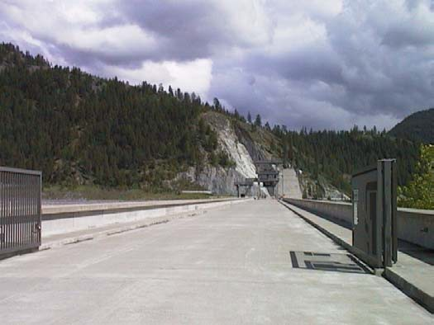

#### Photo 5-2: Road Along Dam Axis

* + - 1. Maintenance Building. The maintenance building, located on the right bank and abutting the downstream face of the dam, provides heated enclosed space for the warehouse, automotive shop, garage, emergency diesel generator unit, maintenance work area, carpentry shop, storage, and maintenance office. Vehicle fueling facilities are located at the downstream end of the building. Vehicle access to this facility is provided by the powerhouse access road from Forest Development Road 228.
      2. Administrative Complex. Inadequate office space has resulted in the planning and development of an administrative office complex for the project manger, his staff, and control room operator. The new complex

Libby Dam-Lake Koocanusa Project Corps of Engineers

Master Plan-September 1997 Seattle District

will be located downstream of the powerhouse approximately 20 feet. The 3700-square-foot building will provide a receiving area for project business and visitors as well as adequate work space for employees.

1. Downstream Structures. Downstream from the powerhouse entrance gates is a building containing the project well and pumping station. Water for the project is pumped up to a holding tank at the visitor observation platform from this building . Approximately a half-mile further downstream is a water quality gauging station maintained by the project and operated by the U.S. Geological Survey water quality group.
2. Upstream Structures. Upstream of the dam along the east bank, in the Souse Gulch Area is the lake weather station. Information such as ambient air temperature, relative humidity, barometric pressure, and precipitation are recorded and monitored here. Located in the Visitor Center Area is the project water holding tank which can be found at the visitor observation platform. All potable water for the project and Souse Gulch Area is stored here.
   * 1. Land Classification. Operations: Project Operations.
     2. Resource Objectives.
3. To conduct operation and maintenance functions for Libby Dam and appurtenant structures according to the Libby Dam Project Operation and Maintenance Manual and the pertinent references listed therein.
4. To increase the public’s understanding and appreciation for Libby Dam and appurtenant structures through interpretive and educational programs.
   * 1. Rationale.
5. This land is required for project operations and maintenance purposes.
6. Promoting a better understanding by the public through interpretation of project purposes and the concept of operations, as well as the natural and manmade features of the area is a means to enhance visitor appreciation of project areas and manage the variety of resources of the project.
   * 1. Land Management Measures. Development and Management Measures (applicable only to second resource objective above).

Libby Dam-Lake Koocanusa Project Corps of Engineers

Master Plan-September 1997 Seattle District

1. Maintain the physical security at the project as specified in

NPDR-190-1-1, Military Police - Physical Security, and in accordance with DM 54, Project Security.

1. Continue to provide guided and/or self-guided tours of the dam and allow controlled public access so long as it does not interfere with project operations purposes.
2. Manage visitor access to public areas of the project during periods of potentially hazardous operations or construction.
3. Install appropriate signs to direct visitors to public areas of the dam, including the dam roadway which provides access from MSH 37 to the Treaty Tower, visitor center, and Souse Gulch day use area.
4. Enclose the Treaty Tower observation deck railing to enhance public safety and viewing opportunities.
5. Provide interpretive signing and displays on the dam roadway, Treaty Tower, and powerhouse to increase public understanding of the purpose and functions of the dam, including spillway, powerhouse, gantry crane, power intake waterways, and trashracks.
6. Install appropriate marking and/or warning devices, both upstream and downstream of the dam, to delineate the restricted waters area (Plate 4-2).
   * 1. Major Constraints. None.

### PROJECT OPERATIONS STORAGE AREA

* + 1. Description. The project operations storage area is situated on an 22-acre mid-level plateau located on the left bank downstream of the dam and below the old resident engineer office (see Photo 5-3). Existing structures include a warehouse, storage building, and covered sand storage area. Present activities and use associated with the site are primarily general storage and stockpiling. Plans have been developed for a garage which will provide a heated maintenance area for project heavy equipment.

Future use of the site will be primarily associated with project resource management. The existing warehouse will be generally used for dry storage of material and equipment unsuitable for storage at other locations. The motor vehicle maintenance building, likewise, will serve as dry storage for certain resource management equipment.

Libby Dam-Lake Koocanusa Project Corps of Engineers

Master Plan-September 1997 Seattle District

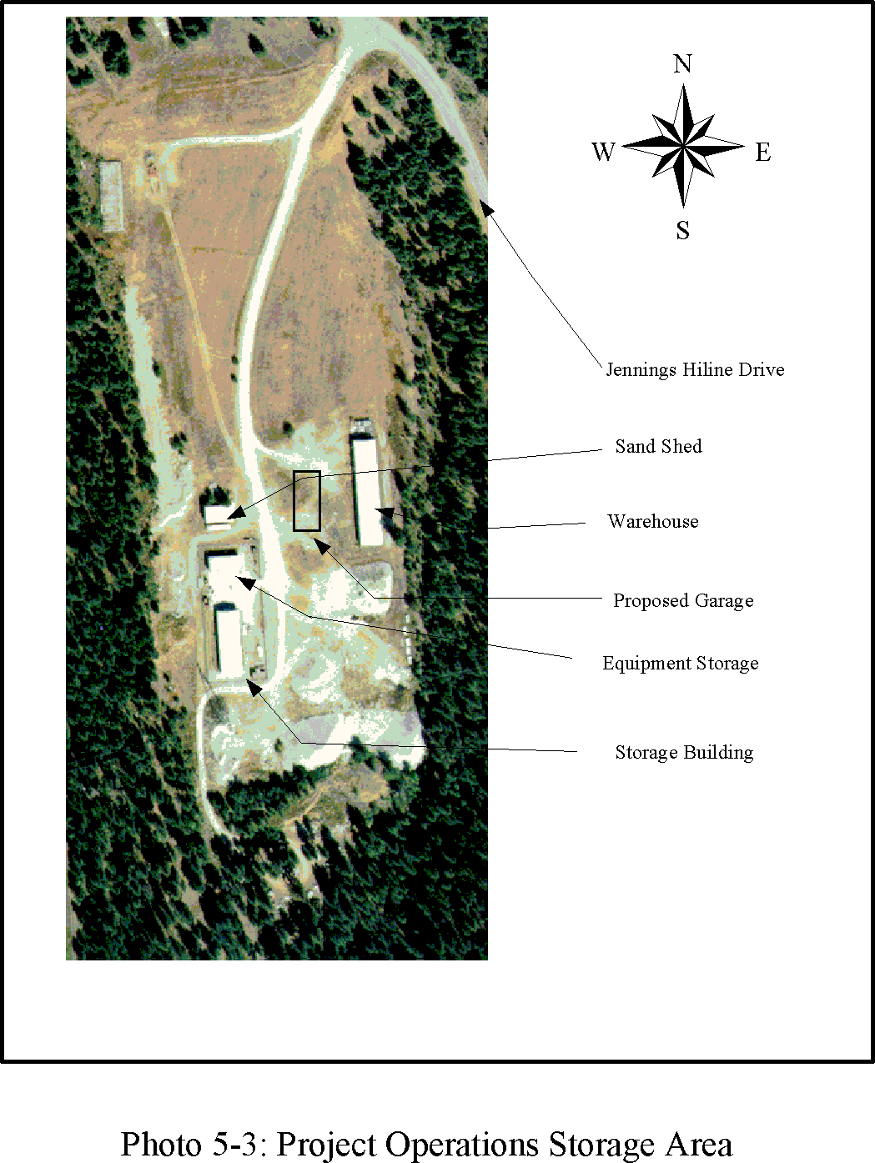

Libby Dam-Lake Koocanusa Project Corps of Engineers

Master Plan-September 1997 Seattle District

* + 1. Land Classification. Operations: Project Operations.
    2. Resource Objective. To consolidate project storage in the left bank storage area, visually screen and physically separate and secure from public access areas.
    3. Development and Management Measures.

1. Establish a visual screen of the area from public viewing points at the dam. Due to height restrictions for vegetation set by Bonneville Power Administration for overhead high tension lines, screening shall be achieved by a combination of earth mounding along the northern perimeter of the area and planting with small evergreen trees and shrubs.
2. Improve appearance and conceal presence of storage buildings on the site by painting them a dark brown or green color.
3. Relocate appropriate storage functions from other project locations to this area.
4. Maintain and install security fencing as appropriate
   * 1. Major Constraints. None.

### RAIL SPUR

* + 1. Description. The 27-acre rail spur is a small off-loading area located off Forest Development Road 763 near the Fisher River Bridge (see Photo 5-4). The 1/3-mile spur is a remnant of the Burlington Northern & Santa Fe Railroad main line which was left to off-load Libby generator units 5-8 and to service existing generator, turbine equipment, or transformers. The rail spur bridge sustained flood damage during 1996 and is currently out of commission. This area is also popular with anglers fishing the confluence of the Fisher and Kootenai Rivers.
    2. Land Classification. Operations: Project Operations.
    3. Resource Objective. To conduct operation and maintenance functions for the rail spur in accordance with the Libby Dam Project Operation and Maintenance Manual and the pertinent references listed therein.
    4. Rationale. This land is used and required for project operations and maintenance purposes.
    5. Development and Management Measures.

Libby Dam-Lake Koocanusa Project Corps of Engineers

Master Plan-September 1997 Seattle District

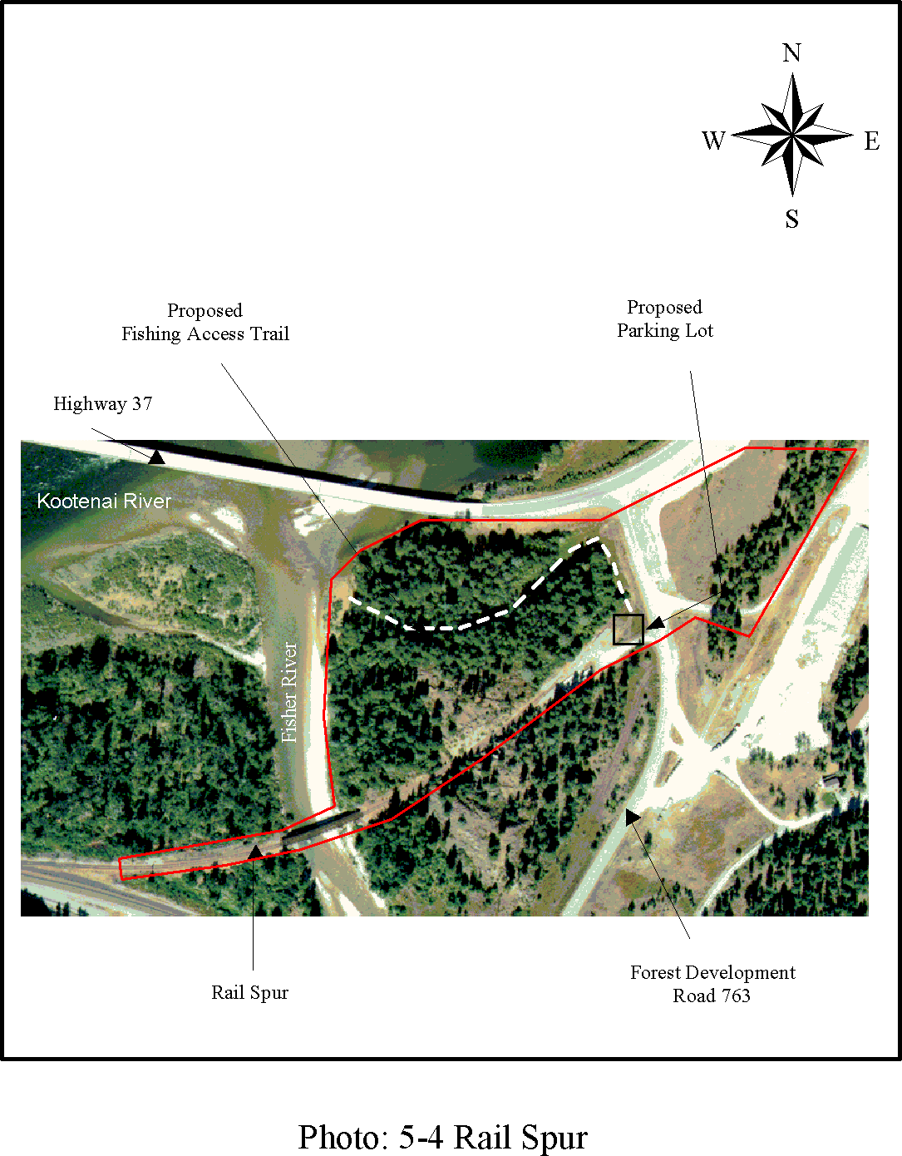

Libby Dam-Lake Koocanusa Project Corps of Engineers

Master Plan-September 1997 Seattle District

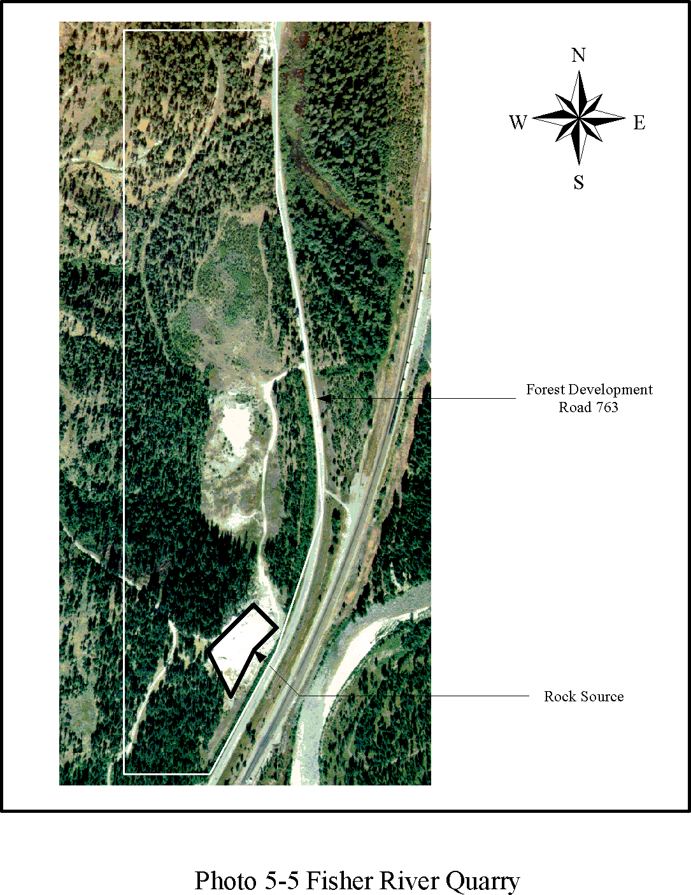

Libby Dam-Lake Koocanusa Project Corps of Engineers

Master Plan-September 1997 Seattle District

1. Ensure structural stability of spur bridge is maintained for operational commitments.
2. Provide a public parking area for four cars and graveled fishing access trail.
   * 1. Major Constraints. Operation and/or improvements to the rail spur facility may impact a National Register eligible cultural resource site. Specific plans for maintenance or improvements will need to be evaluated and a determination of effect made in consultation with the Montana State Historic Preservation Officer and the Advisory Council on Historic Preservation (see Section 3.7 for discussion).

### FISHER RIVER QUARRY

* + 1. Description. The 63-acre Fisher River quarry is located along the Fisher River adjacent to Forest Development Road 763 and is 1.5 miles from MSH 37 (see Photo 5-5). The quarry provided a rock and common borrow source for construction of the relocated MSH 37 and was anticipated for use as a rock and common source for construction of the Libby Reregulating Dam project. Today it is the primary source of riprap for development and maintenance of flood control levees in the area. There is in excess of 2,000,000 cubic yards of available material at this site. Due to a 25-year flood event in 1996 and extensive damage to a primary road, expansion of the pit was necessary. The US Forest Service developed a pit plan providing necessary material for streambank stabilization and road fill. The pit plan can be found in the Operational Management Plan.
    2. Land Classification. Operations: Project Operations.
    3. Resource Objective. To maintain and utilize the Fisher River quarry as a rock and common source.
    4. Rationale. This land is used and required for project operations and maintenance purposes.
    5. Development and Management Measures.

1. Use the quarry as a rock and common source for project purposes.
2. Restore the quarry site to native vegetation when depleted or no longer required for project purposes and surplus the site through normal procedures.
   * 1. Major Constraints. None.

Libby Dam-Lake Koocanusa Project Corps of Engineers

Master Plan-September 1997 Seattle District

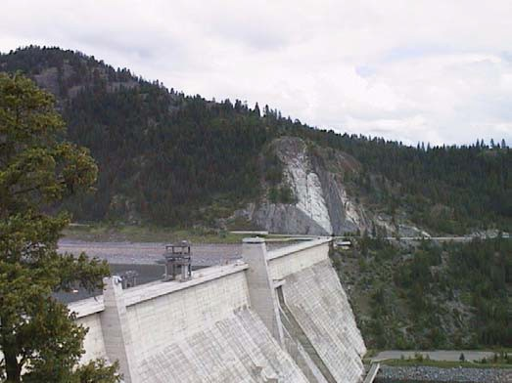

**Photo 5-6: Left Abutment Slope (background)**

### LEFT ABUTMENT SLOPE

* + 1. Description. The 16-acre left abutment slope area, which includes the Dirty Shame Fault, is located on the steep left abutment slope near the axis of Libby Dam east of MSH 37 (see Photo 5-6). Rock instability and rock movement on the Dirty Shame bedding fault (see Section 2) has required removal of slide material and hazardous overhanging rock, slope stabilization by installation of post- tensioned cable tendons and drainhole drilling, and installation of monitoring equipment for surveillance of the potential slide mass.
    2. Land Classification. Operations: Project Operations.
    3. Resource Use Objective. To continue instrument monitoring of the left abutment slope rock mass and take corrective actions as necessary should further rock instability be detected.
    4. Rationale. This land is required for bank stabilization purposes.
    5. Development and Management Measures. None.
    6. Major Constraints. Restrict public access to insure their safety.

Libby Dam-Lake Koocanusa Project Corps of Engineers

Master Plan-September 1997 Seattle District

## SECTION 6-OPERATIONS: RECREATION

### GENERAL

This section describes and analyzes six developed project recreation areas classified under the category Operations: Recreation, and prescribes criteria for their future development and management, including identification of measures to increase management efficiency. The recreation areas include Souse Gulch, the visitor center area, the left abutment visitor orientation area, Alexander Creek, Blackwell Flats, and Dunn Creek Flats. These areas are shown on Plate 4-2.

The analysis for each recreation area includes a brief description of the site, existing facilities, and present use patterns; land classification; establishment of resource objectives; identification of development and management measures; and identification of major constraints to resource use, development, and management. Identified development and management measures for the areas vary from minimal, such as constructing semi-developed campsites at Dunn Creek and Blackwell Flats, to major improvements such as renovation of the Visitor Center complex. Most major improvements or site alterations are neither necessary nor desirable for most of the recreation areas. Minor changes are recommended to protect natural and cultural resources and "fine tune" existing facilities to improve the quality and functionality of the areas, thereby increasing resource management efficiency.

### SOUSE GULCH DAY USE AREA

* + 1. Description. The 78-acre Souse Gulch day use area is located on the right bank (west shore) of Lake Koocanusa just upstream of Libby Dam and is adjacent to and north of the visitor center area (see Photos 6-1 and 6-2). Public access is from Forest Development Road 228 and from Montana State Highway (MSH) 37 by way of the roadway on top of the dam.

Day use facilities at Souse Gulch complement the visitor facilities available at the visitor center and the dam. Major amenities include a total of three picnic shelters with two barbecue stoves, one sink, and four concrete picnic tables each; two flush rest rooms; 2 playgrounds; boat ramp for public and emergency launching (with an operating range from elevation 2,310 to 2,459 feet); floating boat moorage dock with ramp (with an operating range from elevation 2,336 to 2,459 feet); and associated parking. Other features found in the area that contribute to visitor comfort and recreational opportunities include three horse shoe pits, 28 picnic tables, 11 water fountains, 11 trash receptacles, and 13 fireplace units. These amenities are concentrated in two separate locations, the north end and the south end of the Souse Gulch area.

Libby Dam-Lake Koocanusa Project Corps of Engineers

Master Plan-September 1997 Seattle District

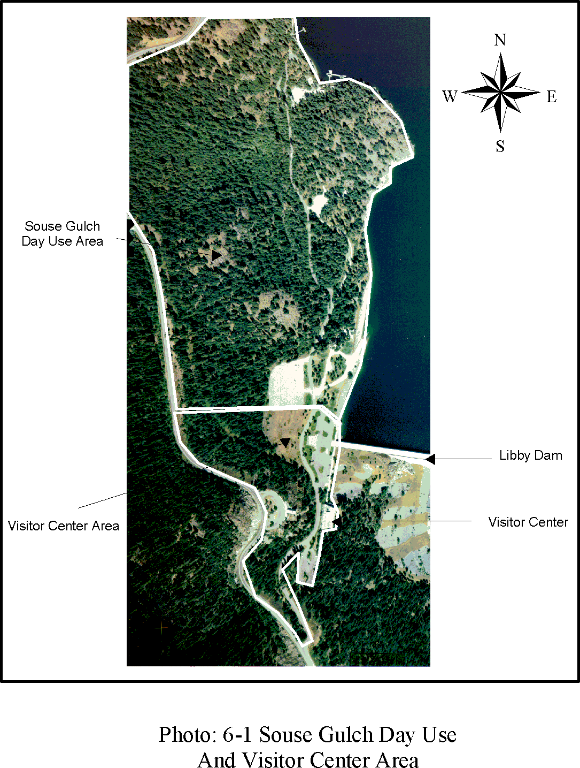

Libby Dam-Lake Koocanusa Project Corps of Engineers

Master Plan-September 1997 Seattle District

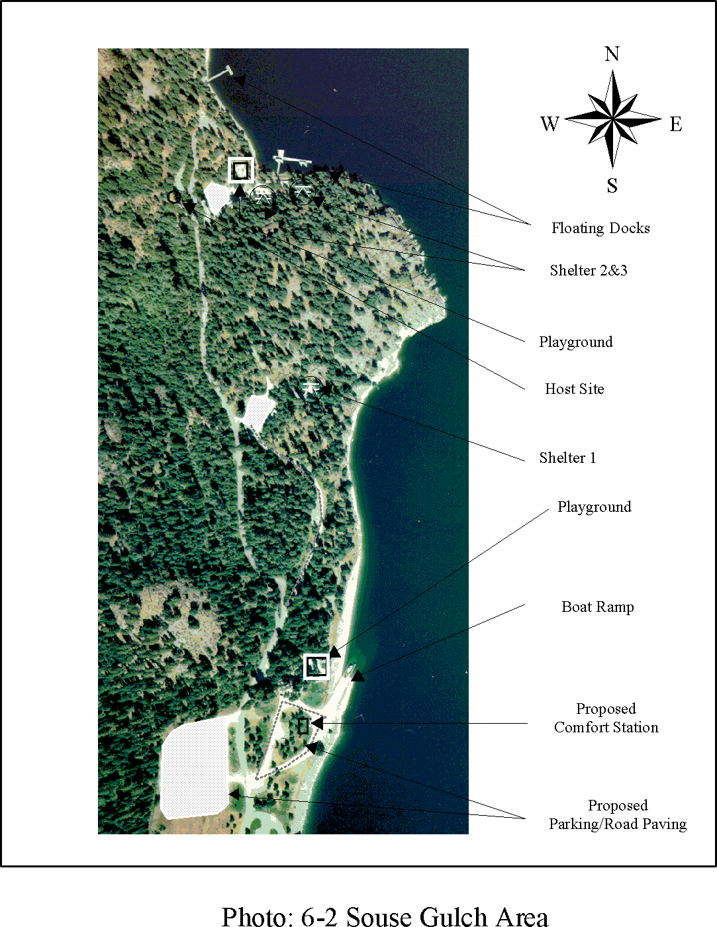

Libby Dam-Lake Koocanusa Project Corps of Engineers

Master Plan-September 1997 Seattle District

Facilities at the north end of the site include two picnic shelters, one volleyball court, one rest room, one campsite for the area host, one children’s playground, one ski dock, and one boat moorage facility. The remaining picnic shelter and rest room is located at the south end of the site as well as the other children’s playground, and a boat launch and parking area. A network of nature and hiking trails extends along much of the shoreline and through the wooded areas of the site and provides a link to the visitor center area. A wood yard was developed to store and provide firewood for recreational users.

In addition to its value as a recreation area, Souse Gulch, with its varied topography and diversity of vegetation, also supports relatively large numbers of animals. The area receives relatively heavy use by deer and elk during the winter. Other mammals, including black bear, red squirrels, and Columbia ground squirrels, also use the area on a regular basis. The area contains a number of snags and fallen logs which provide habitat for several cavity-nesting species of birds and mammals. Also two environmentally sensitive areas are located here containing yellow lady’s slippers and a bald eagle nest (see Section 7).

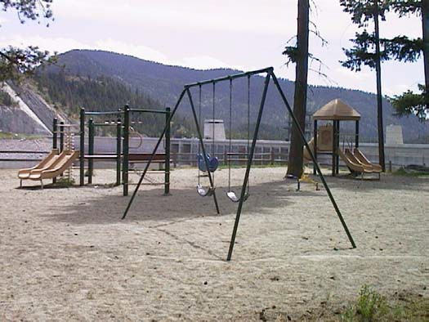

#### Photo 6-3: Playground At South End of Souse Gulch

* + 1. Land Classification. Operations: Recreation.
    2. Resource Objective. To improve opportunities for a wide segment of society, including the elderly and handicapped, for engaging in day use recreation activities while maintaining the tranquil atmosphere and qualities of the site.
    3. Rationale. The Souse Gulch day use area is managed to complement the visitor center area amenities. The combined Souse Gulch/Visitor Center area complex is a focal point for vacationers and local residents alike to observe and appreciate the purposes and functions of the project. Plans have been prepared to

Libby Dam-Lake Koocanusa Project Corps of Engineers

Master Plan-September 1997 Seattle District

pave portions of the roads and parking lots in this area to provide dust abatement and protect the resources.

* + 1. Development and Management Measures.
       1. Pave roadways and parking areas and define edges of parking areas with wheel stops to maximize their efficiency.
       2. Provide comfort station (bathroom facility) near boat ramp and playground.
       3. Provide landscape planting to buffer parking from access road and picnic areas. Select primarily native vegetative specimens with wildlife value, with appropriate consideration to aesthetic appeal, for landscaping.
       4. Provide defined pathways from parking areas to picnic shelters and rest rooms, including provision for limited maintenance vehicle access to these facilities. To the extent practicable, assure that trail access will accommodate the handicapped.
       5. Upgrade the existing play area equipment to meet ADA standards.
       6. Provide interpretive and destination signage for the existing trail system, upgrading the trail as appropriate. Interpretive themes should relate to management topics, site flora and fauna, geology of the area, and cultural features of the project.
       7. Maintain and improve wildlife habitat through the application of appropriate measures, including retention of den trees and provision of artificial nest structures; establishment of shrub and vine cover between day use activity areas and at the periphery of the area to provide food, cover, and nesting opportunities for a variety of wildlife; protection of sensitive areas from human and domesticated animal intrusion with natural fence rows or guards; and preservation of snags and fallen logs.
       8. Upgrade electrical system to all shelters to ensure reliable service for present and future needs.
       9. Maintain lower parking at boat ramp to accommodate low reservoir levels.
       10. To maintain a healthy diverse stand, selectively thin trees only as necessary to eliminate safety hazards; to prevent disease and insect population buildup; and where trees are too closely spaced such that they are small, unhealthy, and there is little or no understory or ground cover.

Libby Dam-Lake Koocanusa Project Corps of Engineers

Master Plan-September 1997 Seattle District

* + - 1. Lengthen boat ramp handling dock if a way can be found to physically handle the addition.
      2. Continue integrated pest management program for control of noxious weeds.
    1. Major Constraints. None.

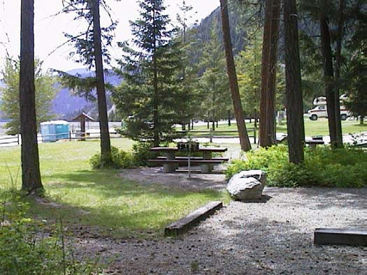

#### Photo 6-4: Picnic Area At South End of Souse Gulch

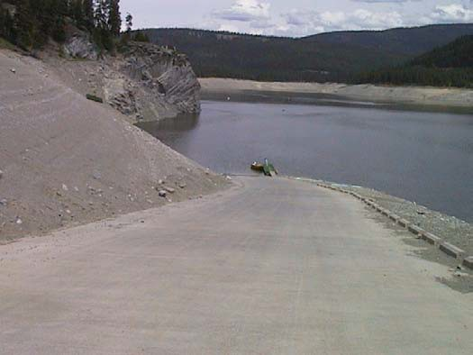

**Photo 6-5: Boat Ramp and Floating Dock at South End of Souse Gulch.**

Libby Dam-Lake Koocanusa Project Corps of Engineers

Master Plan-September 1997 Seattle District

### VISITOR CENTER AREA

* + 1. Description. The 23-acre visitor center area is located on the right abutment of Libby Dam and is adjacent to and south of Souse Gulch (see Photo 6- 6). Public access is from Forest Development Road 228, and from MSH 37 via the roadway on top of the dam. Existing visitor facilities in the area complement the day use facilities maintained at Souse Gulch and provide a focal point for project visitors. Facilities include: (a) visitor center building, (b) flag plaza, (c) two visitor overlooks, and (d) visitor observation platform adjacent to the Forest Development Road.

The visitor center building presently consists of an upper level observation deck; main floor area with drinking fountains, public rest rooms, information desk, and project resource management office; and a lower level with auditorium, exhibits and work area. Between 1975 and 1980, the visitor center was operated for the Corps of Engineers by the Montana State Historical Society. It featured interpretive displays and exhibits primarily illustrating the history and development of the Kootenai Valley. In 1980, the Corps of Engineers assumed operation of the visitor center and began preparation of an interpretive plan to focus future displays and exhibits on project related information. The interpretive plan, entitled “Working Water” was completed by late 1980 and construction of exhibits for the visitor center was initiated. The exhibits, together with a narrated multi-image slide program in the auditorium called Harmony, were completed by June 1981 for the summer tourist season. In 1994, plans were initiated to move the lower exhibit gallery and auditorium to the mid-level area and expand the management offices to accommodate permanent and seasonal employees.

The current visitor center exhibits include a description of project development and Corps of Engineers history; displays of Libby Dam, the powerhouse and its benefits; displays of native wildlife; a description of electrical generation concepts; and history of the Kootenai River valley and environmental concerns in project development. In 1996 an audio visual program was developed to provide visitors with information regarding Libby Dam and the Columbia River system, as well as a computer generated interactive display dealing with the management issues of Libby Dam and the Columbia River system. Exhibits and displays are upgraded, modified, and changed as need and as visitation trends indicate. The facility may house a cooperative association sales gallery in the future.

The flag plaza is a symbol of the international cooperation which led to the construction of Libby Dam, and includes a project dedication plaque in addition to American, Canadian, British Columbia, and Montana State flags.

Libby Dam-Lake Koocanusa Project Corps of Engineers

Master Plan-September 1997 Seattle District

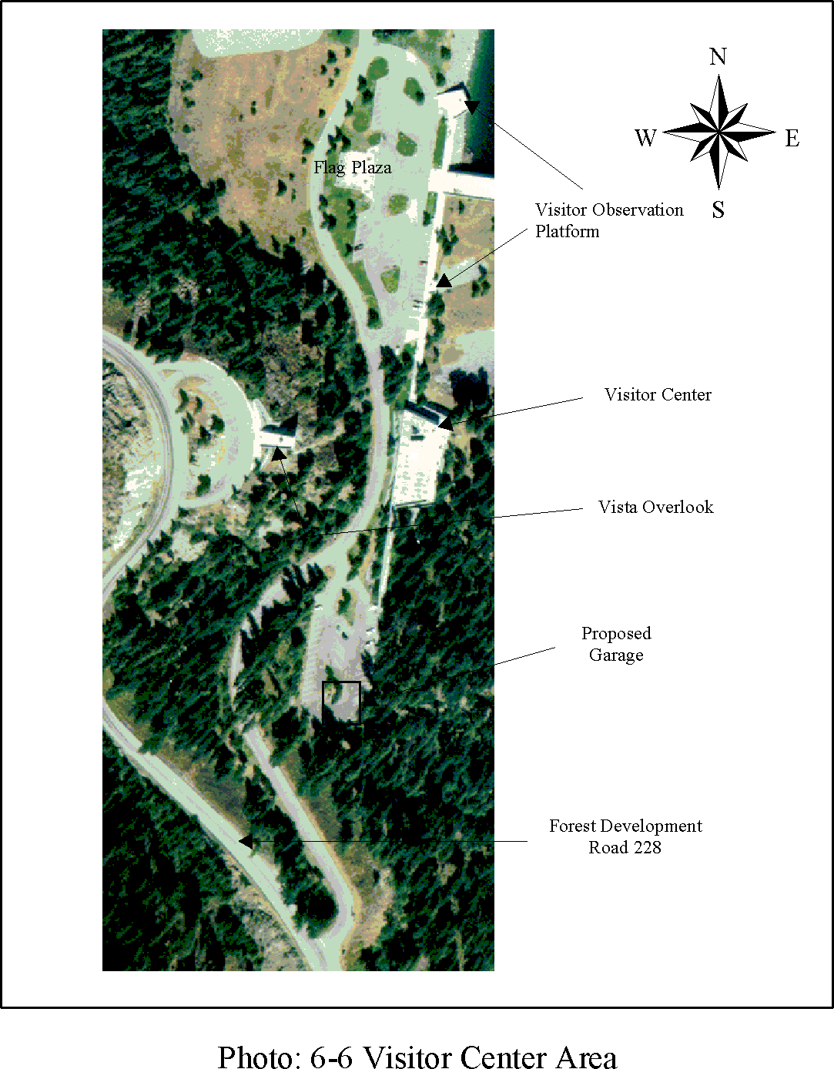

Libby Dam-Lake Koocanusa Project Corps of Engineers

Master Plan-September 1997 Seattle District

There are two visitor overlooks in the flag plaza adjacent to the right abutment. The northern one affords views of Lake Koocanusa and trashracks and powerhouse intake section on the face of the dam. The southern one overlooks the Kootenai River and powerhouse on the downstream side of the dam.

The visitor observation platform is a cantilevered concrete structure 120 feet above the visitor center building and adjacent to the Forest Development Road. Facilities include public rest rooms and parking for 24 automobiles. The Libby Dam water tower is also located in the structure. The facility provides a commanding view of the project area both upstream and downstream of the dam.

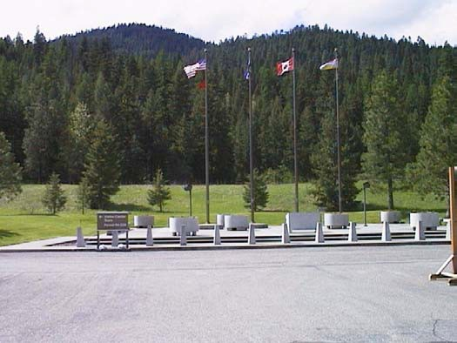

#### Photo 6-7: Flag Plaza

* + 1. Land Classification. Operations: Recreation.
    2. Resource Objective. To maintain and improve visitor facilities and the educational and recreational opportunities of the area.
    3. Rationale. The visitor center area is managed to provide necessary visitor amenities at the dam. Interpretive programs provide the public a better understanding of the Columbia River system, project purposes and concepts of operations, and the natural and manmade features of the project area. These programs enhance visitor appreciation of the Corps' mission in operating Libby Dam and managing the variety of resources.
    4. Development and Management Measures.
       1. Supplement the existing directive and informational signing to alert visitors to the public facilities and recreational opportunities available at the project, including powerhouse tours, camping, picnicking and day use

Libby Dam-Lake Koocanusa Project Corps of Engineers

Master Plan-September 1997 Seattle District

areas, visitor center exhibits, trails, and fishing access locations. Some signs will be a part of the Lake Koocanusa interpretive scenic byway.

* + - 1. Build a closed-in garage to accommodate parking and storing of emergency vessels/vehicles in the upper visitor center parking area.
      2. Implement approved plans to construct exhibit area, auditorium, and office complex on the mid-level of the visitor center building.
    1. Major Constraints. None.

### LEFT ABUTMENT VISITOR ORIENTATION AREA

* + 1. Description. The one-acre left abutment visitor orientation area is located on the same level as the dam and is adjacent to MSH 37 (see Photo 6-8). Parking on the upstream side of the dam is available for 18 cars and three car-trailer combinations. A sidewalk parallels the reservoir providing a view of the upstream face of the dam, the reservoir, and Souse Gulch day use area on the right bank. Two picnic tables are provided for day use picnicking. A pedestrian ramp leads visitors under the dam roadway to a viewpoint on the downstream side of the dam. This point provides an excellent view of the downstream face of the dam, the powerhouse, and the downstream area. Rest room facilities are built into a partially buried structure against the MSH 37 roadbed. In addition, the left abutment visitor area turnoff from MSH 37 provides access to the road across the dam which links MSH 37 to the visitor center area and Souse Gulch day use area.

This area was envisioned in early planning as the visitor orientation and rest area adjacent to MSH 37. Because the turnoff is essentially invisible to approaching motorists from north or south due to topography, and because the MSH 37 turnoff is too sharp to adequately accommodate medium to large recreational vehicles, the site has never functioned adequately to serve as a visitor orientation area. In response to these problems, alternative turnoff locations were analyzed as part of the 1983 Libby Dam-Lake Koocanusa Project Master Plan.

When these alternatives were precluded by sight distances, a conceptual design was developed for a visitor orientation area adjacent to MSH 37 approximately ½ mile downstream from Libby Dam on the left bank. The proposed visitor orientation area was not constructed and the original problems still exist today.

As an alternative to the visitor orientation area, a conceptual design for a RV/trailer pullout with two spaces was considered during the master plan process. Two sites for the pullout were considered, both located on the buttress fill area just north of the left abutment orientation area parking lot (see page for ArcView

Libby Dam-Lake Koocanusa Project Corps of Engineers

Master Plan-September 1997 Seattle District

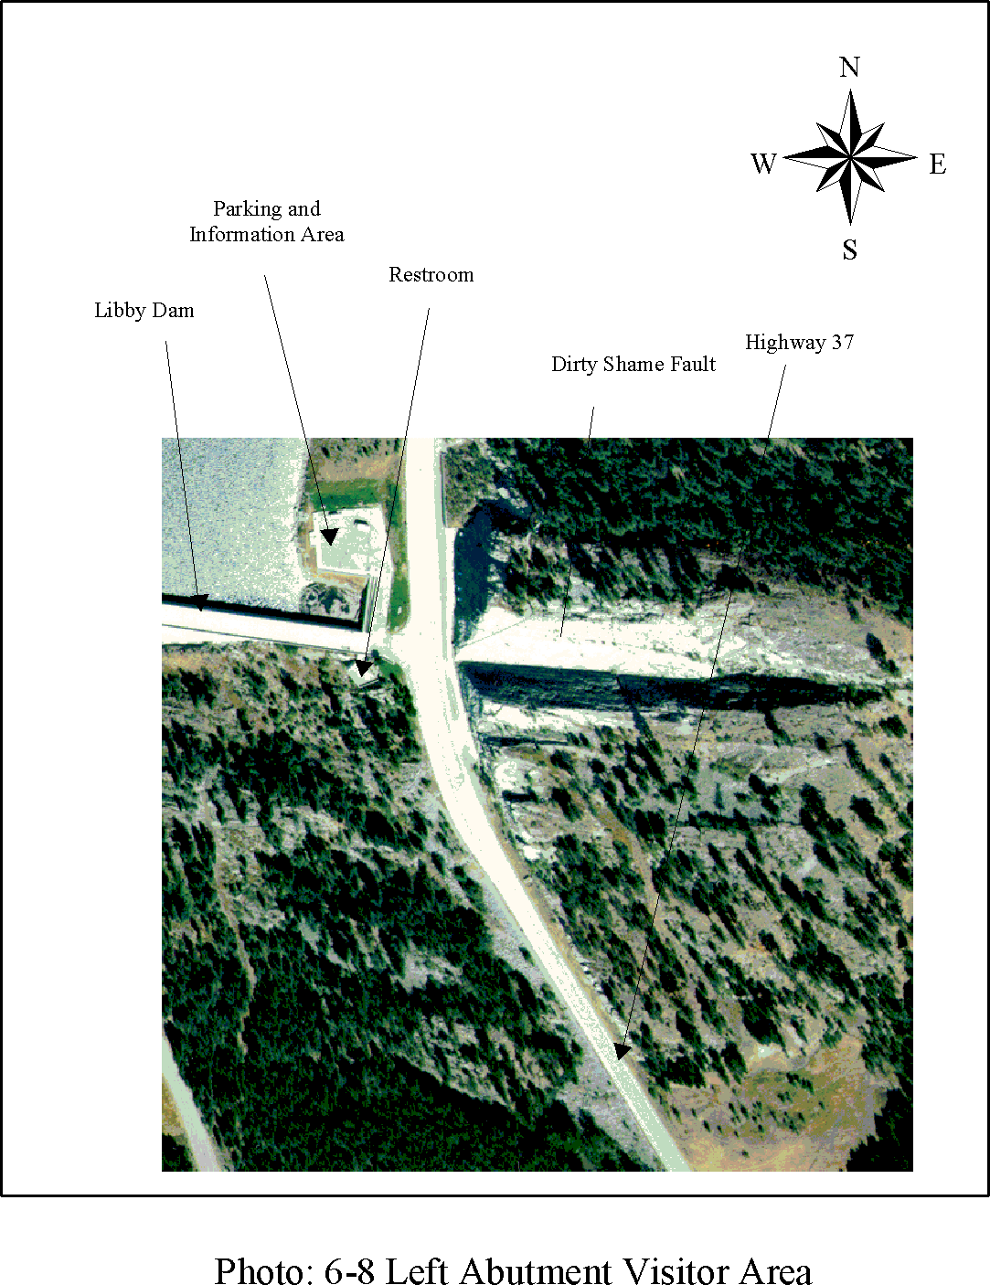

Libby Dam-Lake Koocanusa Project Corps of Engineers

Master Plan-September 1997 Seattle District

Appendix G). Consultation with the Montana State Department of Transportation concluded that the site located at the south end of the buttress fill area did not meet highway sight distance minimums. The northern site did meet sight distance minimums, but its distance from the existing parking lot, the relatively few number of visitors served, and budget priorities led to the decision to postpone the design at this time.

In addition, as part of the current master plan process, a decision was made to eliminate the proposed design for the 1983 visitor orientation area. This was due to changes in the use of the left abutment area (highway signs now direct visitors directly to the visitor center and bypass the site), design considerations at the visitor orientation area (trees now obscure the view of the dam, and there is no need at this time for a development of this size), and overall budget priorities.

6.4 2 Land Classification. Operations: Recreation.

* + 1. Resource Objective. To maintain the existing visitor facilities and improve informational signage.
    2. Rationale. The left abutment visitor area is the gateway from MSH 37 to visitor accommodations at the visitor center and Souse Gulch day use areas and atop the dam at the Treaty Tower. Rest room facilities located here will continue to be needed in the future. Inability of the left abutment visitor area to be modified so as to function adequately as a visitor orientation and rest area for MSH 37 travelers and potential design solutions have been documented. The area still provides important viewpoints of project and landscape features.
    3. Development and Management Measures.
       1. Provide a project identification (entrance) sign.
       2. Continue integrated pest management program for control of noxious weeds.
       3. Provide informational signage to alert visitors to the public facilities available at the project, including powerhouse tours, the visitor center, picnicking and day use areas, and fishing access locations which are available to them at the dam. Some signs will be a part of the Lake Koocanusa interpretive scenic byway.
    4. Major Constraints. None.

Libby Dam-Lake Koocanusa Project Corps of Engineers

Master Plan-September 1997 Seattle District

### ALEXANDER CREEK RECREATION AREA

* + 1. Description. Alexander Creek recreation area is located on the right bank of the Kootenai River downstream of Libby Dam. Two dirt access roads into the camping/picnicking sites are located near the intersection of the powerhouse access road and Forest Development Road 228 (see Photo 6-9).

This area, by virtue of its small size (1 acre) and nearby tall Douglas fir trees, possesses an intimate character unique to the project. The intimacy of the site is further enhanced by its close proximity to the Kootenai River and its relative short distance downstream of the dam. The site possesses a sloping bank which permits launching of small boats from a primitive ramp, and the area receives moderate use by boaters and fishermen. Two campsites separated by Alexander creek and connected by a foot bridge provide overnight camping and picnicking. One handicapped-accessible toilet services the campsites and boat launch.

Existing site uses also include bird watching, nature study, and related activities.

* + 1. Land Classification. Operations: Recreation. This area has been reclassified from Recreation-low density in the 1983 master plan due to increased public use over the years.
    2. Resource Objective.
       1. To maintain existing recreation and fishing access facilities to enhance visitor safety and control.
       2. To maintain and protect the site’s environmental resources.
    3. Rationale. Modest site improvements are necessary to maintain and protect the ecological and scenic values which make this site a popular day use and camping area for project visitors. Measures to control public access and use of the site will foster proper resource stewardship by minimizing further impacts to natural and cultural resources, reducing long-term resource management costs and enhancing public relations.
    4. Development and Management Measures.
       1. Improve existing foot trail for fishing access from the parking area to the river's edge.
       2. Provide interpretive signage.
       3. Maintain serviceability of boat launch ramp for car-top boat access.

Libby Dam-Lake Koocanusa Project Corps of Engineers

Master Plan-September 1997 Seattle District

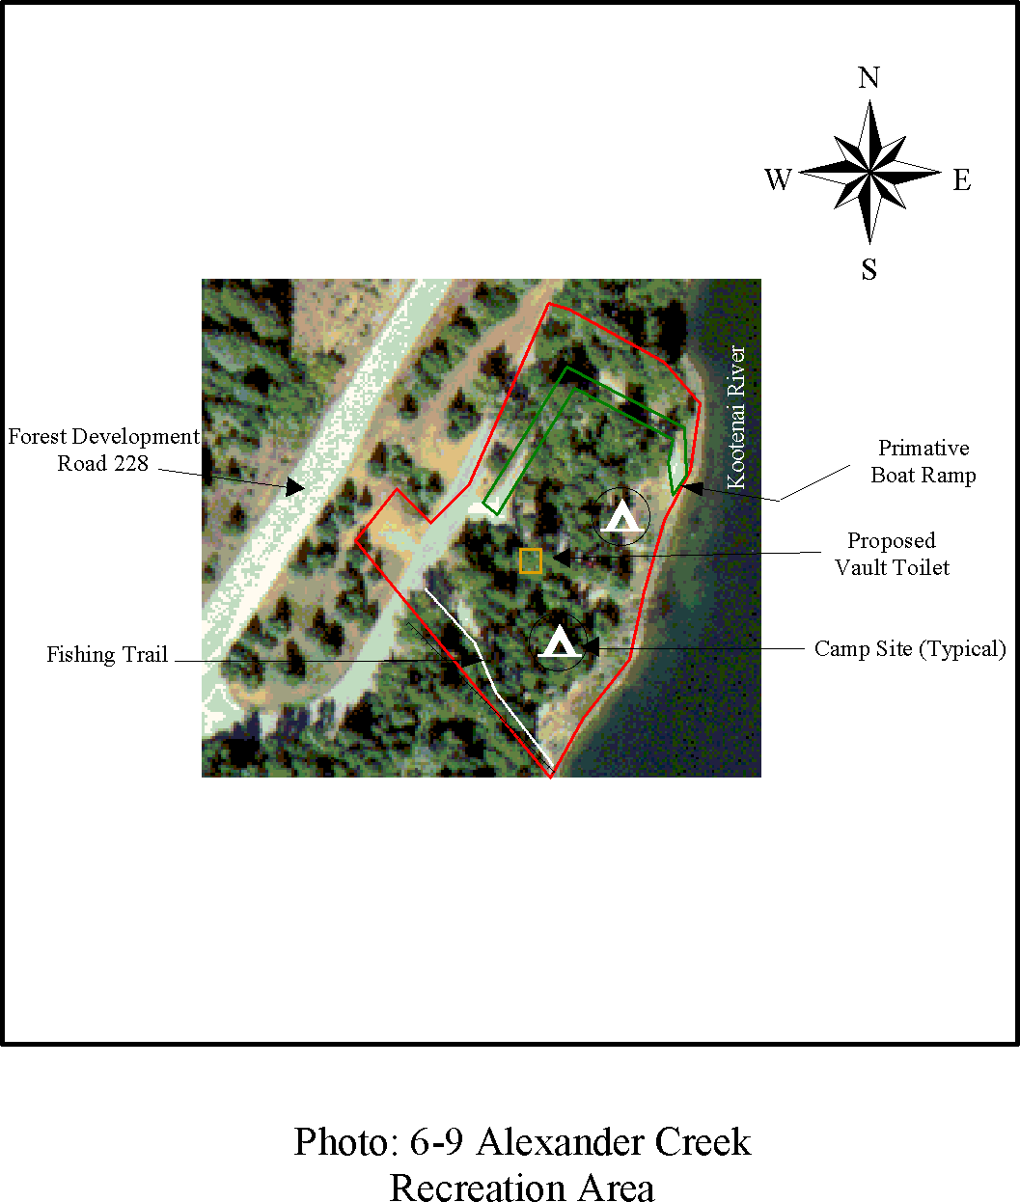

Libby Dam-Lake Koocanusa Project Corps of Engineers

Master Plan-September 1997 Seattle District

* + - 1. Install a handicapped-accessible vault toilet to replace the existing portable toilet.
      2. Recover cultural materials from the area for protection and preservation.

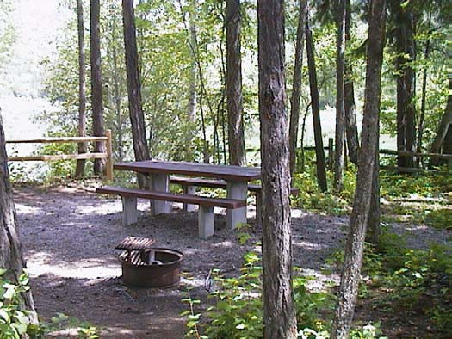

#### Photo 6-10: View of Alexander Creek Recreation Area

* + 1. Major Constraints. This area coincides with a National Register eligible cultural resource site and will require a determination of effect from the Montana State Historic Preservation Officer and the Advisory Council on Historic Preservation prior to development. Any determination of need for data recovery mitigation of unavoidable adverse effects may preclude some facility development (see Section 3 for discussion).

### BLACKWELL FLATS RECREATION AREA

* + 1. Description. Blackwell Flats is a 11-acre site located on the right bank of the Kootenai River downstream of Libby Dam and near the confluence of the Fisher River and the Kootenai River (see Photo 6-12). Moonshine Island is adjacent to and upstream of the site (see Plate 4-2). Access to the site is from Forest Development Road 228 near its intersection with MSH 37.

The site is primarily open meadow with riparian vegetation consisting of alders and willows adjacent to the river, and is frequented by fishermen who either fish from the banks or launch small boats from a gently sloping primitive boat ramp. In summer the area receives heavy day use. A gravel road off of Forest Development Road 228 provides access to the six semi-developed campsites within close proximity to the Kootenai River. Two portable toilets are located in

Libby Dam-Lake Koocanusa Project Corps of Engineers

Master Plan-September 1997 Seattle District

the recreation area, one of which is for handicap use. Additional public uses include ice skating, picnicking, bird watching, and nature study.

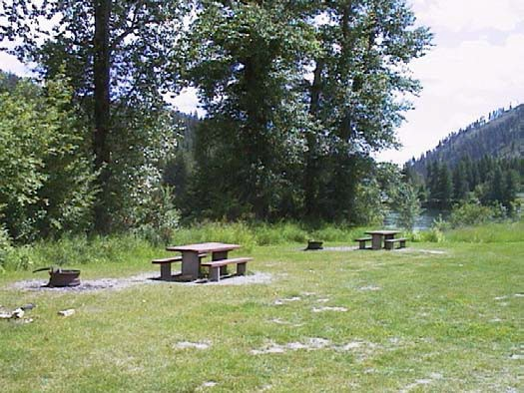

#### Photo 6-11: Blackwell Flats Recreation Area Campsites

* + 1. Land Classification. Operations: Recreation. This area has been reclassified from Recreation-low density in the 1983 master plan due to increased public use over the years.
    2. Resource Objective.
       1. To upgrade existing camping/day use recreation and fishing access facilities to enhance visitor safety, accessibility and control.
       2. To maintain and protect the site environment.
    3. Rationale. Modest site improvements are necessary to maintain and protect the ecological and scenic values which make this a popular recreational area to project visitors. Measures to control public access and use of the site will foster proper resource stewardship by minimizing further impacts to natural and cultural resources, reducing long-term resource management costs, and enhancing public relations.
    4. Development and Management Measures.
       1. Provide defined parking for four car/trailer combinations near the primitive boat launch site.
       2. Improve six semi-developed picnic/overnight campsites which are currently being used with graveled vehicle pullouts, tables, and firerings.

Libby Dam-Lake Koocanusa Project Corps of Engineers

Master Plan-September 1997 Seattle District

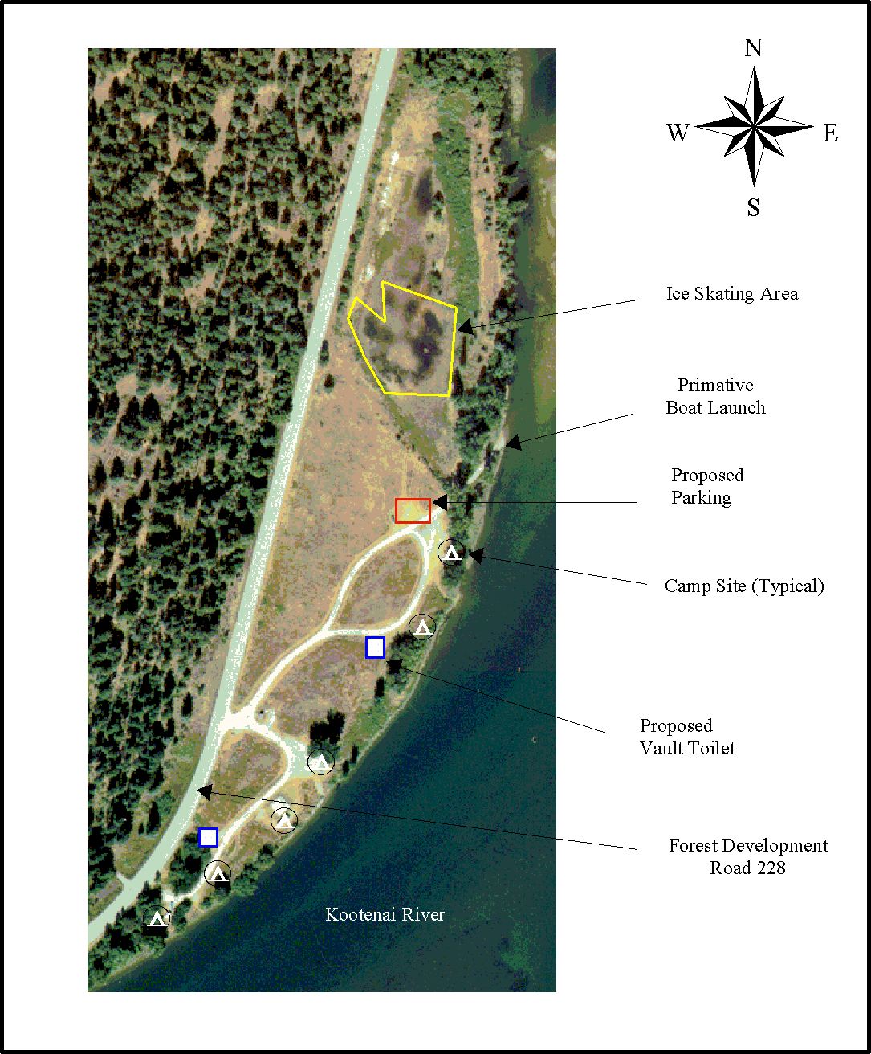

## Photo 6-12: Blackwell Flats Recreation Area

Libby Dam-Lake Koocanusa Project Corps of Engineers

Master Plan-September 1997 Seattle District

* + - 1. Replace existing portable toilets with accessible vault toilets.
      2. Upgrade 20-25% of existing campsites into accessible campsites.
      3. Provide interpretive and informational signs about other project areas.
      4. Landscape area with native and adapted non-native vegetative specimens having wildlife value, with appropriate consideration for privacy screening, circulation control, resource protection, and aesthetic appeal.
      5. Continue integrated pest management program for control of noxious weeds.
    1. Major Constraints.
       1. This area coincides with a National Register eligible cultural resource site and will require a determination of effect from the Montana State Historic Preservation Officer and the Advisory Council on Historic Preservation prior to development. A determination of need for data recovery mitigation of unavoidable adverse effects may preclude some facility development (see Section 3.7 for discussion).

### DUNN CREEK FLATS RECREATION AREA

* + 1. Description. Dunn Creek Flats is a 35-acre site on the left bank of the Kootenai River downstream of Libby Dam and upstream from Moonshine Island (see Photo 6-14). The area parallels Dunn Creek between the Kootenai River and MSH 37. A gravel road from MSH 37 provides access to the recreation area.

Most of the area is an open, dry meadow of grasses and forbs. The area is relatively low in elevation, lying only 12-13 feet above the river. Currently the area provides day use and overnight camping as well as river access and wildlife viewing opportunities. This area receives substantial recreational use. Twelve semi-developed picnic/campsites have been added to accommodate project visitors and a camp host. The campsites are enhanced by their close proximity to the Kootenai River. One site meets accessibility requirements and there is one accessible portable toilet. Two other portable toilets are located in the recreation area as well. The area has one developed boat launch facility for launching small to medium craft and emergency vessels, with a seven-car/trailer parking lot. The area is frequented by anglers who either fish from the banks or launch their boats. Anglers are provided parking and fishing access trails to the river at various points. Additional public use includes picnicking, bird watching, and nature study. A trail extends along the former Burlington Northern Santa Fe Railroad grade from this area, through the Dunn Creek Environmental Sensitive Area, to

Libby Dam-Lake Koocanusa Project Corps of Engineers

Master Plan-September 1997 Seattle District

the parking lot at the left bank visitor area near the dam. During the nesting season, the trail is not plowed to restrict public access and provide secure nesting for bald eagles in the Dunn Creek Environmental Sensitive Area (see Section 7).

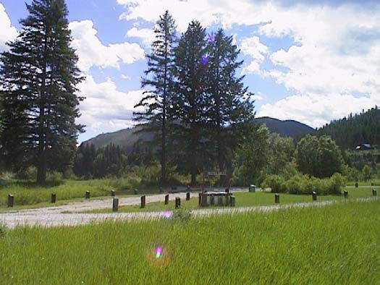

#### Photo 6-13: View of Dunn Creek Recreation Area

* + 1. Land Classification. Operations: Recreation. This area has been reclassified from Recreation-low density in the 1983 master plan due to increased public use over the years.
    2. Resource Objective.
       1. To maintain existing recreational facilities.
       2. To enhance visitor safety and accessibility by controlling and protecting the site’s environmental resources.
    3. Rationale. Modest site improvements are necessary to maintain and protect the ecological and scenic values which make this site a popular recreation area to project visitors. Measures to control public access to and use of the site will foster proper resource stewardship by minimizing further impacts to natural and cultural resources, reducing long-term resource management costs, and enhancing public relations.
    4. Development and Management Measures.
       1. Rehabilitate two primitive picnic/overnight campsites which are currently being used by the public but have no pullout for parking, picnic table, or firering.

Libby Dam-Lake Koocanusa Project Corps of Engineers

Master Plan-September 1997 Seattle District

* + - 1. Install three vault toilets (two handicapped) to replace existing portable toilets.
      2. Provide area host site.
      3. Establish limited interpretive signing and informational signage about other project areas.
      4. Develop a capped water well to provide potable water.
      5. Landscape area with native and adapted non-native vegetative specimens having wildlife value, with appropriate consideration for privacy screening, circulation control, resource protection, and aesthetic appeal.
      6. Continue integrated pest management program for control of noxious weeds.
    1. Major Constraints.
       1. This facility coincides with a National Register eligible cultural resource site and will require a determination of effect from the Montana State Historic Preservation Officer and the Advisory Council on Historic Preservation prior to development. A determination of need for data recovery mitigation of unavoidable adverse effects may preclude some facility development (see Section 3.7 for discussion.).
       2. Use of the Burlington Northern Santa Fe railroad grade as a public trail must be coordinated with site requirements for the Dunn Creek bald eagle Environmental Sensitive Area (see Section 7).

Libby Dam-Lake Koocanusa Project Corps of Engineers

Master Plan-September 1997 Seattle District

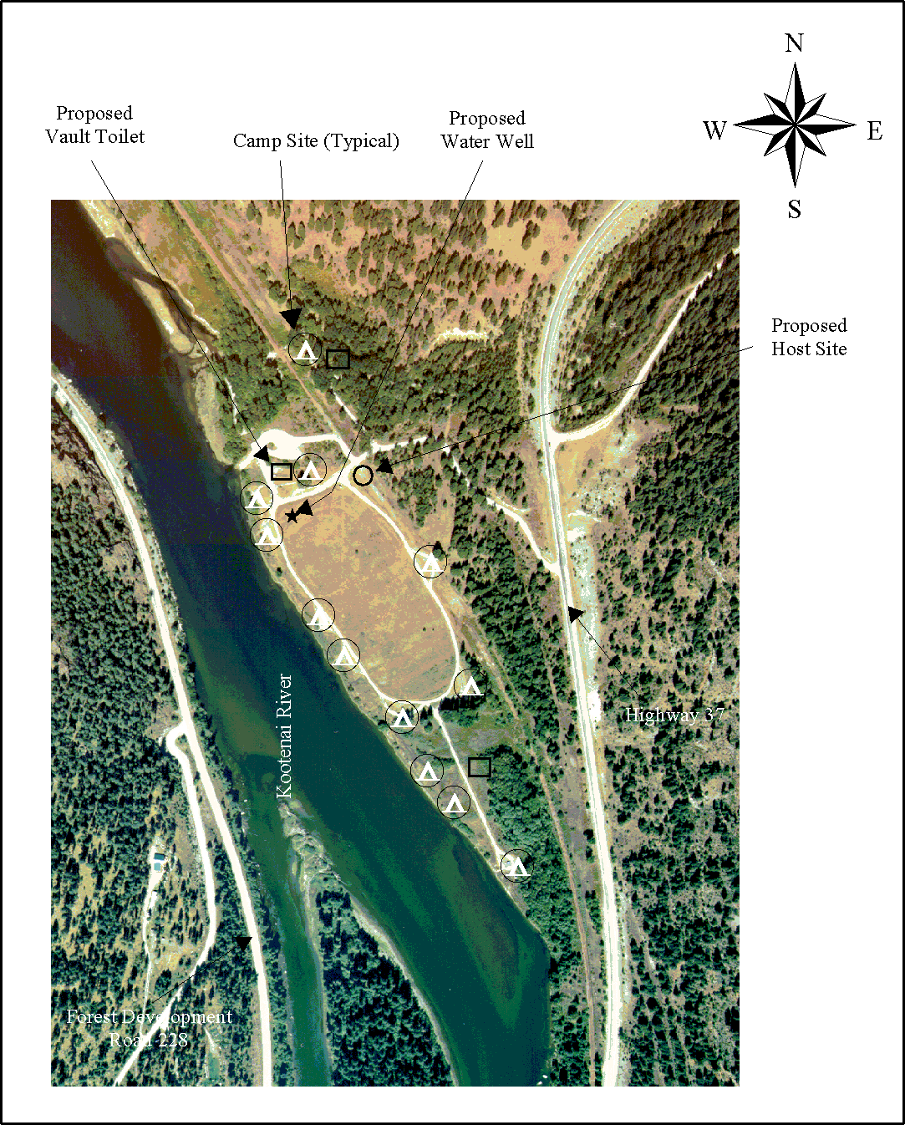

#### Photo 6-14: Dunn Creek Flats Recreation Area

Libby Dam-Lake Koocanusa Project Corps of Engineers

Master Plan-September 1997 Seattle District

## SECTION 7-OPERATIONS: ENVIRONMENTAL SENSITIVE AREAS

### GENERAL

While several endangered/threatened animal and plant species exist in habitats near the project, only the bald eagle *(Haliaeetus leucocephalis)* is known to regularly use the project for nesting and migratory purposes. The yellow lady’s slipper (*Cypripedium parviflorum),* while not listed as endangered or threatened, is considered a sensitive species by the U.S. Forest Service (USFS). Species are determined to be endangered or threatened if any of the following conditions may render the species extinct: 1) the present or threatened destruction, modification, or curtailment of its habitat or range, 2) over utilization for commercial, recreational, scientific, or educational purposes, 3) disease or predation, 4) the inadequacy of existing regulatory mechanisms, or 5) other natural or manmade factors affecting its continued existence. See Plate 4-2 for the general location of Environmental Sensitive Areas.

### BALD EAGLE NESTING HABITAT

* + 1. Description. Two Environmental Sensitive Areas associated with bald eagle nesting sites are located on project lands: the Dunn Creek nest 007-029-03 and the Souse Gulch nest 007-114-1. The Dunn Creek nest is located across the Kootenai River from Alexander Creek Recreation Area. This Environmental Sensitive Area is 47 acres in size. The nest was first documented in 1983 and has been documented annually since then (Table 7-1). The nesting territory has been occupied during each of the 14 years surveyed, and eggs laid in at least 13 of those years. The nest has produced 24 fledglings in 13 of the 14 years it has been occupied. This high productivity of the nest, averaging 1.7 young/occupancy and a ninety three percent success rate, is well above what is considered minimum for recovery by the 1986 Pacific States Bald Eagle Recovery Plan. Average productivity and nesting success for the Dunn Creek bald eagles is slightly higher than Montana's 10-year average (about 1.3 young/occupancy and 70 percent nest nesting success).

It is believed that the Dunn Creek nesting pair overwinter at or near the project. Their courtship and nest building activities begin in late February and early March. Incubation begins between mid- and late March, with hatching occurring approximately 35 days later. Fledging of the young usually occurs in July. After fledging, the young remain at or near the project until dispersal in late August or mid-September.

A new bald eagle nest (007-114-1) was established in the Souse Gulch area in 1996 but was productively unsuccessful in its first year with the adults abandoning the nest in late May. The size of this Environmental Sensitive Area is

Libby Dam-Lake Koocanusa Project Corps of Engineers

Master Plan-September 1997 Seattle District

nine acres. It is assumed the same nesting pair reoccupied the area in 1997 and appears to be successful at this time. Further monitoring of the nest will provide important nest productivity results in what is considered one of the most used areas on the project by recreationists.

* + 1. Land Classification. Operations: Environmental Sensitive Area
    2. Resource Objective.
       1. To eliminate disturbance and maintain suitable nesting and migratory habitat for bald eagles using project lands.
       2. To provide public awareness through interpretive programs.
    3. Rationale. Recreational use at the project occurs all year round. Boat use on the river is common from May 15 through March 15. March 15 to May 15 the river is closed to fishing resulting in almost no boating activity. The timing of the river closure is ideal as there is no disturbance to the nesting pair during critical foraging activities. There is one campground (Alexander Creek) and boat ramp located approximately 1/4 mile from the nest site. From nest activity reports, the nesting pair have tolerated the activities at this developed recreation area since occupancy began in 1983. The local law enforcement agencies and National Guard use a shooting range approximately ½ mile west of the nest. The USFS authorizes the shooting range through a special use permit. There has been no disturbance to the nest from small arms fire, but there appeared to be some minimal disturbance when automatic weapons were discharged (G. Altman USFS, personal communication). Due to the proximity of the nest to the shooting range the USFS has restricted the use of the range from February 15 to May 15 to reduce disturbance to the nesting pair. After this period the nestling and adults seem to tolerate the shooting range.
    4. Development and Management Measures.
       1. Conduct mid-winter eagle surveys, and productivity reports in cooperation with the U.S. Fish and Wildlife Service and the state of Montana.
       2. Provide interpretive programs including eagle displays, talks, and eagle watches for educational purposes.
       3. Support the seasonal closure of the shooting range by supporting USFS restrictions.
       4. Provide suitable perching sites for migrating eagles.

Libby Dam-Lake Koocanusa Project Corps of Engineers

Master Plan-September 1997 Seattle District

* + - 1. Continue monitoring of nest chronology and success of hatching and fledging to aid in management decisions for the area.
    1. Major Constraints.

Management for the bald eagle is limited to ensuring that Corps activities do not disturb nesting and roosting sites. To ensure compliance with the Endangered Species Act, the U.S. Fish and Wildlife Service must be consulted before any proposed activities are undertaken.

* based on nest site surveys

|  |  |  |  |  |
| --- | --- | --- | --- | --- |
| Year Clutch* Fledged Nest # | | | | |
| 1996 | 3 | 3 | 007-029-03 | |
| 1995 | 2 | 2 | 007-029-03 | |
| 1994 | 2 | 2 | 007-029-03 | |
| 1993 | 1 | 0 | 007-029-03 | |
| 1992 | 2 | 2 | 007-029-03 | |
| 1991 | 2 | 2 | 007-029-03 | |
| 1990 | 2 | 2 | 007-029-02 | |
| 1989 | 2 | 1 | 007-029-02 | |
| 1988 | 2 | 2 | 007-029-02 | |
| 1987 | 2 | 1 | 007-029-02 | |
| 1986 | 2 | 2 | 007-029-01 | |
| 1985 | 2 | 2 | 007-029-01 | |
| 1984 | 2 | 2 | 007-029-01 | |
| 1983 | 1 | 1 | 007-029-01 | |
| **SUMMARY:** No. of years occupied | | | | 14 |
| No. of years active | | | | 14 |
| No. of years successful | | | | 13 |
| No. of young produced | | | | 24 |
| No. of young/occupancy  % nesting success 93 | | | | 1.7 |

#### Table 7-1. Dunn Creek Bald Eagle Nest History

Libby Dam-Lake Koocanusa Project Corps of Engineers

Master Plan-September 1997 Seattle District

### ENDANGERED/THREATENED/SENSITIVE PLANTS

* + 1. Description. Only one species of vascular plants and mosses listed as sensitive by the USFS is known to be on project land and this is the yellow lady's slipper (*Cypripedium parviflorum),* a member of the orchid family. The orchid family is perhaps the largest family of vascular plants, with over 15,000 species worldwide. The yellow lady's slipper is one of a genus of about 50 species native to North America and Eurasia. Fifteen significant populations of these rare orchids have only recently been documented on the Kootenai National Forest (KNF) and have been found to occupy unique habitats which face many potential threats. All of the known populations in the area of the KNF occur on USFS land except for one found at Libby Dam. This 1-acre Environmental Sensitive Area, which is located within the Souse Gulch Recreation Area, is found growing along the ecotonal margin of a spruce habitat type in a moist draw with a calcareous glacial till soil. In late May to early July it can be found flowering and produces fruit in July.
    2. Land Classification. Operations: Environmental Sensitive Area.
    3. Resource Objective: To preserve and protect the site.
    4. Rationale. Current threats to the population include road building and cattle grazing. Logging may have indirect effects by affecting the hydrology of the site. Any other activities which may impede or reduce ground water flow may also be a threat. There is a potential for populations to be threatened by collection of plants by the general public. Lady's slippers are among the most beautiful flowers known and are coveted as cut flowers and for propagation as ornamentals; the rhizomes were historically in high demand for their reputed medicinal properties and continue to be offered by some dealers of native medicinal herbs.

Historical accounts suggest that species of *Cypripedium* were once far more plentiful than they are today, and their downfall has been partially attributed to over-collection. Digging the plants up is especially detrimental considering the long time it takes for them to mature. The strict habitat requirements make it difficult or impossible to propagate. The resurgence of interest in herbal medicines may increase collection and significantly threaten populations of the species in the future. At the present time, the Souse Gulch lady’s slipper site is not accessible by trail and collection is not a problem. The collecting pressures on this species among hobby gardeners and commercial collectors are under review whereupon precise location information may not be distributed by the Montana Heritage Program except as needed by managing agencies and researchers.

Libby Dam-Lake Koocanusa Project Corps of Engineers

Master Plan-September 1997 Seattle District

* + 1. Development and Management Measures.
       1. Prohibit logging and road building adjacent to the area.
       2. Preserve current population levels.
       3. If collecting becomes a problem in the future, prepare plant protection guidelines and public educational programs in the Operational Management Plan (OMP).

7.3 6 Major Constraints.

a) Management for sensitive species is limited to ensuring that activities do not disturb ecologically sensitive areas.

Libby Dam-Lake Koocanusa Project Corps of Engineers

Master Plan-September 1997 Seattle District

## SECTION 8-OPERATIONS: MULTIPLE RESOURCE MANAGEMENT

### GENERAL

This section describes operation lands classified as Multiple Resource Management and prescribes criteria for their future development and management. Lands allocated to operations and classified as Multiple Resource Management are managed for one or more of the following activities: Recreation-Low Density, Wildlife Management General, and Inactive and/or Future Recreation Areas.

### OPERATIONS: MULTIPLE RESOURCE MANAGEMENT: RECREATION- LOW DENSITY

* + 1. General.

Two areas are classified as Multiple Resource Management: Recreation-Low Densitythe left bank visitor area and the right bank visitor area.

* + 1. Left Bank Visitor Area.
       1. Description. The 43-acre left bank visitor area is located on the left bank of the Kootenai River downstream from the toe of Libby Dam (see Photo 8-1). Public access is from MSH 37 by way of Jennings-Hiline Drive. Existing facilities consist of paved parking for 57 cars, fishing access trail, three camping/picnicking sites, a wildlife viewing area, two information kiosks, a primitive boat launch facility, and portable toilet. Adjacent to parking is a restored meadow which borders the forebay channel and a gravel road which parallels the channel on the left bank. The parking area and gravel road are used principally by fishermen who frequent the shore.
       2. Land Classification. Multiple Resource Management: Recreation-Low Density.
       3. Resource Objective. To maintain existing parking and meadow for low density day use activities.
       4. Rationale. The left bank visitor area offers an alternative setting for bank fishing and helps diversify recreational opportunities and settings available to project visitors.

Libby Dam-Lake Koocanusa Project Corps of Engineers

Master Plan-September 1997 Seattle District

* + - 1. Development and Management Measures.
         1. Maintain the meadow but enhance the diversity of wildlife using the area by planting some native trees (for perching) and shrubs (food and cover).
         2. Provide informational signage to alert visitors to the public facilities and wildlife viewing available at the project.
         3. Provide suitable perching sites for migrating eagles.
      2. Major Constraints. None.
    1. Right Bank Visitor Area.
       1. Description. The 21-acre right bank visitor area is located on the right bank of the Kootenai River downstream from the toe of Libby Dam (see Photo 8-2). Six vehicle pullouts, totaling less than 1 acre, are located on the right bank downstream of Libby Dam: two of the pullouts are located on the east side of Forest Development Road 228, providing motorists approaching Libby Dam from the south a preview of the dam before reaching the turnoff to the visitor center, and four pullouts are located on the east side of the powerhouse access road. Each pullout accommodates one car and offers excellent views of the project area. In addition, anglers using the David Thompson Bridge and river shoreline are provided with one handicapped-accessible portable toilet and parking area for five cars.
       2. Land Classification. Multiple Resource Management: Recreation-Low Density.
       3. Resource Use Objective. To maintain vehicle pullouts and repair them when necessary.
       4. Rationale. The six vehicle pullouts afford sightseers opportunities to safely view Libby Dam and adjacent landscape features while motoring.
       5. Development and Management Measures.
          1. Provide appropriate fishing access trails.
          2. Provide interpretive signage at each pullout.
       6. Major Constraints. None.

Libby Dam-Lake Koocanusa Project Corps of Engineers

Master Plan-September 1997 Seattle District

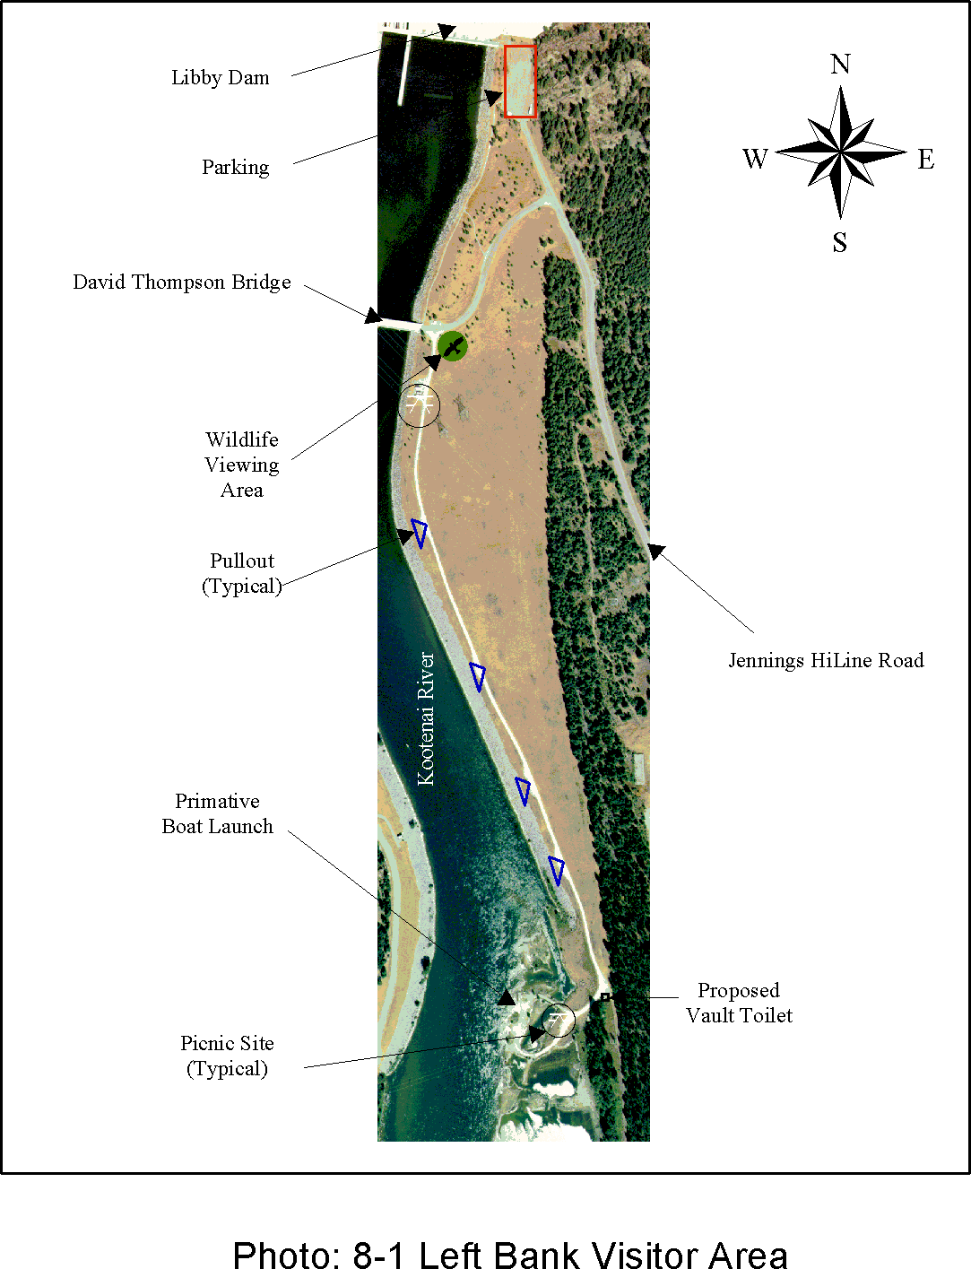

Libby Dam-Lake Koocanusa Project Corps of Engineers

Master Plan-September 1997 Seattle District

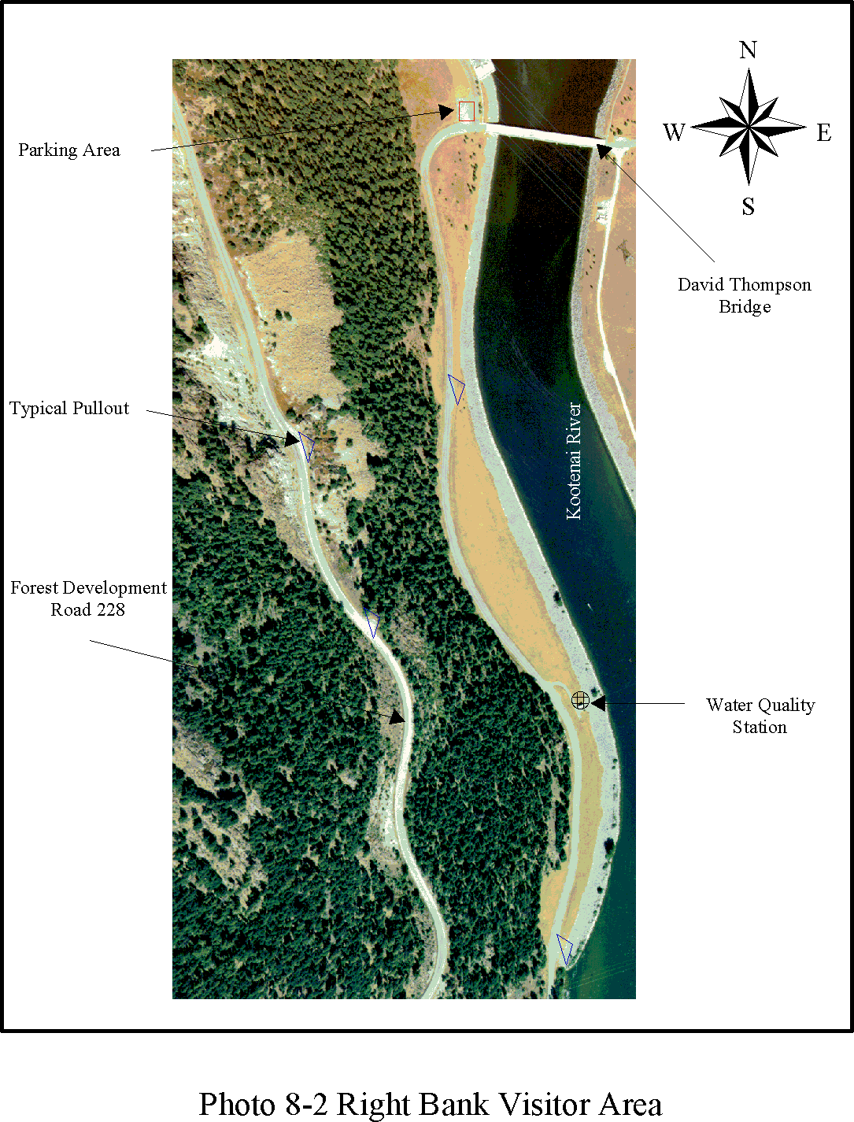

Libby Dam-Lake Koocanusa Project Corps of Engineers

Master Plan-September 1997 Seattle District

### OPERATIONS: MULTIPLE RESOURCE MANAGEMENT: WILDLIFE MANAGEMENT

* + 1. General.

Lands classified as Multiple Resource Management: Wildlife Management lands include six areas located upstream of the Fisher River and Kootenai River confluence, and the reregulation lands which are located downstream of the Fisher River and Kootenai River confluence.

* + 1. Reregulation (Rereg) Lands.
       1. Description. The Rereg lands consist of several noncontiguous parcels which comprise 382 acres south of MSH 37, downstream of Libby Dam (see Plate 4-1). The 382 acres of land were originally acquired in fee simple title for the Libby Dam Additional Units and Reregulation Dam (LAURD) project. At this time, installation of the reregulation dam is not authorized and the 1996 Water Resources Development Act (WRDA) calls for the removal of the haul bridge. Piers for the haul bridge have already been removed. These parcels are zoned on an interim basis for wildlife management. Final disposition of this land is pending.
       2. Land Classification. Operations: Multiple Resource Management:

Wildlife Management

* + - 1. Resource Objectives.
         1. To maintain and protect wildlife habitats for the benefit of existing resident and migratory game and non-game species.
         2. To allow for low density recreational activities and operational uses which do not significantly impact wildlife management.
      2. Rationale. This area provides suitable habitat for wildlife species, including riparian vegetation adjacent to the Kootenai River*.* The area has attributes which provide viable opportunity to manage existing wildlife habitat to improve species richness. Passive wildlife management of the 382-acre noncontiguous parcels, pending higher authority decisions of the property, provides the highest and best use of the site, while minimizing federal land management requirements.
      3. Land Management Measures. None
      4. Major Constraints. None.

Libby Dam-Lake Koocanusa Project Corps of Engineers

Master Plan-September 1997 Seattle District

* + 1. Wildlife Management Lands Upstream of the Fisher River and Kootenai River Confluence.
       1. Description. Additional wildlife management lands at Libby Dam include six designated areas which comprise 598 acres located upstream of the confluence between the Kootenai and Fisher Rivers. These areas are delineated primarily by manmade and physical features rather than by differences between vegetation associations or between wildlife species. The six wildlife management areas are as follows (see Plate 4-2):

Area Location Acres

|  |  |
| --- | --- |
| A Left Bank Lake Koocanusa | 18 |
| B East of MSH 37 | 111 |
| C Left Abutment | 134 |
| D Left Bank Kootenai River | 234 |
| E Dunn Creek | 96 |
| F Right Bank Kootenai River | 89 |

Total Acres 682

Lands managed for wildlife are not presently of high quantity for wildlife habitat, though some features of these lands are important for a few species. Among the more important attributes of project lands are that they are among the lowest elevation lands in Montana and, as such, provide winter habitat to big game animals, particularly during winters of heavy snowfall. Operation of Libby Dam results in warmer water in the Kootenai River below the dam during winter months, preventing the formation of ice. This ‘warm’ water, while a potential impact to aquatic resources, improves the availability of prey for bald eagles and, when combined with readily available perch sites, makes the project area important for the eagles, a species listed as threatened in Montana on the federal list of endangered and threatened wildlife and plants. The backwaters and islands of the Kootenai River are also especially suited to waterfowl breeding and feeding.

It should be noted that, although big game animals are the most visible animals in the project area and are traditionally given the highest priority for habitat management, many other species of animals live on project lands and each species is important to assure the continued health of an ecosystem. Management of project lands should, therefore, strive to maintain each habitat to improve species richness. Improving diversity of vegetation species and structure creates more opportunities for foraging and breeding, thus allowing a greater number of wildlife species to inhabit the area. This is accomplished by creating openings in forests, thinning of

Libby Dam-Lake Koocanusa Project Corps of Engineers

Master Plan-September 1997 Seattle District

trees, and planting of native shrubs and forbs in areas lacking diversity. An inventory of vegetation and wildlife in the project area is provided in Appendices C and D, respectively.

Area A. Area A is a 18-acre narrow strip of land between Lake Koocanusa and Montana State Highway (MSH) 37 extending about 1 mile upstream from Libby Dam. Access is limited as no parking is available along MSH 37. The area is on a west-facing slope, half forest, half rock. The rock was placed as buttress fill to reduce slide potential due to rock instability in the left abutment area. The rock is devoid of vegetation and is of little value to wildlife. The upstream half of the area is the typical Douglas fir/ninebark association found on west-facing slopes throughout most of the project area, the overstory consisting of approximately 76 percent Douglas fir, 14 percent western larch, and 10 percent ponderosa pine. The understory is dominated by ninebark, serviceberry, Oregon grape, golden currant, and ceanothus. Felled trees from the post- construction period are scattered throughout the upstream half of the site and make walking difficult for large animals, but provide habitat for numerous small mammals and some birds.

Area A is an excellent example of an area that should be managed in a way to improve species richness. The location of MSH 37 bordering the east side of the area makes crossing from the lands east of MSH 37 a dangerous and often fatal venture for a big game animal to undertake.

Thus, major improvements to attract greater numbers of big game animals to the area would largely be offset by increased road kills of animals. The area presently receives only moderate use by big game animals, and is utilized also by other forest dwelling animals such as chipmunks, red squirrels, and many birds. Measures to improve species richness can be accomplished by implementing such actions as piling the felled trees in several piles throughout the site. This action would provide better cover for small mammals and make the area more accessible to the large animals that frequent the area. In addition, selective thinning of trees would create additional forest openings (though such thinning should not be accomplished until the existing openings develop more of an understory, approximately five years).

Area B. Area B is a 111-acre tract of land located east of MSH 37 and directly across the highway from area A and C. Access is limited due to lack of parking along MSH 37. There are no trails in this area.

The forested area includes both north-facing and south-facing slopes. The dominant vegetation is variable across the site, ranging from a forest dominated by Douglas fir and western larch (north-facing slope) to one dominated by ponderosa pine (south-facing slope), with varying

Libby Dam-Lake Koocanusa Project Corps of Engineers

Master Plan-September 1997 Seattle District

percentages of these three species ranging across the area as the slopes change from north to south to north. The overstory is approximately 81 percent Douglas fir, 11 percent western larch, and 8 percent ponderosa pine.

The varied topography of the site, which is characterized by numerous hills and hollows, as well as rocks and fallen logs, provides cover and protection for deer and other big game animals. The fallen timber also provides drumming logs for grouse. This quite healthy forest provides habitat for many species of mammals and birds, and is one of the most diverse forested habitat among the project lands. As such, it should receive priority for management to maintain its present condition as much as possible. Some improvements such as planting shrubs like serviceberry, ceanothus, and bitterbrush in areas suited for their growth, should be pursued. These plants provide additional winter and early spring forage for elk and deer. Increasing the abundance of these plants should improve the winter carrying capacity of the area and result in greater numbers of big game animals utilizing Area B.

Area C. Area C is a 134-acre tract of land bounded by Libby Dam to the north, MSH 37 to the east, the left bank visitor area to the west, and Jennings-Hiline Drive and the project operations storage area to the south. The area is readily accessible from the parking area at the base of the dam. There are no trails through the area.

The area is on a rather steep west-facing slope and supports a sparse growth of second growth timber between 20 and 40 feet in height. The area was cleared about 50-60 years ago. The overstory consists of approximately 58 percent Douglas fir, 6 percent western larch, and 36 percent ponderosa pine. The understory vegetation is comprised primarily of young Douglas fir, ninebark, serviceberry, Oregon grape, kinnikinnik, grasses, and a small number of huckleberries. Deer use of this area is moderate, with nearly all use coming during the winter months. Because the forest here is in a developing period, diversity of vegetation is not high and use by wildlife in general is limited. Management should focus on encouraging important shrubs such as serviceberry, Oregon grape, and kinnikinnik, and establishing others such as rose, snowberry, and ceanothus. These plants will all benefit deer and elk, as well as fruit- and insect-eating birds such as grosbeaks, thrushes, and tanagers. In addition, improvements to the habitat could also be accomplished by thinning of overly dense stands of Douglas fir and planting conifers in open areas.

Area D. Area D is a 234-acre tract of land located between MSH 37 and the Kootenai River and is bordered by Dunn Creek on the south and

Libby Dam-Lake Koocanusa Project Corps of Engineers

Master Plan-September 1997 Seattle District

Jennings-Hiline Drive on the north. A few primitive roads cross the area, although there is only one access point from MSH 37.

This area supports much the same kinds of forests as described for Area B, with the same breakdowns in percentages of overstory trees for each of the slopes. However, the understory is quite open and is much less diverse than any other area of project lands associated with Libby Dam and Lake Koocanusa Where understory is present, it is usually dominated by young Douglas firs. As a result of its low diversity, big game and other wildlife use of the area is moderate. The area does, however, support at least one nesting pair of bald eagles (see Section 7).

Management of Area C should center on planting many shrubs, especially snowberry, serviceberry, kinnikinnik, and ceanothus. However, because the area at present is relatively open and largely devoid of shrubs, there is some question whether shrubs planted in this area will survive. It may be necessary to irrigate and/or fertilize the first year or two after planting. Controlled fires may encourage fire-dependent species such as ceanothus, but any burning must first be coordinated with the U.S. Forest Service and the Montana Department of Fish, Wildlife and Parks*.* Where small Douglas firs are clumped together, particularly on the west- and north-facing slopes, these should be severely thinned to leave only the two or three healthiest trees and allow shrubs to grow in place of the harvested trees. Area D is lacking in fallen logs and snags, and where trees are growing even a little bit more densely than is typical for this area, some trees should be sacrificed to make snags and logs.

Area E. Area E comprises 96 acres and includes the riparian vegetation immediately adjacent to Dunn Creek between MSH 37 and the Kootenai River, the forested and non-forested lands adjacent to the railroad grade south to where the grade meets MSH 37 and north to where the grade meets Area C.

Access to the area west of MSH 37 is by a graveled road leading to the Dunn Creek recreation area. The riparian vegetation near the creek is a deciduous bottomland woodland dominated by cottonwoods, but also includes alders, birches, serviceberry, ninebark, rose, and red-osier dogwood. This woodland has been somewhat disturbed by human activity and can be improved by the planting of such shrubs as paper birch, Rocky Mountain maple, mountain alder, red-osier dogwood, and willows. The forested areas adjacent to the railroad grade are riparian in nature. The vegetation in these areas is dominated by cottonwoods, but also includes birch, as well as ninebark and serviceberry. Non-forested areas consist of various species of grasses and forbs representative of a dry meadow. The area also includes a strip of cottonwoods bordering the Kootenai River.

Libby Dam-Lake Koocanusa Project Corps of Engineers

Master Plan-September 1997 Seattle District

Although the entire area receives only moderate use by big game animals, the diverse mixture of vegetation in this area provides food, water, and cover for many species of birds, and some small mammals. Birds include ruffed grouse, finches, grosbeaks, thrushes, vireos, and chickadees. Small mammals include chipmunks, squirrels, shrews, and meadow mice, as well as beaver and porcupine. At the present time, few improvements other than the above plantings are necessary to this site. A potential action could be to place a culvert at either end of the riparian area adjacent to the railroad grade to allow a more consistent presence of water through this woodland. This would not only make water more available to wildlife but would also improve the vegetation diversity and structure, providing better cover and a greater food supply for wildlife as well.

Area F. Area F comprises the 89 acres of right bank project lands between the Kootenai River and the Forest Development Road 228 that are not otherwise zoned. They are readily accessible from the road, from Alexander Creek Recreation Area, and from the visitor center.

This forested area with an eastern-facing aspect consists of Douglas fir (56 percent), ponderosa pine (4 percent), Engelmann spruce (13 percent) western larch (9 percent) and assorted hardwoods (18 percent). The understory is very dense, and consists of serviceberry, ninebark, rose, and Rocky Mountain maple. In addition there are many snags and fallen logs throughout the area. The strips of land immediately adjacent to the Kootenai River consist of cottonwood in the overstory and primarily ninebark and rose in the understory. The cottonwoods provide excellent perches for bald eagles and are also good nesting trees for hawks, owls, and woodpeckers. Some of the Douglas firs and larches also provide perches for wintering bald eagles, including a highly visible snag dubbed the "water quality snag" (due to its close proximity to a water quality sampling station). Area F supports better than average deer use (relative to other project areas), as well as providing good habitat for grouse, woodpeckers, owls, and small mammals. The area could be improved by making small openings in the understory, and by stockpiling some of the fallen logs where they make passage difficult. Snags should be protected due to their extreme value to many species of wildlife.

* + - 1. Wildlife Management Framework. The wildlife management framework presented below reflects general wildlife management opportunities available within existing budgetary and personnel constraints. The resource objectives and accompanying development and management measures presented in this section may be subject to further refinement as wildlife needs and habitat potentials are further analyzed and detailed unit management plans are cooperatively formulated with

Libby Dam-Lake Koocanusa Project Corps of Engineers

Master Plan-September 1997 Seattle District

appropriate resource agencies and adjoining landowners. The resource objectives for wildlife management areas address the following:

* Habitat Management (1)
* Waterfowl Production (2)
* Ospreys (3)
* Bald Eagles and Other Raptors (4)
  + - * 1. Habitat Management

*Resource Objective*. To maintain and protect wildlife habitats for the benefit of existing resident and migratory game and non-game wildlife species.

*Rationale*. Management of wildlife habitat is an excellent way to maintain lands not otherwise utilized or targeted for future development specifically for project operations or outdoor recreation purposes. These lands, though not presently of high quality for wildlife habitat, do have important attributes and features including being among the lowest elevation lands in Montana and bordering a major segment of the Kootenai River downstream of Libby Dam which is ice-free during winter months. These attributes provide opportunities to maintain existing wildlife habitats and to improve species richness.

*Applicable Wildlife Management Areas*. All areas.

*Development and Management Measures*.

Establish a fire policy appropriate to wildlife management.

Control human encroachment, trespass, and unauthorized livestock grazing. Any fencing that is constructed should be designed such that the passage of wildlife with the least possible hindrance is assured.

Safeguard areas from off-road vehicle use such as motorcycles and, if necessary in the future, mountain bikes.

Interpret wildlife management techniques and conservation practices and highlight unique qualities of the area.

Libby Dam-Lake Koocanusa Project Corps of Engineers

Master Plan-September 1997 Seattle District

* Provide maximum edge effect consistent with sound management practices and improve species richness, primarily at Area A and secondarily at other areas.
* Monitor effects of management on wildlife population density and diversity.
* No logs will be stockpiled in areas where it is so dense that they obstruct the movement of big game and other animals. Maintain some piles of logs and place them at intervals throughout the site, to provide habitat for small birds and mammals.
* Selectively thin trees only as necessary to create additional and/or larger openings in the forest and to thin too dense stands (primarily in Area E), to eliminate safety hazards, to prevent disease and insect population buildup, and, above all, to improve the health of the forest and increase the growth of shrubs and trees. All existing snags should be saved, and new snags created where needed by girdling trees to provide nesting sites, foods and hunting perches for a number of snag- dependent wildlife including ospreys, woodpeckers, swallows, owls wrens, finches, bluebirds flycatchers, and kingbirds.
* Plant native species of shrubs attractive to target wildlife species to improve species richness of the habitats and increase wildlife populations.
* Maintain and improve coordination with the U.S. Forest Service; Montana Department of Fish, Wildlife and Parks; and other responsible federal state, and local agencies. Through preparation of a Fish and Wildlife Management Plan, seek to cooperatively develop and utilize a systematic approach in analyzing wildlife resource needs and problems, to establish population levels and habitat goals for selected wildlife species, and to develop and evaluate alternative resource management plans.

*Major Constraints*. None.

* + - * 1. Waterfowl Production.

*Resource Objective*. To maintain and protect wildlife habitat for resident and migratory waterfowl, especially Canada geese, wood ducks, mallards, common mergansers, and goldeneyes.

*Rationale*. Waterfowl populations along the Kootenai River in Montana

Libby Dam-Lake Koocanusa Project Corps of Engineers

Master Plan-September 1997 Seattle District

have never been high. However, the backwaters and islands of the river are especially suited to waterfowl breeding and feeding. Several low-cost methods can be implemented to not only protect and maintain the existing waterfowl production but also enhance the aesthetic appearance of project lands in the process.

*Applicable Wildlife Management Areas*. Area E.

*Development and Management Measures*.

* Leave nesting cover (i.e., bulrushes) undisturbed.
* Erect and maintain artificial goose and wood duck nesting structures where natural nest sites are found lacking in otherwise suitable habitat.
* Plant orchard grass, alfalfa, and clover for brooding pastures for Canada geese and to provide food and cover for other birds and mammals.
* Maintain and improve brooding pastures for Canada geese close to nesting areas. Mow as necessary to maintain optimum pasture height.
* Prevent vehicular traffic on railroad grade trail during nesting season.

*Major Constraints*. None.

* + - * 1. Ospreys.

*Resource Objective*. To maintain and protect habitat for the nesting osprey population.

*Rationale*. Ospreys are a highly visible and important bird species. Monitoring and maintaining of the local osprey population is highly desirable from a wildlife management point of view and will result in excellent public relations.

*Applicable Wildlife Management Areas*. Areas D, E, and F.

*Development and Management Measures.*

Erect and maintain artificial osprey nesting platforms if existing natural nests become unusable from blowdown, fire, or other causes.

Libby Dam-Lake Koocanusa Project Corps of Engineers

Master Plan-September 1997 Seattle District

* Monitor and record the number and productivity of the osprey population, and the effect of disturbance from recreationists on nesting success.

*Major Constraints*. None.

* + - * 1. Bald Eagles and Other Raptors

*Resource Objective*. To maintain and protect habitat utilized by wintering bald eagles and other raptors. See Section 7.2 for additional information about bald eagles.

*Rationale*. A biological assessment was prepared by Seattle District in 1979 on potential impacts to bald eagles (listed as threatened in Montana on the federal list of endangered/threatened wildlife and plants) which would result from construction of the Libby Dam Additional Units and Reregulation Dam (LAURD) project. The U.S. Fish and Wildlife Service provided recommendations which would prevent losses to the local and regional bald eagle populations should the LAURD project be constructed. Though the LAURD project was not constructed, a number of the recommendations are still applicable. These measures would benefit other raptors as well.

*Applicable Wildlife Management Areas*. All areas.

*Development and Management Measures.*

Maintain tall perching and nesting trees, especially tall tree clumps, for bald eagles and other raptors.

Maintain snags to the maximum extent possible to provide perches from which bald eagles and other raptors can hunt, fish, and rest.

Monitor and record the number and distribution of wintering bald eagle populations and report the results to the state of Montana.

*Major Constraints*. None.

### OPERATIONS: MULTIPLE RESOURCE MANAGEMENT: INACTIVE AND/OR FUTURE RECREATION AREAS

* + 1. General. Multiple Resource Management areas classified as Inactive and/or Future Recreation Areas are those areas planned for future use or that have been temporarily closed. Tobacco River Land (8.4.2) is planned as a Future Recreation Area. Multiple lands referenced in 8.4.3 are inactive lands.

Libby Dam-Lake Koocanusa Project Corps of Engineers

Master Plan-September 1997 Seattle District

* + 1. Tobacco River Land
       1. Description. The U.S. Forest Service and interested citizens of Eureka and Rexford have proposed building a barrier-free hiking, biking, and equestrian trail as part of the national Rails-to-Trails program on this 48- acre tract of land. The proposed trail would connect the town of Eureka with the Rexford Bench Recreation Area along a section of the old Great Northern Railroad line. The Corps of Engineers owns approximately two miles of the old railroad grade (see Photo 8-3). This project would improve the physical condition and enhance the historic value of the railroad and associated sites. Small portions of the gravel grade which had been removed after abandonment would need to be restored to implement the planned trail. Damaged portions of the grade would be repaired and graded, and a new surface laid for non-motorized traffic. Toilets and trash collection stations would be installed to facilitate proper disposal of waste. Interpretive displays and/or trail guide brochures would be developed to help enrich the users' experience and preserve information on the history of the railroad and the Tobacco Valley. In addition, fishing access and wildlife observation decks may be constructed along the route to improve the recreational value of the trail. In short, the proposed recreation trail is a potential asset to the communities of Eureka and Rexford and would showcase the past history of the Great Northern Railroad.
       2. Land Classification. Operations: Multiple Resource Management- Inactive and/or Future Recreation Area.
       3. Resource Objectives.
          1. To improve opportunities for a wide segment of society, including the elderly and handicapped.
          2. To engage in day use recreation activities while maintaining the tranquil atmosphere and qualities of the area.

Libby Dam-Lake Koocanusa Project Corps of Engineers

Master Plan-September 1997 Seattle District

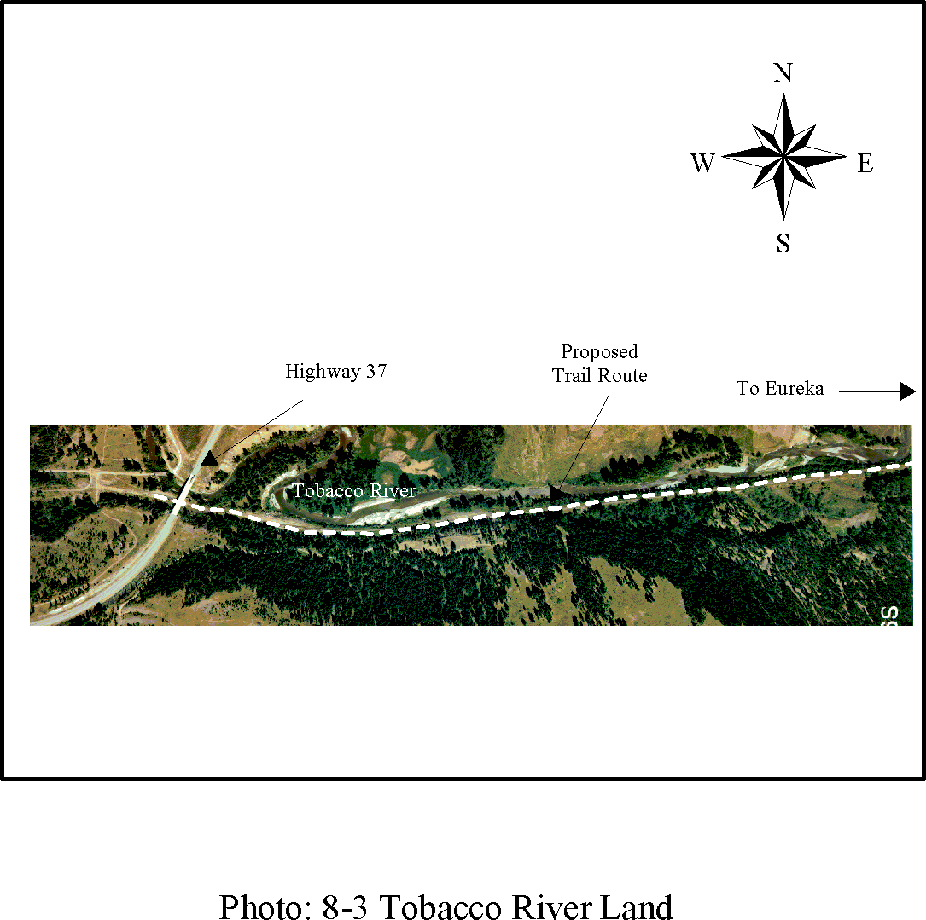

Libby Dam-Lake Koocanusa Project Corps of Engineers

Master Plan-September 1997 Seattle District

* + - 1. Rationale. This narrow piece of land is an important link for the further development of the Rails-to-Trails project between the U.S. Forest Service and the town of Eureka. It would be in the best interest of the Corps of Engineers to establish an interagency agreement to further develop the trail.
      2. Development and Management Measures.
         1. Allow for low density recreational activities.
         2. Control noxious weeds.
      3. Major Constraints. This area coincides with a National Register eligible cultural resource site and will require a determination of effect from the Montana State Historic Preservation Officer and the Advisory Council on Historic Preservation prior to development. Any determination of need for data recovery mitigation of unavoidable adverse effects may preclude some facility development (see Section 3 for discussion).
    1. Multiple Areas
       1. Description. There are approximately 164 acres of land that were not disposed of during the railroad, town of Rexford, and Highway 37 relocation contracts. Resolution of these contracts is on-going. There are also approximately 132 acres bordering Souse Gulch Day Use Area and MRM: Wildlife Area A that are inundated at full pool. Multiple area tracks are not identified on master plan plates.
       2. Land Classification. Operations: MRM- Inactive.
       3. Resource Objectives.
          1. Dispose of relocation lands in excess of project needs and purpose.
       4. Rationale. Portions of the relocation lands should be turned over to the state of Montana, the town of Rexford, or disposed of through the GSA
       5. Development and Management Measures.
          1. Work with USFS, the town of Rexford and other involved parties to dispose of excess relocation land.
       6. Major Constraints. None

Libby Dam-Lake Koocanusa Project Corps of Engineers

Master Plan-September 1997 Seattle District

Libby Dam-Lake Koocanusa Project Corps of Engineers

Master Plan-September 1997 Seattle District

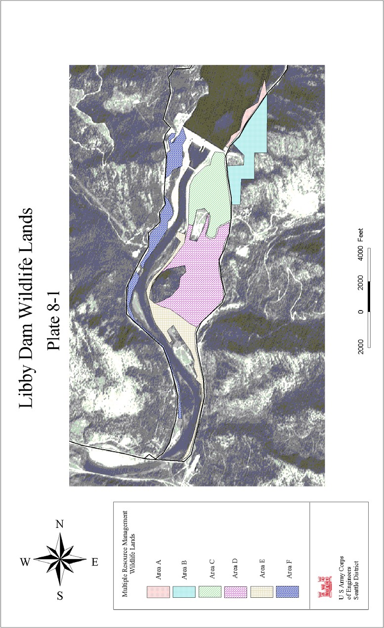

Plate 8-1: Libby Dam Wildlife Lands; missing some text

Libby Dam-Lake Koocanusa Project Corps of Engineers

Master Plan-September 1997 Seattle District

#### back of Plate 8-1

Libby Dam-Lake Koocanusa Project Corps of Engineers

Master Plan-September 1997 Seattle District

## SECTION 9-MITIGATION: MITIGATION

### GENERAL

Mitigation lands are defined as lands acquired or designated in accordance with authorizing documents to offset losses associated with development of the project. This includes only those mitigation lands currently owned and managed by the Corps of Engineers. For the Libby Dam-Lake Koocanusa Project, this includes the Murray Springs Fish Hatchery and associated lands (76 acres) that were acquired specifically for mitigation of fishery losses.

For a description of the three land units deeded to the state of Montana in 1982 for wildlife mitigation, see Paragraph 2.5 of Section 2. The Corps has no management responsibilities for these three units; therefore, there are no resource use objectives developed for this master plan. For an overall description of cultural resource mitigation requirements, see Section 2.16 and 2.17 of Section 2 and Paragraph 3.6 of Section 3.

### MURRAY SPRINGS FISH HATCHERY

* + 1. Description. Murray Springs Fish Hatchery, located 7 miles northwest of Eureka, Montana, was built by the Seattle District Corps of Engineers in cooperation with the Montana Department of Fish, Wildlife and Parks to mitigate fishery losses attributed to the construction of Libby Dam (see Plate 4-1). The 76-acre hatchery complex (see Photo 9-1) utilizes water from one of the finest artesian springs in Montana which supplies from 5 to 13 million gallons of water per day at a constant temperature of 520 F (110 C). The hatchery is operated by the Montana Department of Fish, Wildlife and Parks under a cooperative agreement contract with the Corps of Engineers.

Construction of the hatchery began in June 1978. Facilities include a hatchery building, spawning building, head tank, pumphouse, a settling pond, a brood pond, eight rearing raceways, storage building, and three residences with garages. The original brood stock, consisting of 18,600 westslope cutthroat trout 2 to 5 years of age and nearly 600,000 eggs, were transferred into the facility from other Montana hatcheries in June 1979. However, water temperatures proved unsuitable for cutthroat brood (egg) development, so the broodstock were moved in 1988 to other hatcheries in a reciprocal arrangement whereby the other hatcheries would produce the cutthroat eggs in exchange for rearing of juvenile fish at Murray Springs. The hatchery is operated to provide fish for planting in Lake Koocanusa, the Kootenai River and adjacent waters. Production in 1995-96 totaled plants of 456,955 cutthroat weighing 12,900 pounds, 75,418 Kamloops (Gerrard) rainbow weighing 4,518 pounds, and 200,360 other rainbow weighing 3,261 pounds. The hatchery was constructed and is currently operated with the $4,000,000 authorized in the Water Resource and Development Act of 1974

Libby Dam-Lake Koocanusa Project Corps of Engineers

Master Plan-September 1997 Seattle District

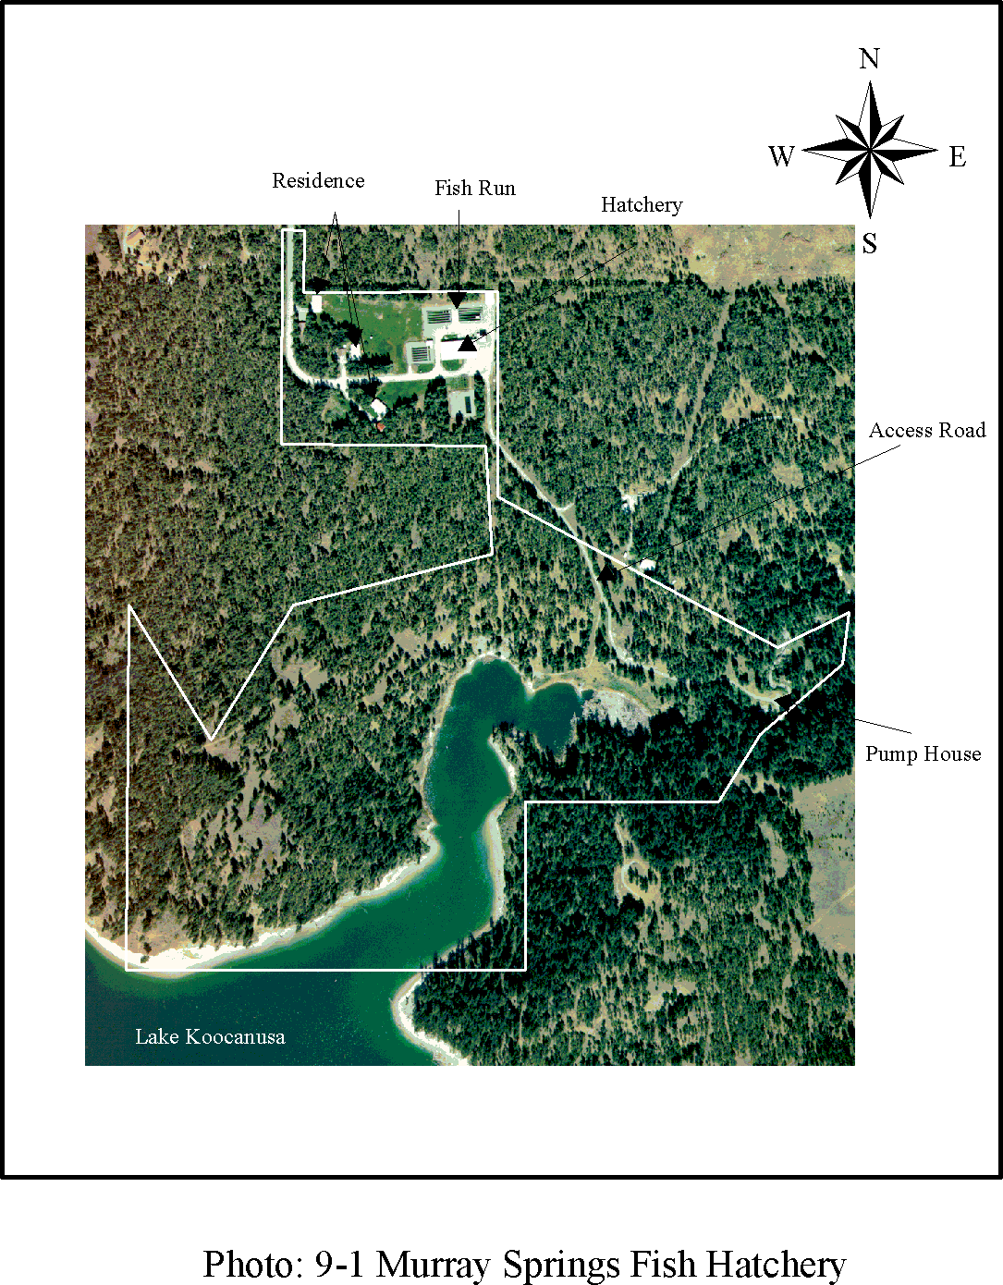

Libby Dam-Lake Koocanusa Project Corps of Engineers

Master Plan-September 1997 Seattle District

(Public Law 93-251, Section 48, 88 Stat. 12). It is anticipated that future operation and maintenance over the 100-year life of the hatchery will be funded through the project operations and maintenance budget.

* + 1. Land Classification. Mitigation: Mitigation
    2. Resource Objective. Mitigate fishery losses attributed to the construction of Libby Dam by providing fish for planting in Lake Koocanusa and adjacent waters.
    3. Rationale. Fishery loss mitigation is in accordance with the Water Resource Development Act of 1974, Public Law 93-251, which authorized construction and operation of a mitigation fish hatchery.
    4. Development and Management Measures.
       1. Continue to operate and maintain the Murray Springs Fish Hatchery as authorized by Congress.
    5. Major Constraints. None.

Libby Dam-Lake Koocanusa Project Corps of Engineers

Master Plan-September 1997 Seattle District

## SECTION 10-DESIGN CRITERIA

### GENERAL

General policies and procedures for the planning, design, operation, and maintenance of recreation facilities at Corps of Engineers Civil Works projects are given in engineer manuals, regulations, and pamphlets referenced below:

ER 200-2-3, Environmental Compliance Policies

EP 200-2-3, Environmental Compliance Guidance and Procedures

EP 310-1-6a and b, U.S. Army Corps of Engineers Sign Standards Manual EM 1110-2-400, Recreation Planning and Design Criteria

ER 1110-2-400, Design and Recreation Sites, Areas, and Facilities

ER 1110-2-102, Design Features to Make Buildings and Facilities Accessible to and Usable by the Physically Handicapped

ER 1130-2-500, Partners and Support (Work Management Policies)

EP 1130-2-500, Partners and Support (Work Management Guidance and Procedures) ER 1130-2-540, Environmental Stewardship Operations and Maintenance Policies

EP 1130-2-540, Environmental Stewardship Recreation Operations and Maintenance Guidance and Procedures.

ER 1130-2-550, Recreation Operations and Maintenance Policies

EP 1130-2-550, Recreation Operations and Maintenance Guidance and Procedures ER 1165-2-400, Recreational Planning, Development, and Management Policies Uniform Federal Accessibility Standard (UFAS)

ADA Accessibility Guidelines for Buildings and Facilities (ADAAG) Universal Access to Outdoor Recreation: A Design Guide

These publications guide the development of recreational facilities to assure that they are of the highest quality while serving the health, safety, and enjoyment of the visiting public.

Libby Dam-Lake Koocanusa Project Corps of Engineers

Master Plan-September 1997 Seattle District

Design principles and criteria particularly appropriate to the Libby Dam-Lake Koocanusa project are discussed in the following paragraphs.

### ACCESSIBILITY STANDARDS

Buildings and facilities shall be designed, constructed and altered to meet or exceed ADA Accessibility Guidelines for Buildings and Facilities (ADAAG) and Uniform Federal Accessibility Standards (UFAS). For existing buildings and facilities, physical barriers to entering and using facilities must be removed when “readily achievable.”

Due to different conditions encountered when designing for outdoor spaces rather than the “built” environment, guidelines to address recreation areas and facilities are currently under development. Until these guidelines are finalized, it is Corps of Engineers’ policy to used ADAAG and UFAS standards in conjunction with the reference document Universal Access to Outdoor Recreation: A Design Guide for all outdoor recreation planning, design, new construction, and renovation activity. Specific design alterations necessary to meet ADA standards at the project have been identified in Libby Dam-Lake Koocanusa Project Americans With Disabilities Act Evaluation (1994). For purposes of this report, the following design recommendations are assumed to incorporate ADA requirements.

### SITING

Development should be sensitive to the natural landscape character of the site and area. The landscape character of each site and its natural factors should be fully analyzed so that the most scenic parts of the site or area will remain undisturbed, to be enjoyed in their most natural condition. Facilities should be sited to blend with the existing landscape rather than compete with it. Only the most adaptable terrain will be used for siting of facilities. Cuts and fills should be minimized.

Physical development of recreation facilities should avoid impacts to significant natural and cultural resource sites and features. If endangered species are present, their sensitivity to disturbance shall be determined. Harassment of endangered species, which includes construction work, and any human activity that is too close, shall be avoided. In some cases, however, siting of facilities may enhance or interpret natural or cultural sites through signing, displays, or the visitor center exhibits. When significant cultural resource sites cannot be avoided and they are directly impacted by the installation of tables, firepits, restrooms, access roads, or boat ramps, then a determination of effect should be made. If unavoidable adverse effects are determined then a mitigation plan may be required, or the area may be avoided for development altogether (see Section 3).

* + 1. Picnic Tables.
       1. Site tables in the afternoon shade of existing or proposed trees.

Libby Dam-Lake Koocanusa Project Corps of Engineers

Master Plan-September 1997 Seattle District

* + - 1. Site picnic tables so that they will be exposed to prevailing summer breezes.
      2. Locate picnic tables upwind of gravel parking areas.
      3. Do not site picnic tables underneath alder or birch trees which drip sap.
    1. Firepits.
       1. Locate firepits downwind of picnic tables.
       2. Stagger location of firepits and picnic tables in larger developments so that adjacent firepits do not adversely affect other picnic tables.
    2. Rest Rooms.
       1. Locate vault toilets downwind of nearby visitor and picnic facilities.
       2. Site toilet facilities in shade of existing or proposed trees.
       3. Site toilet facilities in such a manner that visitors do not have to pass close by them on their way to picnicking facilities.
    3. Boat Launching Ramps.
       1. Site adjacent facilities such as picnic tables upwind of launching ramp activities to avoid car and boat engine exhaust fumes.
    4. Trash Receptacles.
       1. Locate trash receptacles in shady areas a sufficient distance away from other facilities to minimize bee and hornet attraction.
       2. Use containers with well sealed tops.

Libby Dam-Lake Koocanusa Project Corps of Engineers

Master Plan-September 1997 Seattle District

### ACCESS AND CIRCULATION

* + 1. Roads, trails/walks, parking.
       1. Roads, trails, and walks play a major role in establishing the safety and character of a project area. Within project sites, no road or other circulation system should be designed simply as a connecting link between points of interest. Every segment of every recreation path should relate to the environment through which it passes, constituting an enjoyable and informative experience in itself.
       2. Horizontal and vertical alignment of circulation systems should follow the existing topography.
       3. Parking areas are an integral part of the circulation system. Large parking areas should be designed so that the desired circulation and parking pattern is obvious. Parking edges should be physically defined. Planting and naturalistic grading should be used to shade and screen parking areas and to reduce their apparent size. Parking within day use areas should be restricted to designated areas to avoid damage to resources and to minimize visual impact at the site.
       4. Existing paved areas which are not necessary for normal circulation and parking patterns should be restored to a natural condition.
       5. Walks and designated paths should be designed to provide convenient and safe pedestrian access and circulation between primary site facilities including kiosks, rest rooms, picnic areas, and parking areas. Topography and existing vegetation should influence siting of walks. When appropriate, consider the use of surfaces other than concrete that blend sensitively into natural edges but are firm, stable and meet accessibility requirements
       6. Paths in high use areas should be curbed or fenced to protect ground level vegetation (see Photo 10-1)

### SITE PREPARATION

Detailed information on the site should be obtained before design begins.

Vegetation to be preserved should be selected early in the design phase. All vegetation to be preserved shall be fenced off during construction work. No stockpiling of materials or disturbance to root zones shall be allowed in these areas.

Grading for construction of park facilities should be minimized. Necessary cuts and fills should blend uniformly with existing natural contours. Their edges should be neatly

Libby Dam-Lake Koocanusa Project Corps of Engineers

Master Plan-September 1997 Seattle District

finished to blend with the natural landform and vegetation. Careful consideration should be given to how and where excess material is to be used. Excess material may often be used to create landforms such as mounds or berms of earth to separate and screen use areas.

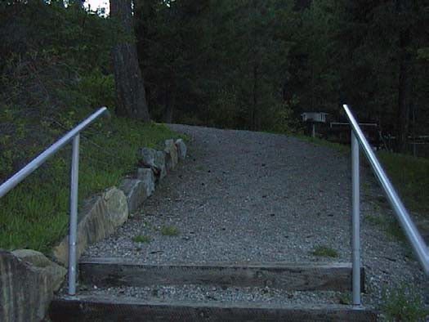

#### Photo 10-1: Natural Stone Edging Along Trail 10.6LANDSCAPE RESTORATION

Predominantly native plant material should be used for landscaping. Use of native rock and forest litter should be considered to increase the natural regeneration process and appearance. Disturbance of the natural environment shall be minimized. Planting should be informal in character and emphasize natural landforms with groupings of native trees and an understory of shrubs and ground covers.

### 10.7 LANDSCAPE ARCHITECTURAL FEATURES

Design and materials of landscape features (benches, shelters, fences, picnic tables, flagpoles, walls, kiosks, etc.) should reflect the character of the natural landscape, and when applicable, the established architectural style of the project. Landscape features in the vicinity of the dam were originally designed by architect Paul Thiry as a comprehensive site design and have a distinct visual character. Therefore, designs for landscape features in the visitor use areas in the vicinity of the dam, such as the visitor center, Souse Gulch, left abutment visitor orientation area, and left and right bank visitor areas should use timber and concrete materials to blend with existing features (see Photos 10-2 through 10-3). When possible, landscape features designed by Paul Thiry should be maintained.

Libby Dam-Lake Koocanusa Project Corps of Engineers

Master Plan-September 1997 Seattle District

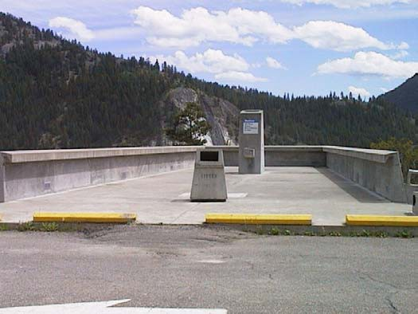

#### Photo 10-2: Typical Concrete Features

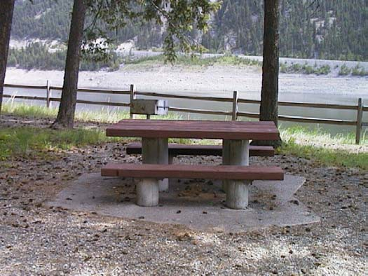

**Photo 10-3: Typcial Concrete and Timber Picnic Table**

Outlying recreation areas such as Alexander Creek, Blackwell Flats, Dunn Creek Flats, etc., do not contain landscape features designed by Thiry. Therefore, landscape features should be designed to blend more with the natural landscape; for example, design rustic timber features (see Photos 10-4 and 10-5).

Although designs for areas in the vicinity of the dam and designs for outlying recreation areas will be somewhat different in character, they should also be compatible with each other to establish visual unity for the project. For example, treatment of timber materials should be consistent (for example, are timbers rough hewn, milled, or rounded), and paints and stains should be consistent throughout the project.

Libby Dam-Lake Koocanusa Project Corps of Engineers

Master Plan-September 1997 Seattle District

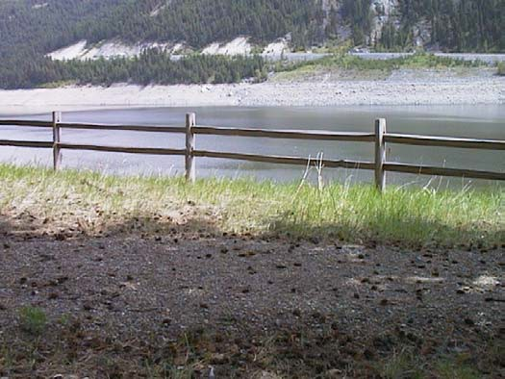

#### Photo 10-4: Rustic Timber Fence

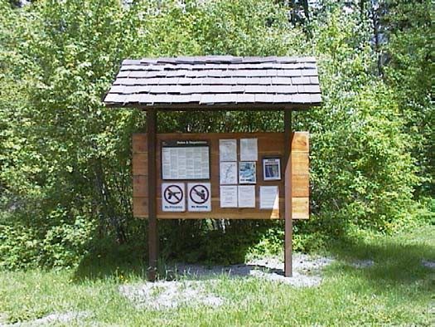

**Photo 10-5: Rustic Information Kiosk 10.8STRUCTURES**

New structures should be sited to avoid visual competition in the landscape. Architectural treatment should be sensitive to established architectural style of the project, and should be sited to reflect local ground forms and vegetative patterns and surroundings. Increased use of natural materials, natural colors, and earth and landscape screening is recommended. As noted above, paints and stains should be consistently applied to structures as well as landscape features to aid in establishing the visual unity of Corps project sites.

Libby Dam-Lake Koocanusa Project Corps of Engineers

Master Plan-September 1997 Seattle District

### ELECTRICAL DISTRIBUTION

All existing power lines are located underground with the exception of the BPA high tension lines. Future electrical utilities, excepting high tension lines, should also be located underground as well to maintain a clean, uncluttered appearance.

Above-ground transformers and utility boxes that are located in areas visible to the public should be screened with shrubs. Use native shrub species for screening when possible.

### SIGNS

* + 1. Design and Location.
       1. Direction and control of visitors to and within public use areas depends partly on a coherent and ordered signage system. Location of signs on the project should be set in a fully coordinated sign plan. A sign plan helps to eliminate unnecessary duplication and aids in placing signs where they will be effective. A sign inventory for the project was completed in 1996. This inventory should be updated to reflect current conditions and recommendations of the master plan, and a sign plan prepared, in coordination with the USFS, for the project area.
       2. Signs must communicate direction, information, and regulation messages effectively while remaining compatible with the surrounding environment. Federally adopted symbols used for both recreation and traffic control should be incorporated into the signage system. Project signs will be in accordance with criteria stated in the U.S. Army Corps of Engineers Graphic Standards Manual (EP 310-1-6), U.S. Army Corps Engineers Sign Standards Manual (EP 310-1-6a and 6b), and applicable regulations, and with consideration to the following:
       3. The design of all project signs should be consistent as possible within the project area and in accordance with the national sign standards.
       4. Entrance signs should be highly visible at the entrances to visitor facilities.
       5. Highway signs should be designed to effectively direct and inform project visitors regarding recreation and information facilities.
       6. Design and material of signs should be as vandal-resistant as practicable.

Libby Dam-Lake Koocanusa Project Corps of Engineers

Master Plan-September 1997 Seattle District

* + - 1. Project signs should be properly maintained, including rehabilitation, removal, or prompt replacement, as required.
      2. Interpretive signs will follow the guidelines set forth in chapter thirteen of the Corps Sign Standard Manual, Engineering Pamphlet 310-1-6a

### WASTE COLLECTION TREATMENT SYSTEMS

The sanitary system collects and treats waste water from the dam, maintenance building, powerhouse, left and right abutment overlooks, visitor center, and Souse Gulch Recreation Area. The effluent is collected and treated in a sewage treatment lagoon located in the powerhouse. The system is gravity operated with the exception of the northern picnic facilities at Souse Gulch which is pumped up to the south end facilities where it continues under gravity feed.

Commercial portable toilets are located at Souse Gulch boat ramp, left bank visitor area, David Thompson Bridge, Alexander Creek, Blackwell Flats, and Dunn Creek Flats recreation areas. These are serviced by a private vendor.

Based on long-term ecomomic considerations, it is recommended that some portable toilets be upgraded to more permanent facilities and additional improved sanitary facilities be installed in recreation areas. For example, improved sanitation facilities will be required at Souse Gulch boat ramp, left bank visitor area, Dunn Creek Flats, Alexander Creek, and Blackwell Flats recreation areas. With the exception of the Souse Gulch boat ramp, vault toilets appear to be the most cost-effective at this time. Plans and specifications have been completed for a water borne rest room uphill from the Souse Gulch boat ramp.

Libby Dam-Lake Koocanusa Project Corps of Engineers

Master Plan-September 1997 Seattle District

## SECTION 11-CONCLUSIONS AND RECOMMENDATIONS

### CONCLUSIONS

The Libby Dam-Lake Koocanusa Project Master Plan has been prepared to provide guidance for the preservation, conservation, restoration, maintenance, management, and development of project lands, waters, and associated resources. The Libby Dam-Lake Koocanusa project was constructed by the U.S. Army Corps of Engineers in accordance with the treaty between the United States and Canada relating to international cooperation in water resources development of the Columbia River basin.

Project lands and facilities administered by the Corps of Engineers provide recognized opportunities for water oriented overnight and day use recreation, interpretive programming, fish and wildlife management, sport fishing and hunting, and cultural, biological, and scenic resource maintenance and protection. Study and analysis of regional needs, resource capabilities and potentials, and public desires has identified a variety of measures to enhance the future use, development, and management of project resources administered by the Corps of Engineers. These measures are formalized by the project through land use classification and resource objectives.

### RECOMMENDATIONS

* + 1. General. It is recommended that the Libby Dam-Lake Koocanusa Project Master Plan be adopted as a guide to the orderly use, development and management of the natural and manmade resources of the Libby Dam-Lake Koocanusa project administered by the Seattle District, U.S. Army Corps of Engineers. The land classification and hazardous waters zones and resource objectives formalized by the project will provide for sound resource use, development, and management consistent with authorized project purposes and based on determination of highest and best use. Periodic reevaluation of the identified resource objectives, accompanied by possible modification of some objectives and/or established priorities, will be necessary; accordingly, updating of the project should be scheduled as appropriate (EP 1130-2-550 recommends every five years). Specific additional recommendations are identified in the following paragraphs.
    2. Management of Visitor Accommodations. The visitor accommodations recommended by the project (see Sections 6 and 8) are not subject to non-federal participation in their administration and will be developed at 100 percent federal cost and managed by the Corps of Engineers. In accordance with article 3 of the October 3, 1966 Memorandum of Understanding between the Corps of Engineers and the U.S. Forest Service (see paragraph 2.1 and Appendix A), the Corps of Engineers is responsible for the development and administration of dam site visitors' facilities and the appurtenant works needed for public accommodations on project lands administered by the Corps of Engineers. The U.S. Forest Service

administers recreation areas, including overnight accommodations, on project lands administered by that agency upstream of Libby Dam within the United States.

Opportunity for development of visitor accommodations downstream of Libby Dam on lands administered by the Corps of Engineers is identified and criteria for development prescribed at sites which are suited for and presently experience significant public use. Delegation of management responsibility for these accommodations to non-federal entities is not feasible due to the location and character of the sites and the nature of their existing and recommended facilities. These factors impose inescapable management obligations upon the Corps of Engineers. A stewardship responsibility exists to manage these sites to enhance visitor health and safety and to protect the cultural, biological, and scenic resources of the sites as part of the project resource management program.

Modest site improvements are necessary at the Alexander Creek, Blackwell Flats, and Dunn Creek Flats recreation areas to maintain and protect the ecological and scenic values which make these sites popular recreation areas to visitors.

Measures to control public access to and use of these three sites will foster proper resource stewardship by minimizing further impacts to natural and cultural resources, reducing long-term resource management costs, and enhancing public relations. Clearly, the resource management framework for these sites recommended in Section 6 is in the best interest of both the public and the Corps of Engineers.

* + 1. Sign Plan. A project sign plan that is responsive to public needs should be updated as necessary. Informational signing pertaining to Lake Koocanusa recreation areas should be cooperatively developed with the U.S Forest Service.
    2. Operational Management Plan. As prescribed by ER and EP 1130-2-550, and upon approval of the project, an operational management plan (OMP) which achieves the objectives outlined in the project shall be developed and fully implemented. The OMP objectives and implementation plans shall be established for each area of emphasis: Natural Resources Management and Park Management. Specific guidance on the OMP preparation and implementation processes is provided in Chapter 3 of EP 1130-2-550. The OMP is currently under preparation.
    3. Historic Properties Management Plan. As prescribed by EP 1130-2-540, a Historic Properties Management Plan shall be developed and fully implemented (see Paragraph 3.7 of Section 3).

Libby Dam-Lake Koocanusa Project Corps of Engineers

Master Plan-September 1997 Seattle District

Insert Appendix A: MOU: Planning, Development & Mgt of Land and Water Resosurces

Insert Appendix B: Action plan for construction of the initial recreation developments on lake Koocanusa

**APPENDIX C:**

# Biotic Inventory - Vegetation

The biotic inventory of vegetation is by no means intended to be a complete list of all plants within the Project area. The list does, however, represent the more important plants on the basis of abundance and economic importance both to human and to wildlife. The inventory was developed jointly by the U.S. Army Corps of Engineers and the U.S. Forest Service planning team at the Kootenai National Forest near Libby, Montana, for the final environmental impact statement supplement I Libby Additional Units and Reregulating Dam.

A - Abundant C - Common

BIOTIC INVENTORY - VEGETATION O - Occasional

R - Rare

P - Present-Abundance Uncertain

N, S, W, E - Cardinal Compass Points

OCCURANCE BY HABITAT

SPECIES Aquatic Riparian Bottomland Hillside COMMENTS

|  |  |  |  |  |
| --- | --- | --- | --- | --- |
| TREES: |  | | | |
| *Abies grandis*/Grand Fir | - - | C | C | N. Facing Slopes, Highly Elevated |
| *Betula papyrifera*/Paper Birch | - - | C | - | Locally Conmn |
| *Juniperus scopulorum*/Rocky Mt. Juniper | - | O | O | Dry, Hot, Rocky |
| *Larix occidentalis*/Western Larch | - - | A | A | N. & E. Slopes - Less Severe |
| *Picea englemanni*/Engleman Spruce | - C | C | - | Environment than P. Pine  N. Exposures Creek Bottoms |
| *Pinus contorta*/Lodgepole Pine | - - | C | A | Logged & Burned Areas - Sunny |
| *Pinus ponderosa*/Ponderosa Pine | - - | A | A | Hot Dry S. Slopes |
| (Also Bull or Yellow Pine)  *Populus tremuloides*/Quaking Aspen | - C | C | O | Moisture Loving |
| *Populus trichocarpa*/California Black  Cottonwood | - - | C/A | - | Moisture Loving |
| *Pseudotsuga menziesii*/Douglas Fir | - - | A | A | Similar Environment as Larch |
| *Thuja plicata*/Western Red Cedar | - C | R | R | Moist Sites, Shade Tolerant |
| (Also Giant Arborvitae)  *Tsuga heterophylla*/Western Hemlock | - - | - | R | Shade Tolerant |
| SHRUBS: |  |  |  |  |
| *Acer glabrum*/Rocky Mountain Maple | - - | - | A | H. & E. Exposures |
| *Alnus sinuata*/Thinleaf Alder | - - | - | A | Stream Bottoms, High Elevations |
| *A. tenuifolia*/Mountain Alder | - A | A | - | Stream Bottoms |
| *Amelanchier alnifolia*/Common Serviceberry | - - | A | A |  |
| *Artemisia tridentata*/Big Sagebrush | - - | - | A | Locally Abundant - Hot, Dry, |
| *Ceanothus sanguineus*/Redstem Ceanothus | - - | P | P | Well Drained  Occurrence in Area Uncertain |
| *Ceanothus velutinuo*/Greenstem Ceanothus | - - | - | C | Locally Common |

A - Abundant C - Common

BIOTIC INVENTORY - VEGETATION O - Occasional

R - Rare

P - Present-Abundance Uncertain

N, S, W, E - Cardinal Compass Points

OCCURANCE BY HABITAT

SPECIES Aquatic Riparian Bottomland Hillside COMMENTS

|  |  |  |  |  |
| --- | --- | --- | --- | --- |
| (Evergreen C.) |  | | | |
| *Chrysothamnus nausaosus*/Rabbit Brush/ | - - | - | P | Hot Dry S. Exposure |
| *Cornus stolonifera*/Red Osier Dogwood | - A | O | - |  |
| *Crataegus douglasii*/Douglas Hawthorn | - - | C | - | Also on Benches - Needs Sun |
|  |  |  |  | Moisture |
| *Holodiscus discolor*/Oceanspray | - - | C | C | S., Severe Exposure Associates |
|  |  |  |  | With Douglas Fir |
| *Juniperus communis*/Common Jtmiper | - - | - | O |  |
| *Oplopanax horridus*/Devils Club, | - - | R | - | Very Moist Sites |
| *Pachystima myrsinitea*/Myrtle Pachystima | - - | - | C | Locally Coumn - Associates |
|  |  |  |  | With Grand Fir |
| *Philadelphus lewisii*/Mock Orange | - - | C | C |  |
| *Physocarpus malvaceus*/Nine Bark | - - | C | A | Requirements Similar to |
|  |  |  |  | Oceanspray |
| *Prunus virginiana*/Common Chokecherry | - - | A | C | S. & W. Exposures - Moist Sunny |
|  |  |  |  | Sites |
| *Purshia tridentata*/Bitterbrush | - - | O | A | Locally Abundant on Semiarid S. |
|  |  |  |  | Slopes |
| *Ribes lacustre*/Wild Currant (Gooseberry) | - - | C/A | - | N. & E. Exposures |
| *Rosa acicularia*/Prickly Rose | - - | C/A | - | Sunny, Moist Sites |
| *Rosa gymnocarpa*/Baldhip Rose | - - | C/A | - | Sunny, Moist Sites |
| *Rosa woodsii*/Woods Rose | - - | C/A | - | Sunny, Moist Sites |
| *Rubus parviflorus*/Thimbleberry | - - | - | C | Shade Tolerant, Moist Habitats, |
|  |  |  |  | Associates With Grand Fir |
| *Salix spp*. (Mostly *Scouleriana*)/(Willows) | - A | C | O | Moist,Sunny Sites |
| *Sambucus spp*. (Mostly *Racemosum*)/(Elderberry) | - C | C | C | Common Most Sites Except Most Extreme |
| *Shepherdia canadensis* - Buffalo Berry | - P | P | P | Moist Sites |
| *Shepherdia argentea* - Buffalo Berry | - P | P | P | MDist Sites |
| *Spiraea betulifolius* | - - | - | C | Cool, Shady, Dry Soils - Associated |
|  |  |  |  | With Douglas Fir |

A - Abundant C - Common

BIOTIC INVENTORY - VEGETATION O - Occasional

R - Rare

P - Present-Abundance Uncertain

N, S, W, E - Cardinal Compass Points

OCCURANCE BY HABITAT

SPECIES Aquatic Riparian Bottomland Hillside COMMENTS

|  |  |  |  |  |  |
| --- | --- | --- | --- | --- | --- |
| *Symphoricarpos albus*/Snowberry | - | - | - | A | Cool, Shady, Dry Soils - Associate |
| *Symphoricarpos occidentalis*/Snowberry | - | - | - | A | With Douglas Fir  Cool, Shady, Dry Soils - Associated |
| *Taxus brevifolia*/Western Yew | -. | - | - | O | With Douglas Fir  Locally Conmon |
| *Vaccinium spp*./Huckleberry | - | - | - | R | C/A At High Elevations Outside Influence of Rereg. Dam |
| SUBSHRUBS AND VINES: |  |  |  |  |  |
| *Arctostaphylos uva-ursi*/Bearberry, Kinnikinnik | - | - | - | A | Semishade - Well Drained |
| *Berberis (Mahonia) repens*/Oregon Grape | - | - | A | A | Shade, Semishade |
| *Clematis columbiana*/Blue Clematic | - | C | - | C | Moist Soils |
| *Clematis ligusticifolia*/White Clematic | - | C | - | C | Moist Soils |
| *Litnaea borealis*/Twinflower | - | - | - | A | Higher Moist Shady Site a |
| *Lonicera ciliosa*/Western Trumpet Honeysuckle | - | - | - | C | Moist Soils |
| FERNS AND FERN ALLIES: |  |  |  |  |  |
| *Athyrium filix*-Femina | - | - | - | P | Associated With Grand Fir, Cedar |
| *Cystopterus fragilis* | - | - | P | P | Associated with Douglas Fir and |
| *Gymnocarpum dryopteris* | - | - | P | P | Ninebark  Associated With Grand Fir, Cedar |
| GRAMNOIDES: |  |  |  |  |  |
| *Agropyron spicatum*/Bluebunch Wheatgrass  *Bromus tectorum*/Downey Brome, Cheatgrass | -  - | -  - | C  P | A  P | Associates with P. Pine, Douglas Fir - Hot Dry Slopes |

A - Abundant C - Common

BIOTIC INVENTORY - VEGETATION O - Occasional

R - Rare

P - Present-Abundance Uncertain

N, S, W, E - Cardinal Compass Points

OCCURANCE BY HABITAT

SPECIES Aquatic Riparian Bottomland Hillside COMMENTS

|  |  |  |  |  |  |
| --- | --- | --- | --- | --- | --- |
| *Bromus vulgaris*/ | - | - | - | P | Higher Slopes Associate With |
| *Calamagrostis rubescens*/Pinegrass, | - | - | - | C | Spruce, Douglas Fir, Grand Fir  Associated With Douglas Fir, |
| Red Reedgrass  *Carex geyerii*/Elk Sedge | - | - | - | A | Primarily. Locally Abmdant, Dryer Sites  Primarily Associated With Douglas |
| *Equisetum spp*./Horsetail | - | P | P | P | Fir |
| *Festuca idahoensia*/ldaho Fescue | - | - | - | A | Sunny Dry Sites, P. Pine, |
| *Festuca scabrella*/Rough Fescue | - | - | - | P | Douglas Fir Zones  Primarily With Douglas Fir |
| *Koeleria christata*/June Grass | - | - | - | P | Dry Sites |
| *Luzula campestria* | - | - | P | P | Primarily Associated With Douglas |
| *Melica aubulata*/Onion Grass | - | P | P | P | Fir, Spruce  Moist Sites |
| *Oryzopsis asperifolia* | - | - | - | P | Wooded Slopes, Associated With |
| *Poa juncifolia* | - | - | - | P | Spruce, Grand Fir  Dry Slopes |
| *Scirpua spp*./Bulrush | P | P | P | - |  |
| *Typha latifolia*/Coman Cattail | P | P | P | - |  |
| FORBS: |  |  |  |  |  |
| *Achilles millefolium*/Yarrow | - | C | C | C | Sunny Sites |
| *Actaea rubra*/Western Baneberry  *Agoseris glauca*/Pale Agoseris (False | - | - | - | R | Moist Woods, High - Associated With Cedar Hemlock |
| Dandelion) | - | - | C | C |  |
| *Aralia hudicaulia*/Wlld Sarsaparilla | - | - | - | R | Moist Woods, High - Associated  With Cedar Hemlock. |

A - Abundant C - Common

BIOTIC INVENTORY - VEGETATION O - Occasional

R - Rare

P - Present-Abundance Uncertain

N, S, W, E - Cardinal Compass Points

OCCURANCE BY HABITAT

SPECIES Aquatic Riparian Bottomland Hillside COMMENTS

|  |  |  |  |  |  |
| --- | --- | --- | --- | --- | --- |
| *Artemisia frigida*/Fringed Sage  *Astragalus spp.*/Milkvetch  *Balsamorhiza sagittata*/Arrowleaf Balsamroot | -  -  - | O  -  - | O  - | - C  A | Dry Site  Mostly Moist Slopes  Dry Slopes Lower Elevations |
| *Calypso bulbosa*/Calypso | - | - | - | R | Deep Humus in Dense Woods |
| *Chimaphila umbellata*/Common Pipsissewa | - | - | - | R | Dry Woods, Higher Elevations |
| *Clintonia uniflora*/Clintonia | - | - | - | C | Moist Woods with Cedar At Higher |
| *Coptis occidentalis*/Western Goldthread | - | - | - | P | Elevations Moist Woods |
| *Cornus canadensis*/Bunchberry | - | - | - | C | Moist Woods |
| (*Cypripedium parviflorum*) yellow lady’s slipper | - | - | - | R | Mostly Moist Slopes |
| *Erythronium grandiflorum*/Trout Lily | - | - | - | C/A | Open Woods, Grassy Slopes - |
| *Eriogonum flavum*/Yellow Eriogonum | - | - | - | - | Locally Abundant  Dry Open Slopes |
| *Fragaria virginiana*/Viriginiana Strawberry | - | - | - | C | Grassy and Open Slopes |
| *Galium triflorum*/Beostraw | - | - | P | P | Moist Soil - Associated With |
| *Heuchera spp*./Allumroot | - | - | - | R | Spruce and Grand Fir  Moist Slopes and Woods |
| *Lewisia redivia*/Bitterroot | - | C | C | C | Sunny Well Drained Sites |
| *Lupinus spp*./Lupine | - | C | C | C | Sunny Moist Well Drained Sites |
| *Nuphar spp*./Pondlilly | R | - | - | - | Presence Uncertain |
| *Penstemon confertus*/Yellow P. | - | - | - | P | Meadows |
| *Penstemon eriantherus*/Fuzzytongue P. | - | - | - | P | Dry Soil |
| *Penstemon wilcoxii*/Wilcox P. | - | - | - | P | Dry Coniferous Woods |
| *Phlox ridida*/  *Streptopus amplexifolius*/Twisted-Stalk | - | - | - | P | Moist Woods High Elevations, |
| *Pyrola asarifolia*/Wintergreen | - | - | - | C | Bogs  Uncommon |

A - Abundant C - Common

BIOTIC INVENTORY - VEGETATION O - Occasional

R - Rare

P - Present-Abundance Uncertain

N, S, W, E - Cardinal Compass Points

OCCURANCE BY HABITAT

SPECIES Aquatic Riparian Bottomland Hillside COMMENTS

|  |  |  |
| --- | --- | --- |
| *Tiarella unifoliata*/ | - - - P | Moist Woods. Along Straits, |
|  |  | High Elevations |
| *Trillium ovatum*/Trillium | - - - P | Moist Woods, Deep Humus |
| *Veratrum virioe*/Green False Hellebore | - - - P | Wet Soil, High Elevations |
| *Viola orbiculata*/Round Leafed Violet | - - - P | Moist Coniferous Woods |
| *Xerophyllum tenax*/ | - - - P | Dry Slopes, High Elevations |
| *Zygadenus venenosus*/Meadow Death Camas | - - - R | Moist Meadows Locally Common |

**APPENDIX D:**

# Biotic Inventory Wildlife and Fish

The biotic inventory on wildlife is the result of field investigations and checks by Montana State game agencies. Species not identified in this inventory may occur in the Project area but have not been identified with sufficient frequency to consider in this summary. The inventory was developed for final environmental impact statement supplement I at Libby Additional Units and Reregulating Dam.

A - Abundant C - Common

U - Uncommon

BIOTIC INVENTORY - WILDLIFE AND FISH R - Rare

X - Nonexistent

Abundance

Seasonal By Habitat

Species Status Aquatic Riparian Bottomland Hillside

|  |  |  |  |  |  |  |  |
| --- | --- | --- | --- | --- | --- | --- | --- |
| *Aechmophorus occidentalis* Western Grebe |  | C-Spring, Summer, U-Fall | C/U |  |  | | |
| *Aix sponsa* Wood Duck |  | C-Spring/Summer U-Fall | C/U | C/U |
| *Anas platyrhychos* Mallard |  | Yearlong |  | A |  | A |  |
| *Anas acuta* Northern Pintail |  | U-Spring, R-Summer, Fall | U/R | U/R |  |  |  |
| *Anas clypeata* Northern Shoveler |  | U-Spring, R-Summer, Fall | U/R | U/R |  |  |  |
| *Anas americana* American Wigeon |  | C-Spring, U-Summer, Fall | C/U | C/U |  |  |  |
| *Anas strepera* Gadwall |  | U-Summer, C-Fall | C/U | C/U |  |  |  |
| *Anas cyanoptera* Cinnamon Teal |  | Summer-r, Fall | U | U |  |  |  |
| *Anas crecca* Greenwing Teal |  | Summer-r | C | C |  |  |  |
| *Ardea herodias* Great Blue Heron |  | Spring, Summer, Fall |  | U | U |  |  |
| *Aythya collaris* Ring-necked Duck |  | Spring, Summer, Fall | U |  |  |  |  |
| (*Aythya americana*) Redhead |  | xxx |  |  |  |  |  |
| *Bonasa umbellus* Ruffed Grouse |  | Spring, Simmer, Fall, |  | A | A |  |  |
|  |  | Winter |  |  |  |  | A |
| *Branta canadensis* Canada Goose |  | Spring, Summer, Fall | U | U |  |  |  |
| *Bucephala albeola* Bufflehead |  | Winter, Spring | U |  |  |  |  |
| *Bucephala clangula* Common Goldeneye |  | Fall, Winter, Spring | C |  |  |  |  |
| *Bucephala islandica* Barrows Goldeneye |  | Winter, Spring | U |  |  |  |  |
| *Cygnus columbianu* Tundra Swan *s* |  | Summer, Fall | R | R |  |  |  |
| *Dendragapus obscurus* Blue Grouse |  | Yearlong |  |  |  |  | A |
| *Gavia immer* Common Loon |  | R-Spring | R |  |  |  |  |
| *Lophodytes cucullatus* Hooded Merganser |  | Spring, Summer | U |  |  |  |  |
| *Mergus merganser* Common Merganser |  | Yearlong | A |  |  |  |  |
| *Nycticorax nycticorax* Black-Crowned Night | Heron | Summer |  | R |  |  |  |
| *Podiceps auritus* Horned Grebe |  | U-Spring, R-Summer | U/R |  |  |  |  |
| *Podiceps nigricolli* Eared Grebe *s* |  | U-Spring, R-Summer | U/R |  |  |  |  |
| *Podilymbus podiceps* Pied-billed Grebe |  | Spring | U | U |  |  |  |

A - Abundant C - Common

U - Uncommon

BIOTIC INVENTORY - WILDLIFE AND FISH R - Rare

X - Nonexistent

Abundance

Seasonal By Habitat

Species Status Aquatic Riparian Bottomland Hillside

|  |  |  |  |  |  |
| --- | --- | --- | --- | --- | --- |
| *Accipiter cooperii* Cooper's Hawk | U-Spring, Fall, R-Summer |  |  | U/R | U/R |
| *Accipiter gentilis* Goshawk | Spring, Summer, Fall |  |  | C | C |
| *Accipiter striatus* Sharp-shinned Hawk | Spring,, R-Summer, Fall |  |  |  | R |
| *Aquila chrysaetos* Golden Eagle | C-Winter,U-Spring, Fall, R-Summer |  |  | C/U/R |  |
| *Actitis macularia* Spotted Sandpiper | Spring, Summer, Fall |  | C | C |  |
| *Aegolius acadicus* Northern Saw-Whet Owl | Yearlong |  |  | U | U |
| *Aegolius funereus* Boreal Owl | R-Winter, U-Spring, Summer, Fall |  |  | R/U | R/U |
| *Asio otus* Long-Eared Owl | Spring, Summer, Fall |  |  | R | R |
| *Asio flammeus* Short-Eared Owl | Yearlong |  |  | U | U |
| *Bubo virgianus* Great Horned Owl | Spring, Summer, Fall |  |  | C | C |
| *Buteo jamaicensis* Red Tailed Hawk | A-Spring, Fall, C-Summer |  |  | A/C | A/C |
| *Buteo lagopus* Rough Legged Hawk | A-Spring, Fall |  |  | A | A |
| *Buteo regalis* Ferruginaus Hawk | U-Spring, Fall |  |  | U | U |
| *Buteo swainsoni* Swainson's Hawk | U-Spring, Fall |  |  | U | U |
| *Charadrius vociferus* Killdeer | C-Spring, Summer |  | C | C |  |
| *Chordeiles minor* Common Nighthawk | Summer |  |  | A | C |
| *Circus cyaneus* Marsh Hawk | R-Summer |  | R | R |  |
| *Falco sparverius* American Kestrel | A-Spring, C-Summer, Fall |  |  | A/C | A/C |
| *Falco columbarius* Merlin | Siring, Summer, Fall |  |  | C | C |
| *Gallinago gallinago* Common Snipe | Spring, Simmer Fall |  | C | C |  |
| *Glaucidium gnoma* Northern Pigmy Owl | Yearlong |  |  | R | R |
| *Haliaeetus leucocephalus* Bald Eagle | A-Fall, Winter, Spring, U-Summer |  | A/U | A/U | A/U |
| *Larus argentatus* Herring Gull | Spring, Summer, Fall | C | C | C |  |
| *Larus californicus* California Gull | Spring, Summer, Fall | C | C | C |  |
| (*Meleagris gallopavo)* Wild Turkey |  |  |  |  |  |
| *Pandion haliaetus* Osprey | C-Spring, U-Summer, Fall |  | C/U | C/U |  |
| *Tringa flavipes* Lesser Yellowlegs | Spring, Summer |  | U | U |  |
| *Zenaida macroura* Mourning Dove | Spring, Summer |  |  | C | C |

A - Abundant C - Common

U - Uncommon

BIOTIC INVENTORY - WILDLIFE AND FISH R - Rare

X - Nonexistent

Abundance

Seasonal By Habitat

Species Status Aquatic Riparian Bottomland Hillside

|  |  |  |  |  |  |  |
| --- | --- | --- | --- | --- | --- | --- |
| *Aeronautes saxatalis* White-Throated Swift  *Agelaius phoeniceus* Red-winged Blackbird  *Archilochus alexandri* Black-Chinned Hummingbird | Summer Spring,, Summer  Summer |  | U | | U | R  U |
| *Bombycilla garrulus* Bohemian Waxwing *Bombycilla cedrorum* Cedar Waxwing *Carduelis flammea* Common Redpoll  (*Carduelis hornemanni*) Hoary Redpoll | A-Fall, C-Spring, C-Fall, U-Spring, R-Winter | U-Summer R-Summer |  | | A/C/U C/U/R R | A/C/U C/U/R R |
| *Carduelis pinus* Pine Siskin *Carduelis tristis* American Goldfinch *Carpodacus cassinii* Cassin's Finch *Carpodacus mexicanus* House Finch *Certhia americana* Brown Creeper C*eryle alcyon* Belted Kingfisher *Chaetura vauxi* Vaux's Swift  *Cinclus mexicanus* Dipper  *Coccothraustes vespertinus* Evening Grosbeak  *Colaptes auratus* Northern Flicker | A-Fall, Winter, Spring, C-Summer U-Spring, Summer, R-Fall, Winter C-Winter, U-Spring  Yearlong Yearlong  U-Winter, C-Spring, Simmer, Fall Summer  Yearlong  A-Spring, Fall, C-Summer Spring, Summer, Fall | | U/C C | U/C C  C | A/C U/R  U U  U/C  C  C/A C | A/C U/R C/U U  C R  C/A  C |
| *Corvus corax* Common Raven  *Cyanocitta stelleri* Steller's Jay | Yearlong  C-Spring, Fall U-Summer, Winter | | A | A | A  C/U | A  C/U |
| *Cypseloides niger* Black Swift  *Dendroica coronata* Yellow-rumped Warbler | Summer  Spring,, Summer | |  | U | U | U |
| *Dendroica pensylvanica* Chestnut-Sided Warbler | Spring,, Summer | |  |  | R |  |
| *Dendroica petechia* Yellow Warbler it | Spring,, Summer | |  | A | A |  |
| *Dendroica townsendi* Townsend's Warbler | Spring,, Summer | |  |  | U | U |
| *Dryocopus pileatus* Pileated Woodpecker | Yearlong | |  |  | U | U |
| *Euphagus cyanocephalus* Brewer's Blackbird | Spring, ,Summer | |  |  | C | C |
| *Geothlypis trichas* Common Yellowthroat | Spring,, Summer | |  | A | A |  |

A - Abundant C - Common

U - Uncommon

BIOTIC INVENTORY - WILDLIFE AND FISH R - Rare

X - Nonexistent

Abundance

Seasonal By Habitat

Species Status Aquatic Riparian Bottomland Hillside

|  |  |  |  |  |
| --- | --- | --- | --- | --- |
| *Hirundo pyrrhonota* Cliff Swallow | Spring, Summer | C | C | C |
| *Hirundorustica* Barn Swallow | Spring, Summer |  | U | U |
| *Icterus bullockii* Bullock’s Oriole | Spring,, Summer | U | U | U |
| *Ixoreus naevius* Varied Thrush | C-Spring, U-Summer |  | C/U | C/U |
| *Junco hyemalis hyemalis* Slate-colored Jmco | Winter |  | U | U |
| *Junco hyemalis oreganus* Dark-eyed Junco | A-Spring, C-Summer, Fall, Winter | A/C | A/C | A/C |
| *Lanius excubitor* Northern Shrike | U-Spring, R-Summer |  | U/R | U/R |
| *Leucosticte arctoa* Rosy Finch | U-Spring, Fall, R-Summer |  |  | U/R |
| *Loxia curvirostra* Red Crossbill | Spring, A-Winter, U-Spring, Summer, Fall |  | C | C |
| *Melanerpes lewis* Lewis' Woodpecker | C-Spring, U-Summer |  | C/U | U |
| *Melospiza melodia* Song Sparrow | Spring,, Summer |  | C | C |
| *Myadestes townsendi* Townsend's Solitaire | C-Spring, Summer, U-Fall, Winter |  | C/U | C/U |
| *Nucifraga columbiana* Clark’s Nutcracker | U-winter, R-Spring, Summer, Fall |  |  | U/R |
| *Oporornis tolmiei* Macgillivray's Warbler | Spring,, Summer | A | A |  |
| *Parus atricapillus* Black-Capped Chickadee | A-Winter, C-Spring, Summer, Fall |  | A/C | A/C |
| *Parus gambeli* Mountain Chickadee | A-Winter, C-Spring, Summer, Fall |  | A/C | A/C |
| *Parus hudsonicus* Boreal Chickadee | Yearlong |  | R | R |
| *Parus rufescens* Chestnut-Backed Chickadee | Yearlong |  | U | U |
| *Passer domesticus* House Sparrow | Yearlong |  | C | C |
| *Passerella iliaca* Fox Sparrow | Spring,, Summer |  | C | C |
| *Perisoreus canadensis* Gray Jay | A-Winter, C-Spring, U-Summer, |  |  |  |
| *Pheucticus melanocephalus* Black-Headed Grosbeak | Spring,, Summer |  | R | R |
| *Pica pica* Black-Billed Magpie | Yearlong |  | U | U |
| *Picoides arcticus* Black-backed Woodpecker | Yearlong |  |  | R |
| *Picoides pubescens* Downy Woodpecker | Yearlong |  | C | C |
| *Picoides villosus* Hairy Woodpecker | Yearlong |  | A | A |
| *Picoides tridactylus* Three-Toed Woodpecker | Yearlong |  |  | U |
| *Pinicola enucleator* Pine Grosbeak | C-Winter, U-Spring, Summer, Fall |  | C/U | C/U |

A - Abundant C - Common

U - Uncommon

BIOTIC INVENTORY - WILDLIFE AND FISH R - Rare

X - Nonexistent

Abundance

Seasonal By Habitat

Species Status Aquatic Riparian Bottomland Hillside

|  |  |  |  |  |
| --- | --- | --- | --- | --- |
| *Piranga ludoviciana* Western Tanager | Spring, ,Summer |  | C | C |
| *Seiurus noveboracensis* Northern Waterthrush | Spring,, Summer | U |  |  |
| *Sturnella neglecta* Western Meadowlark | Spring,, Summer |  | U | U |
| *Pipilo maculatus* Spotted Towhee | Summer |  | C | C |
| *Regulus satrapa* Golden-Crowned Kinglet | Spring, Summer |  |  | R |
| *Regulus calendula* Ruby Crowned Kinglet | C-Spring, Simmer, U-Fall |  | U/C | U/C |
| *Riparia riparia* Bank Swallow | Spring, Summer | C | C | C |
| *Sayornis saya* Say's Phoebe | Spring, Summer |  | U | U |
| *Selasphorus rufus* Rufous Hummingbird | A-Summer, U-Pall, C-Spring | U | C/A/U | C/A/U |
| *Sialia currucoides* Mountain Bluebird | A-Spring, C-Summer |  | U | C/U |
| *Sialia mexicana* Western Bluebird | U-Spring, R-Summer |  |  | U/R |
| *Sitta carolinensis* White-Breasted Nuthatch | Yearlong |  | C | C |
| *Sitta canadensis* Red-Breasted Nuthatch | A-Spring, Summer, Fall C-Winter |  | A/C | A/C |
| *Sitta pygmaea* Pigmy Nuthatch | Yearlong |  |  | U |
| *Spizella passerina* Chipping Sparrow | C-Spring, Summer |  | C | C |
| *Sphyrapicus nuchalis* Red-naped Sapsucker | U-Spring, Fall, C-Summer |  | U/C | U/C |
| *Sphyrapicus thyroideus* Williamson's Sapsucker | R-Spring, Fall, U-Simmer |  |  | R/U |
| *Stelgidopteryx serripennis* |  |  |  |  |
| -Northern Rough-Winged Swallow | Spring, Summer | C | C | C |
| *Stellula calliope* Calliope Hummingbird | Spring, Summer |  |  | U |
| *Sturnus vulgaris* European Starling | U-Spring, Summer | U | U | U |
| *Tachycineta thalassina* Violet-green Swallow | Spring, Summer | A | A | A |
| *Tachycineta bicolor* Tree Swallow | Spring, Summer | A | A | A |
| *Thryomanes bewickii* Bewick's Wren | Spring, Summer |  | R | R |
| *Troglodytes aedon* House Wren | Summer |  | U | U |
| *Troglodytes troglodytes* Winter Wren | Spring, Summer |  | U | U |
| *Turdus migratorius* American Robin | Spring, Summer, Fall |  | A | A |
| *Tyrannus tyrannus* Eastern Kingbird | Spring, Summer |  | C | C |

A - Abundant C - Common

U - Uncommon

BIOTIC INVENTORY - WILDLIFE AND FISH R - Rare

X - Nonexistent

Abundance

Seasonal By Habitat

Species Status Aquatic Riparian Bottomland Hillside

|  |  |  |  |  |  |
| --- | --- | --- | --- | --- | --- |
| *Tyrannus verticalis* Western Kingbird | Spring, Summer |  |  | C | C |
|  | Fall |  |  | A/C/U | A/C/U |
| *Vermivora celata* Orange-Crowned Warbler | Spring,, Summer |  | C | C | C |
| *Vermivora peregrina* Tennessee Warbler | Spring,, Summer |  | U | U |  |
| *Vermivora ruficapilla* Nashville Warbler | Spring,, Summer |  |  | U |  |
| *Zonotrichia leucophrys* White-Crowned Sparrow | Spring,, Summer |  |  | U | U |
| *Alces alces* Moose | Yearlong |  | R | R | R |
| *Ambystoma macrodactylum* Long-toed Salamander | Yearlong |  | C | C |  |
| *Ambystoma tigrinum* Tiger Salamander | Yearlong |  | R |  |  |
| *Ascaphus truei* Tailed Frog | Yearlong |  | U |  |  |
| *Bufo boreas* Western Toad | Yearlong |  | C | C |  |
| *Canis latrans* Coyote | Yearlong |  |  | C | C |
| *Castor canadensis* Beaver | Yearlong | C | C | C | X |
| *Cervus canadensis* Rocky Mt. Elk | U-Spring/Fall, R-Winter/Summer |  |  | X | U |
| *Charina bottae* Rubber Boa | ? |  | C | C |  |
| *Chrysemys picta* Painted Turtle | Yearlong | U | U |  |  |
| *Clethrionomys gapperi* Boreal Red-backed Vole | Yearlong |  |  | C | C |
| *Dicamptodon ensatus* Pacific Giant Salamander | Yearlong |  | R |  |  |
| *Elgaria coerulea* Northern Alligator Lizard | Yearlong |  |  |  | R |
| *Eptesicus fuscus* Big Brown Bat | ? |  |  |  | U |
| *Erithizon dorsatum* Porcupine | Yearlong |  |  | C | C |
| *Eumeces skiltonianus* Western Skink | Yearlong |  |  |  | U |
| *Eutamias amoenus* Yellow Pine Chipmunk | Yearlong |  |  | A | A |
| *Eutamias ruficaudus* Red-Tail Chipmunk | ? |  |  |  | U |
| *Felis concolor* Mountain Lion | Yearlong, U-Winter, R-Spring, Fall, |  |  |  |  |
|  | Summer |  | U | U | U |
| *Glaucomys sabrinus* Flying Squirrel | Yearlong |  |  | C |  |
| *Hyla regilla* Pacific Tree Frog | Yearlong | U | U |  |  |

A - Abundant C - Common

U - Uncommon

BIOTIC INVENTORY - WILDLIFE AND FISH R - Rare

X - Nonexistent

Abundance

Seasonal By Habitat

Species Status Aquatic Riparian Bottomland Hillside

|  |  |  |  |  |  |
| --- | --- | --- | --- | --- | --- |
| *Lasionycterus nocivagans* Silver-haired Bat | ? |  |  |  | U |
| *Lepus americanus* Snowshoe Hare | C-Winter, U-Fall, Summer, Spring |  |  | C | U |
| *Lynx rufus* Bobcat | C-Fall, Winter, Spring, U-Summer |  |  | C | C |
| *Martes americana* Marten | Yearlong | X | X | X | U |
| *Mephitis mephitis* Striped Skunk | Yearlong |  | U | U |  |
| *Microtus longicaoudus* Longtail Vole | Yearlong |  |  | C | C |
| *Microtus montanus* Mountain Vole | Yearlong |  |  |  | R |
| *Microtus pennsylvanicus* Meadow Vole | Yearlong |  |  | C | U |
| *Mus musculus* House Mouse | Yearlong |  |  | C | C |
| *Mustela erminea* Shorttail Weasel | Yearlong |  | R | R | R |
| *Mustela frenata* Longtail Weasel | Yearlong |  | C | C | U |
| *Mustela vison* Mink | Yearlong | U | C | C | X |
| *Myotis lucifugus* Little Brown Bat | A-Simmer, U-Spring, Fall, |  |  |  |  |
|  | Winter |  | A/U | A/U | A/U |
| *Myotis evoitis* Long-eared Bat | ? |  |  |  | U |
| *Myotis volans* Long-legged Bat | ? |  |  |  | U |
| *Neotoma cinerea* Bushytailed Wood Rat | Yearlong |  |  | U | U |
| *Ondatra zibethica* Muskrat | Yearlong | C | C | X |  |
| *Odocoileus virginianus* Whitetail Deer | C-Summer/Fall, A-Winter/Spring |  |  | C/A | C/A |
| *Odocoileus hemionus* Mule Deer | U-Simmer, C-Fall/Winter/Spring |  |  | C | U |
| *Peromyscus maniculatus* Deer Mouse | Yearlong |  |  | A | A |
| *Plecotus townsendi* Western Big-eared Bat | ? |  |  |  | U |
| *Procyon lotor* Raccoon | Yearlong |  |  | R |  |
| *Rana pipiens* Leopard Frog |  | C | C |  |  |
| *Rana pretiosa* Spotted Frog | Yearlong | C | C |  |  |
| *Sorex cinereus* Masked Shrew | Yearlong |  |  | R | U |
| *Sorex vagrans* Vagrant Shrew | Yearlong |  | C | C | C |
| *Sorex palustris* Northern Water Shrew | Yearlong |  | C | C |  |

A - Abundant C - Common

U - Uncommon

BIOTIC INVENTORY - WILDLIFE AND FISH R - Rare

X - Nonexistent

Abundance

Seasonal By Habitat

Species Status Aquatic Riparian Bottomland Hillside

|  |  |  |  |  |
| --- | --- | --- | --- | --- |
| *Spermophilus columbianus* Columbia Ground Squirrel | A-Spring, Summer, Fall |  | A | A |
| *Sylvilagus nuttalli* Mountain Cottontail | Yearlong |  | R |  |
| *Tamiasciurus hudsonicus* Red Squirrel | Yearlong |  | A | A |
| *Thanmophis sirtalis* Common Garter Snakes | Yearlong | A | A |  |
| *Thomonys talpoides* Northern Pocket Gopher | Yearlong |  | R | R |
| *Ursus americanus* Black Bear | C-Summer, U-Fall/Spring, |  |  |  |
|  | X-Winter | C/U | C /U | C/U |

A - Abundant C - Common

U - Uncommon

BIOTIC INVENTORY - WILDLIFE AND FISH R - Rare

X - Nonexistent

Abundance

Seasonal By Habitat

Species Status Aquatic Riparian Bottomland Hillside

## KOOTENAI BIOTIC INVENTORY—FISH

Family Lake Kootenai

Scientific Name Species Koocanusa River

Sturgeons—Acipenseridae

*Acipenser transmontanus\** White sturgeon N C Salmon, Trout, Whitefishes—Salmonidae

|  |  |  |  |
| --- | --- | --- | --- |
| *Oncorhynchus clarki\** | Cutthroat trout |  | CC |
| *O. mykiss\** | Rainbow trout | C | C |
| *O. nerka\** | Kokanee | A | C |
| *Prosopium williamsoni\** | Mountain whitefish | C | C |
| *Salvelinus confluentus\** | Bull trout | C | C |

Minnows—Cyprinidae

|  |  |  |  |
| --- | --- | --- | --- |
| *Couesius plumbeus\** | Lake chub | C | N |
| *Mylocheilus caurinus\** | Peamouth | C | C |
| *Ptychocheilus oregonensis\** | Northern squawfish | C | C |
| *Rhinichthys cataractae\** | Longnose dace | R | C |
| *Richardsonius balteatus\** | Redside shiner | C | C |

Suckers—Catostomidae

|  |  |  |  |
| --- | --- | --- | --- |
| *Catostomus catostomus\** | Longnose sucker | C | C |
| *C. macrocheilus\** | Largescale sucker | C | C |

A - Abundant C - Common

U - Uncommon

BIOTIC INVENTORY - WILDLIFE AND FISH R - Rare

X - Nonexistent

Abundance

Seasonal By Habitat

Species Status Aquatic Riparian Bottomland Hillside

Catfish—Ictaluridae

*Amiurus nebulosus* Brown bullhead C C

Cods—Gadidae

*Lota lota\** Burbot C C

Troutperches—Percopsidae

*Percopsis transmontana\** Sandroller U U

Sunfishes—Centrarchidae

*Lepomis gibbosus* Pumpkinseed U U

Perches—Percidae

*Perca flavescens* Yellow perch U U Sculpins—Cottidae

|  |  |  |  |
| --- | --- | --- | --- |
| *Cottus cognatus\** | Slimy sculpin | C | C |
| *C. rhotheus\** | Torrent sculpin | U | C |

* native to Columbia basin

## APPENDIX E: Libby Dam Master Plan Public Coordination

Coordination of the Libby Dam-Lake Koocanusa Master Plan with the public began early in the project and continued to its completion. Public involvement included 1) open houses; 2) early contact with business and organizations; and 3) agency and public review of the draft master plan. Comments received during the early stages of planning were taken into consideration during the development of the draft master plan.

1. OPEN HOUSE SUMMARY

Initial efforts to solicit public input included articles in local newspapers and an interview with a local radio station outlining the purpose of the master plan, a summary of potential land management changes at Libby Dam-Lake Koocanusa, and announcements of the time and date for two open houses for the public. The purpose of the open houses was to obtain the public’s ideas on the current and future use and management of Corps administered lands. These early public involvement efforts were managed by Forest Brooks, Study Manager for fiscal year 1996.

Two open houses were conducted for the public. The first was held on July 24, 1996 at the 1st National Bank in Libby, Montana, from 2-5 PM and from 6-9 PM. The second open house was held on July 25, 1996 at the Lincoln Electric Company in Eureka, Montana. The following is a summary of comments received during the open houses, discussions with organizations and businesses, and by phone and mail. Copies of comments and meeting notes are on file at the Seattle District, Army Corps of Engineers. These comments were discussed during the preparation of the master plan and incorporated when compatible with the project resource objectives. Text highlighted in **bold** indicates explanations that were provided to the public about comments received during the open houses.

-Improve the Dunn Creek parking lot for the boat ramp.

-It’s not possible to disconnect water management (operation plans) from the recreational needs because of the effects of peak discharges to resident fisheries in the Kootenai River.

-Would like to see more recycling containers for glass, newspaper, plastic, and cardboard.

-Interested in being able to drive across the dam year-round.

#### Having employees available to open gates as well as providing security during the winter is difficult.

-Feel that proposed additional campsites are in direct competition with local private business “...free enterprise and small business is the stronghold of America but to compete with the government with their unseemingly unlimited resources is impossible!”

#### The project only provides semi-developed campground facilities. For example there are no trailer hook-ups, toilets are primitive, and no water is provided. There are no plans to expand these services in the future.

-Would like to see a boat dump sanitation station on the Reservoir.

-Do not want the Corps to compete with private campground owners by improving

campgrounds (especially level of services at Souse Gulch).

-Improve access to river for bank-only fishing which is only possible now from boats.

-Provide benches to fish from and cement slab steps at different levels like they have at Chief Joseph dam.

-Like campground improvements and do not see Corps’ primitive campgrounds as competing with private campgrounds which provide more services.

-Like Alexander Creek the way it is.

-Like free firewood.

-Would like to have rest room and fish cleaning area near boat ramp at Souse Gulch.

-Steady flows are best for fishing-dropping flows over the weekend to help launching of boats is bad practice because it puts fishing off for a day.

-Would like a boat ramp at David Thompson bridge and Haul Road Bridge.

#### The Haul Road Bridge is on U.S. Forest Service land. They would be responsible for developing a boat ramp at this location. A boat ramp at the David Thompson bridge is not economically practical.

-Commercial use of the river is increasing over time. Eventually the quality of the experience will decline with more and more boat traffic. Would like setting limits on commercial permits to be considered.

#### The Corps feels that it is the responsibility of the Montana Department of Fish, Wildlife and Parks to determine carrying capacity of commercial outfitters on the river. The Corps would go along with any decision made by the State.

-Jet skis are disruptive and a safety problem on the river.

-Boat ramp at Dunn Creek is a good idea.

1. OTHER EARLY PUBLIC INPUT

In addition to the open houses, a number of local businesses, organizations, and local and state government agencies were contacted by Seattle District and Libby Dam-Lake Koocnusa project staff about the new master plan early in the master plan process.

Information was provided by facsimile, mail, and meetings. The following is a list of contacts.

* + Lincoln County Commissioners: Approved Corps’ efforts to ask people’s opinions.
  + Kootenai National Forest-Eureka, Montana:

Discussed possibility of an interagency agreement with USFS, town of Eureka and COE for a barrier free hiking, biking, and equestrian trail connecting the town of Eureka with the Rexford Bench Recreation Area. See section 8.04.01.

* + Koocanusa Coalition
  + John D. Hellen-Field Representative for Senator Burns-briefing on master plan provided.
  + KCLB Radio-interview with 1996 Study Manager on master plan
  + Montana Department of Natural Resources
  + Montana Department of Fish, Wildlife and Parks
  + Lincoln County Economic Development Council
  + Tobacco Valley News- interview with 1996 Study Manager on master plan

E-21

* + Western News- interview with 1996 Study Manager on master plan
  + Montanian- interview with 1996 Study Manager on master plan
  + Libby Chamber of Commerce
  + Hook-U-Up RV Park-comment included above.
  + Mayor of Eureka, Montana
  + Mayor of Libby, Montana
  + Linehan’s Outfitting, Kootenai River Outfitters, Kootenai Angler: comments included above.
  + Mariners Haven Campground
  + Pool Committee of the Libby Parks District:

The Pool Committee would like to initiate alternative mitigation to develop a swimming pool in the town of Libby, Montana. Because the proposal for the addition of a swimming pool takes place outside of project lands, the Corps of Engineers recommended different avenues for pursuing this proposal. See attached letter from the Pool Committee and the response from the U.S. Army Corps of Engineers, Seattle District.

* + Plum Creek Logging
  + Rotary Club-presentation of master plan provided-comments included above.

1. AGENCY AND PUBLIC REVIEW

Over 70 copies of the draft master plan were distributed for public review in August 1997. Following is the master plan distribution list, comment letters received, and Corps of Engineer responses.

Insert public letter from Libby Parks District and reply from Col. Wynn

## MASTER PLAN DISTRIBUTION LIST

Mr. Dale Becker

Wildlife Program Manager Confederated Salish and Kootenai Tribes PO Box 278

Pablo, Montana 59855-0278

Ms. Diane David Kootenai Tribe of Idaho PO Box 1269

Bonner's Ferry, Idaho 83805-1269

Ms. Patricia Hewankorn Kootenai Culture Commitee Box 155

Elmo, Montana 59915-0155

Ms. Marcia Cross

Tribal Historic Preservation Officer Confederated Salish and Kootenai Tribes of the

Representative 1388 E. 5th Street

Libby, Montana 59923-2360

Honorable Aubyn Curtis PO Box 216

Fortine, Montana 59918-0216

Lincoln County Commissioners

Mr. Larry Dolezal, Mrs. Rita Windom, and Mrs. Marianne Roose

512 California Avenue

Libby, Montana 59923-1942

Honorable Rick Hill Room 1037

Longworth House Office Building Washington, DC 20515-2601

Flathead Reservation Honorable Fred Brown

PO Box 278

Pablo, Montana 59855-0278

Ms. Naida Lefthand

Confederated Salish and Kootenai Tribes of the

Mayor of Libby

418 Mineral Avenue

Libby, Montana 59923-1956

Honorable Conrad Burns

Flathead Reservation United States Senator

PO Box 278

Pablo, Montana 58955-0278

575 Sunset Boulevard, Suite 101

Kalispell, Montana 59901-3652

Jim Abbott, Member of Parliament Kootenai Columbia, Canadian Parliament 35 Cranbrook Street North

Cranbrook, BC, Canada V1C 3P7

Honorable Marc Racicot Governor of Montana 204 State Capitol

Helena, Montana 59620-0001

Honorable Max Baucus United States Senator 715 South Main

Kalispell, Montana 59901-5341

Honorable William Chrismore United States Senator

237 Airfield Road

Libby, Montana 59923-8600 Honorable Scott Orr

Honorable Craig Eaton Mayor of Eureka

c/o Ms. Wendy Eaton

US Forest Service, Rexford Ranger District 1299 Hwy 93 North

Eureka, Montana 59917-9504

Gary Altman

US Forest Service

Canoe Gulch Ranger District 12557 Highway 37

Libby, Montana 59923

Jim Sauser

US Forest Service Kootenai National Forest 506 US Highway 2 West

Libby, Montana 59923-3004

Dick Harlow

US Forest Service

Canoe Gulch Ranger District 12557 Highway 37

Libby, Montana 59923

Nora Bauer, Recreation US Forest Service Kootenai National Forest 506 US Hwy 2 West

Libby, Montana 59923

Eric Heyn

US Forest Service Rexford Ranger District 1299 Hwy 93 North

Eureka, Montana 59917

Ms. Rebecca S. Timmons, Forest Archaeologist Kootenai National Forest

US Forest Service

506 US Highway 2 West

Libby, Montana 59923

Mr. Bob Summerfield Kootenai National Forest US Forest Service

506 U.S. Highway 2 West

Libby, Montana 59923

Jim Claar

US Forest Service, Region One Office Federal Bldg., 200 E. Broadway

PO Box 7669

Missoula, Montana 59801

Ralph Carter

US Bureau of Reclamation HH Project

Hungry Horse, Montana 59919

Gail Kuntz

Bonneville Power Administration 100 N. Park St., Suite 300

Helena, Montana 59601

Mr. Paul Putz

Montana Historical Society

State Historic Preservation Office 1410 8th Avenue

Helena, Montana 59620-1202

Ms. Claudia Nissley

Advisory Council on Historic Preservation 730 Simms Street, Room 401

Golden, Colorado 80401

Mr. Harvey Nyberg

Montana Department of Fish, Wildlife and Parks 490 N. Meridian Rd.

Kalispell, Montana 59901-3854

Mr. Don Childress

Montana Department of Fish, Wildlife, and Parks 1420 East Sixth Avenue

Helena, Montana 59620

Mr. Jim Vashro

Montana Deptartment of Fish, Wildlife and Parks 490 N. Meridian Rd.

Kalispell, Montana 59901-3854

Mike Guthneck US Forest Service

Canoe Gulch Ranger District 12557 Highway 37

Libby, Montana 59923-9397

Bob Hallock

US Fish and Wildlife Service Upper Columbia Basin Office 11103 E. Montgomery Dr., #2

Spokane, Washington 99206

Mr. Alan Wood

Montana Dept. of Fish, Wildlife, and Parks c/o Flathead National Forest

1935 Third Avenue East Kalispell, Montana 59901

Dennis Flatch

Montana Dept. Fish, Wildlife and Parks Fish, Wildlife, and Parks Building Montana State University Campus Boseman, Montana 59717-0001

Steve Dalbey

Mr. Kemper McMaster

US Fish and Wildlife Service PO Box 10023

Helena, Montana 59626-0023

Mr. Larry Lockard

US Fish and Wildlife Service 780 Creston Hatchery Road Kalispell, Montana 59901

Michael Spear, Regional Director US Fish and Wildlife Service

911 NE 11th Ave.

Montana Dept. Fish, Wildlife and Parks Portland, Oregon 97232-4181 475 Fish Hatchery Rd.

Libby, Montana 59923 Mr. Wayne Stetski, District Manager British Columbia Parks

Brian Marotz Box 118

Montana Dept. of Fish, Wildlife & Parks Wasa, BC, Canada VØB 2KØ Region One

490 North Meridian Rd. Ms. Lisa Cox

Kalispell, Montana 59901 Compliance & Enforcement Technician Ministry of Forests

Jim Schreiber 1902 Theater Rd

c/o Thurston Dotson Cranbrook, BC, Canada V1C 4H4 Murray Springs Fish Hatchery

Montana Dept. of Fish, Wildlife & Parks Mr. Neal Shuttleworth

1420 East 6th Ave. District Recreational Office

Helena, Montana 59620

Bill Caldwell

Montana Department of Natural Resources 14096 Hwy 37

Libby, Montana 59923

Richard Sipe, Superintendent

Montana State Department of Transportation Kalispell Area Office

PO Box 7308

Kalispell, Montana 59904-0308

Mark Reller

NW Power Planning Council Capitol Building

Helena, Montana 59620-1704

Ministry of Forests 1902 Theater Rd

Cranbrook, BC, Canada V1C 4H4

Jay Hammond

British Columbia Ministry of Environment, Lands and Parks

401-333 Victoria St. Nelson, British Columbia Canada V1L 4K3

Mariners’ Haven PO Box 477

Eureka, Montana 59917

Ms. Barbara Guthneck

Libby Community Interagencies PO Box 390

Libby, Montana 59923

Koocanusa Marina and Resort 23911 Hwy 37 North

Libby, Montana 59923

John Harrison

NW Power Planning Council

851 Southwest 6th Ave. Suite 1100

Portland, Oregon 97204

George Patterson Hook-U-Up RV Park 16300 Highway 37

Libby, Montana 59923

David Blackburn Kootenai Anglers

13546 North Highway 37

Libby, Montana 59923

Gary McCabe

Kootenai River Outfitters

P.O. Box 1115

Troy, Montana 59935

Tim Linehan Linehan's Outfitting 2240 Yaak River Road Troy, Montana 59935

Ms. Jill Davies

Kootenai River Network 14 Old Bull River Road Noxon, Montana 59853

Donald Kern, Program Director Montana River Action Network PO Box 383

30 N. Last Chance Gulch Helena, Montana 59624

Bernie Hall

The Nature Conservancy

32 S. Ewing

Helena, Montana 59624

Jerry Wolcott

Lincoln County Economic Development Council

126 Pipe Creek

Libby, Montana 59923

Koocanusa International Coalition PO Box 1713

Eureka, Montana 59917

Libby Chamber of Commerce Box 830

Libby, Montana 59923

Lincoln County Library 220 W 6th

Libby, Montana 59923

Lincoln County Library Eureka Branch PO Box 401

Eureka, Montana 59917

Lincoln County Library Troy Branch PO Box 430

Troy, Montana 59935

Rexford Chamber of Commerce PO Box 395

Eureka, Montana 59917-0395

Ms. Blanche Meeker

Eureka Chamber of Commerce Box 324

Eureka, Montana 59917

Lincoln County Parks and Recreation Department

418 Mineral Avenue

Libby, Montana 59923

Insert form from Montana State Historic Preservation Office

Insert public letter from British Columbia Ministry of Environment, Lands and Parks

Insert public letter from Christopher Fox

Insert public letter from US Dept. of Agriculture Kootenai Nat'l Forest and reply from Rick Moshier

## APPENDIX F: Additional Visitation Data for Section 3

|  |  |  |  |  |  |  |
| --- | --- | --- | --- | --- | --- | --- |
|  | | | Visitor | Durable Goods | Trip | Total Trip |
| CY | Visits1 |  | Hours1 | Spending | Spending | Spending2 |
| 1974 | 77,200 |  |  |  |  |  |
| 1975 | 137,400 |  |  |  |  |  |
| 1976 | 191,634 |  |  |  |  |  |
| 1977 | 100,301 |  |  |  |  |  |
| 1978 | 121,300 |  | No recordable data |  |  |  |
| 1979 | 116,300 |  | thru 1986. |  |  |  |
| 1980 | 85,500 |  |  |  |  |  |
| 1981 | 88,604 |  |  |  |  |  |
| 1982 | 99,400 |  |  |  |  |  |
| 1983 | 120,066 |  |  |  |  |  |
| 1984 | 130,745 |  |  |  |  |  |
| 1985 | 148,394 |  |  |  |  |  |
| 1986 | 124,740 |  |  |  |  |  |
| 1987  FY 1988 | 120,966  167,446 |  | 217,417  361,012 |  |  |  |
| 1989 | 143,925 |  | 317,378 | No Recordable Data |  |  |
| 1990 | 180,943 |  | 386,038 | thru 1993. |  |  |
| 1991 | 188,766 |  | 425,108 |  |  |  |
| 1992 | 197,055 |  | 430,371 |  |  |  |
| 1993 | 191,568 |  | 406,664 |  |  |  |
| 1994 | 242,801 |  | 508,751 | $18,143,026 | $ 8,778,807 | $26,902,934 |
| 1995 | 284,198 |  | 592,800 | $21,817,170 | $10,449,250 | $32,266,420 |
| 1996 | 253,278 |  | 523,228 | $19,443,519 | $ 9,312,399 | $28,755,918 |
| 1 The Corps of Engineers measured visitation in Recreation Days thru 1986. Definitions for Recreation Days and Visits are similar enough to use the single label of Visits to represent “the number of visitors.” Congress changed measurement techniques in 1987 to Visits, Visitor Hours, and Visitor Days. A Visit represents one person in an area participating in one or more recreational activities during their visit to the lake or reservoir. A Visitor Hour is one or more people in an area participating in one or more recreational activities during 60 aggregate minutes. It’s a more accurate measurement by multiplying the total number of people under Visits by a calculated average number of hours spent recreating on reservoir lands. Visitor hours is where you’ll *see* the impact on a facility (not under Visits) as it determines the *amount* of use in hours. A Visitor Day is 12 Visitor Hours and is not recorded in this chart.  2 Estimated recreational spending formulas were derived by the Waterways Experiment Station from Corps visitation statistics and national spending profiles. Dollars represent total trip spending by recreating visitors for an entire trip (not just in the area). | | | | | | |

#### Table 3-A. Visitation and Visitor Spending

Dedication of the dam in 1975 probably accounts for the increase in visitation through 1976. When Mount St. Helens erupted in May 1980, tourism decreased in the Pacific Northwest due to ash fallout. Libby Dam missed the worst of the fallout but visitation was nonetheless affected. High gasoline prices and a declining state of the economy also contributed to lower visitation. In 1987 the Corps changed the way they reported visitor counts from ‘Visits and Recreation Days’ to ‘Visits and Visitor Hours’ which altered volume numbers.

Weather cycles, fishing success rates, the size of fish being caught, and general access to the reservoir also contribute to visitation fluctuations. Influences in six of the past ten years show wet and cool summers, some winter/spring flooding, and/or road construction. Fish spawning cycles occurring every three years affect fishing success rates.

Canadian tourism fluctuates with the value of their dollar. There is no incentive for them to vacation in the United States when their dollar value is low. Secondarily, the Canadian government imposed a seven percent Goods and Services Tax (sales tax) in January 1991 which is in addition to the Canadian duty tax.

|  |  |  |  |  |  |  |  |
| --- | --- | --- | --- | --- | --- | --- | --- |
| Activity | 1983 | 1985 | 1992/93 | Activity | 1983 | 1985 | 1992/93 |
| **Spring** |  |  |  | **Summer** |  |  |  |
| Fishing | — | 111% | 264% | Sightseeing | 155% | 69% | 182% |
| Picnicking | — | 73% | 171% | Picnicking | 39% | 74% | 162% |
| Sightseeing | — | 58% | 89% | Fishing | 48% | 117% | 157% |
| Hiking | — | 10% | na | Watercraft | 30% | 6% | 109% |
| Watercraft | — | 5% | 83% | Camping | 3% | 0 | 87% |
| Camping | — | 7% | 0 | Swimming | 17% | 16% | 67% |
| Swimming | — | 1% | 0 | Hiking | 18% | 1% | na |
| Waterskiing | — | 0 | 0 | Waterskiing | 0 | 0 | 16% |
| Misc. Other | — | 307% | 627% | Misc. Other | 157% | 261% | 240% |
| Average Overnight and Day Use Average Overnight and Day Use | | | | | | | |
| No. Nights/Person | — 3 | | 0 | No. Nights/Person | 1 | 0 | 1 |
| No. Hours/Person | — 1.8 | | 1.5 | No. Hours/Person | 1.5 | 2.0 | 2.2 |
| **Fall** |  | |  | **Winter** |  |  |  |
| Picnicking | — — | | 332% | Fishing | — | — | 215% |
| Fishing | — — | | 165% | Sightseeing | — | — | 97% |
| Hunting | — — | | 120% | Hunting | — | — | 0 |
| Watercraft | — — | | 92% | Picnicking | — | — | 0 |
| Sightseeing | — — | | 32% | Watercraft | — | — | 0 |
| Misc. Other | — — | | 544% | Misc. Other | — | — | 303% |
| Average Overnight and Day Use Average Overnight and Day Use | | | | | | | |

#### Table 3-B Summary of Activity Participation.

Percentage Sum of Activity Participation*

Percentage Sum of Activity Participation*

No. Hours/Person —

—

2.1

No. Hours/Person —

—

1.1

*Percentages represent the sum from all areas surveyed during those seasons, and may be over 100 percent as visitors may have participated in more than one activity during the survey time periods. Sightseers are visitors who do not participate in any other activity and includes drive-throughs; visits to a visitor center, overlook and/or viewing area or taking tours; photography; and visits to only the rest room or use of the showers only. “Miscellaneous Other” includes all other activities not listed in the preformatted survey questions. Such activities might include bird watching, painting, reading, walking and dog walking. “NA” denotes the activity was not part of the survey questions; “—” denotes the season was not surveyed.

Since construction of Libby Dam, the Kootenai River between Libby Dam and the town of Libby has been classified by the state of Montana as a Class 1 (Blue Ribbon) stream, a fishery of statewide significance. Whitefish, rainbow and cutthroat trout are the principal fish. Fishing is often excellent in the winter and spring while the reservoir is drawn down for flood control. A number of boat ramps were constructed to operate at these lower lake elevations. Aesthetics during drawdown periods is secondary to some fishermen. Picnicking is usually done in the boat or at any spot along the shore that has convenient, safe moorage with gradual slopes up the shore. Nonresident fishing campers generally stay for an extended period and prefer full-service campgrounds or marina facility. Local resident fishing campers are frequently content to use the less improved sites as their visits are shorter, their needs fewer, and their familiarity with the area greater. The major drawbacks to the dispersed sites are poor boat and lake access, and the lack of drinking water.

The limited amount of boating that takes place independent of fishing is a combination of slow, motored touring, high-speed ski boating, sailing in windy areas of the reservoir, and canoeing in protected areas. Though very scenic, Lake Koocanusa’s potential as a pleasure

boating resource appears to be limited by the lake’s distance from major population centers which creates long boat and trailer hauling distances; limited boating facilities on the reservoir (boat rental, boat repair, gas sales, moorage); lack of an International Customs station to facilitate Canadian/United States boating; presence of floating debris on the lake; and the existence of stumps exposed along the shoreline when the reservoir elevation is 2,439 feet and lower, making boat navigation more demanding and creating a potential hazard to pleasure boaters.

Swimming is important to the young residents of Libby, Eureka and Rexford since there are no public swimming pools in these communities. Shallow inlets and beaches along the reservoir offer safer and warmer swimming than do the open reservoir or the free flowing river.

Scenic driving is a major recreation activity of the area during the summer months.

Driving between Libby and Rexford offers a pleasant drive through wild country with views of the lake, forests, and distant mountains. Numerous viewpoints around Libby Dam allow visitors to stop and picnic or to tour the facilities. Picnickers around Lake Koocanusa have ample opportunities to hike, walk, nature study, bird watch, observe wildlife, and enjoy views of the lake itself.

On the Canadian side of Lake Koocanusa, recreational resources are enjoyed by the people in the immediate region with fishing being the most popular activity. Other area activities include boating, swimming, sightseeing, picnicking, and hiking.

In 1982, primary, secondary and tertiary visitation market areas were partially determined to develop a profile of visitors using the visitor center and Souse Gulch day use areas. Statistics compiled by the Montana Historical Society during their contract operation of the visitor center prior to 1982 provided support to the profiles. Unfortunately, the data was inconclusive, therefore another survey was conducted during the summer of 1985.

In 1992, visitor volume and composition was studied by using a computerized traffic stop survey known as the Direct Data Entry System (DDES). Visitors exiting Libby Dam lands in a vehicle were stopped and guided through a series of questions that were recorded on a laptop computer. The same type of survey was conducted in 1983 and 1985, but answers were recorded on paper forms and analyzed through a mainframe computer.

Analysis for the laptop survey was conducted using the Visitation Estimation and Reporting System (VERS) software. All surveys determined how many people used Libby Dam lands for recreational purposes (as opposed to those using the lands for commercial and daily nonrecreational usage), for how long, and what types of activities in which they participated.

## APPENDIX G: Conceptual Left Abutment Visitor Orientation Parking Pullout

CENPS-EN-DB-AC 21 March 2005

MEMORANDUM FOR Richard Sipe, Superintendent Montana State Dept. of Transportation, Kalispell Area Office

P. O. Box 7308 Kalispell, Montana 59904-0308 SUBJECT: Libby Dam Conceptual Pullout Designs

Thank you for your February site visit and review of two conceptual designs for an RV/trailer

pullout located on the buttress fill area due north of the Left Abutment Parking Area at Libby Dam. The designs were developed during the preparation of a new Master Plan for Libby Dam as a potential solution to design problems that exist at the Left Abutment Parking Area.

Your review concluded the following: 1) Alternative A, located at the north end of the buttress fill area, meets Department of Transportation minimum sight distances and is an acceptable location for developing a 2-space RV/Trailer pullout; 2) Alternative B, located at the south end of the buttress fill area, does not meet minimum sight distances and is an unacceptable location for a pullout.

Although Alternative A meets minimum sight distances, at this time, its distance from the existing parking lot and interpretive features make it a less acceptable location in the context of other design requirements. For these reasons, we will not propose the design of a pullout as part of the 1997 Libby Dam Master Plan. We sincerely appreciate your prompt site visit and review of our conceptual plans. We will send you a draft (for your review) and final copy of Master Plan when they are completed later in the year. Please call if you have any questions (206) 764- 3444.

Terri A. Taylor

Landscape Architect/Study Manager

cc: Michael Shea, Libby Dam-Lake Koocanusa Project Manager

G-2

**APPENDIX H: Previously Issued Design Memoranda (DM)**

|  |  |  |
| --- | --- | --- |
| DM No. | Title | Date |
| 1 | Determination of Axis and Type of Dam | Jun 1952 |
| 1 | (Revised and resubmitted) | Nov 1952 |
| 1 (Sup 1) | Determination of Axis and Type of Dam | Sep 1953 |
| 1 (Sup-2) | Determination of Axis and Type of Dam | Jan 1963 |
| 2 | Derivation of Spillway Design Flood Inflow | Jul 1952 |
| 2 (Sup 1) | Derivation of Spillway Design Flood Inflow | Oct 1962 |
| 3 | Preliminary Master Plan | Dec 1962 |
| 3 (Ltr Sup) | Responsibilities at Damsite for Visitor |  |
|  | Accommodations and Environmental Control |  |
|  | Aspects of Project Operations | Nov 1969 |
| 4 | Hydrology and Reservoir Operation | Jan 1963 |
| 4 (Sup 1) | Snowmelt Runoff Forecasts | Mar 1970 |
| 5 | Great Northern Line Change | Jan 1963 |
| 5 (Sup 1) | Fish & Wildlife Facilities in Channel Changes | Dec 1965 |
| 5 (Sup 2) | Swamp Creek to Rock Creek | Aug 1965 |
| 5 (Sup 3) | Ariana Creek to Jennings | Jul 1965 |
| 5 (Sup 4) | Little Wolf Creek to Ariana Creek | Apr 1966 |
| 5 (Sup 5) | Stryker to Swamp Creek | Jun 1966 |
| 5 (Sup 6) | Rock Creek to Little Wolf Creek | Sep 1967 |
| 5 (Sup 7) | Tunnel Ventilation System | Oct 1966 |
| 5 (Sup 8) | Relocation of Power Transmission Lines-BPA | Jun 1966 |
| 5 (Sup 9) | Relocation of Lincoln Electric Co-Op Powerline | Dec 1966 |
| 5 (Sup 10) | USFS Roads, Little Wolf Creek to Jennings | Dec 1966 |
| 5 (Sup 11) | Great Northern Line Change, Station Facilities | Nov 1968 |
| 5 (Sup 12) | Great Northern Line Change, Power Supply | Aug 1968 |
| 6 | Number and Size of Units | Jul 1963 |
| 6 (Sup 1) | Number and Size of Units | Sep 1965 |
| 6 (Sup 2) | Number and Size of Units | Feb 1967 |
| 7 | Concrete Aggregate Investigations for Dam | Jun 1963 |
| 8 | General Design Memorandum | Dec 1966 |
| 8 (Sup 1) | Support to Local School Districts | Dec 1966 |
| 8 (Sup 2) | Landing Strip | Jun 1967 |
| 8 (Sup 3) | Support to Local School Districts(2nd Incre) | Feb 1968 |
| 8 (Sup 4) | Support to Local School Districts(3rd Incre) | Jun 1968 |
| 9 | Highway and Road Relocation | Aug 1963 |
| 9 (Sup 1) | Relocation Lincoln County Roads Affected by |  |
|  | Unit 1, MSH 37 | Jul 1968 |
| 9 (Sup 2) | FD Road Relocation, Unit I | Jun 1965 |
| 9 (Sup 3) | Reservoir Bridge Location | Aug 1964 |
| 9 (Sup 4) | FD Road Relocation, Unit 2 | Sep 1967 |
| 9 (Sup 5) | FD Road Relocation, FD Unit 4A | Sep 1968 |

|  |  |  |
| --- | --- | --- |
| DM No. | Title | Date |
| 9 (Sup 6) | FD Road Relocation, Unit 3 | Apr 1968 |
| 9 (Sup 7) | Reservoir Bridge & Approach | Jun 1966 |
| 9 (Sup 7(Ltr Sup) | Reservoir Bridge & Approach Roads | Feb 1970 |
| 9 (Sup 9) | Montana State Highway 37, Unit I | May 1967 |
| 9 (Sup 10) | Forest Development Road, Unit 4B | Mar 1970 |
| 9 (Sup 11) | Montana State Highway 37, Unit 3A | Mar 1966 |
| 9 (Sup 12) | Montana State Highway 37, Unit B(2) | Aug 1969 |
| 9 (Sup 12(Ain 1) | Relocation Montana Highway 37, Unit 3B | Mar 1970 |
| 9 (Sup 13) | Montana State Highway 37, Unit 3E | Jun 1969 |
| 9 (Sup 14) | Montana State Highway 37, Unit 3C-D | Mar 1971 |
| 10 | Real Estate for Great Northern Line Change | Oct 1963 |
| 10 (Sup1) | Borrow and Waste Areas | Aug 1965 |
| 10 (Sup2) | Contractors Staging Areas | Oct 1965 |
| 10 (Sup3) | Libby-Jennings Private Road | Nov 1965 |
| 10 (Sup4) | Fisher River Road Relocation, Change |  |
|  | Estate to Easement | Feb 1966 |
| 10 (Sup5) | Borrow, Spoil & Channel Changes, Change |  |
|  | Estate to Easement | Dec 1966 |
| 11 | Real Estate for Dam, Reservoir, Highway and |  |
|  | Road Relocation and Public Access | Oct 1963 |
| 11 (Sup1) | Real Estate for Dam, Reservoir, Highway and |  |
|  | Road Relocation and Public Access | Feb 1966 |
| 11 (Sup2) | Real Estate for Dam, Reservoir, Highway and |  |
|  | Road Relocation and Public Access | Apr 1967 |
| 11 (Sup3) | Real Estate for Dam, Reservoir, Highway and |  |
|  | Road Relocation and Public Access | May 1970 |
| 12 | Tailrace and Downstream Channel Excavation | Mar 1964 |
| 12 (Sup1) | Tailrace and Downstream Channel Excavation | Sep 1965 |
| 13 | Cemetery and Grave Relocation | Oct 1968 |
| 14 | Relocation - USFS Facilities, Ranger Station |  |
|  | and Work Centers (Revised) | Oct 1965 |
| 14 (Ltr Sup) | USFS Facilities, Ranger Station and Work |  |
|  | Centers | May 1970 |
| 15 | Fish and Wildlife | Nov 1965 |
| 15 (Sup1) | Environmental Evaluations | Aug 1968 |
| 15 (Supl(Ltr Sup) | Young’s Creek Fish Barrier Dam | Jun 99 |
| 15 (Supl(Ltr Sup) | Additional Big Game Habitat Improvement, |  |
|  | Waterfowl Habitat Improvement and |  |
|  | Evaluation of Big Came Habitat Improvement | Mar 1970 |
| 16 | Dam - Basis of Design | May 1965 |
| 16 (LtrSup) | Capacity of Parking Areas & Elevators in Dam | Sep 1966 |
| 16 (LtrSup) | Hired Labor Landscaping & Rockscaping Program | Sep 1969 |
| 16 (Ltr Sup) | Dam - Basis of Design Maintenance Building | Dec 1969 |

|  |  |  |  |
| --- | --- | --- | --- |
| DM No. | | Title | Date |
| 16 (LtrSup)  16 (Sup1)  16 (Sup2) | | Security Plan  Supplemental Studies-Powerhouse and Appurtenances  Supplemental Studies-Concrete Temperatures and Instrumentation | Jun 1970  Dec 1965  Apr 1966 |
| 16 (Sup 6)  16 (Sup 7) | | Stilling Basin Bridge  Selective Withdrawal System for Downstream | Oct 1968 |
| 17  17 | (Sup 1) | Water Quality Control  Relocation Power & Telephone Lines, Lincoln Electric Co-Op, Inc., Interbel Teleph. Co-Op, Inc. Relocation Power & Telephone Lines, Lincoln | Oct 1970  Sep 1969 |
| 17 | (Sup 2) | Electric Co-Op, Inc., Interbel Telephone Co-Op, Inc.  Relocation Power and Telephone Lines, Lincoln | Aug 1970 |
| 18 |  | Electric Co-Op, Inc.  Utility Relocation Along FD Road, Unit 1 | Jan 1971  Nov 1965 |
| 19 |  | Relocation of Facilities, General Telephone  Company of the Northwest | Aug 1966 |
| 20 |  | Libby Land Interchange | Jan 1969 |
| 20 | (Sup 1) | Libby Land Interchange | Dec 1970 |
| 21 |  | Preliminary Design Report - Powerhouse | Apr 1967 |
| 22 |  | Hydrologic and Communication Facilities | Jul 1970 |
| 23 |  | Reservoir Clearing | Nov 1966 |
| 23 | (Ltr Sup) | Reservoir Clearing | Apr 1969 |
| 27 |  | Drift Control | Feb 1970 |
| 30 |  | Relocation of Rexford | Feb 1968 |
| 30 | (Ltr Sup) | Relocation of Rexford, Montana | Jul 1969 |
| 30 | (Ltr Sup) | Relocation of Rexford, Montana | Dec 1970 |
| 30 | (Ltr Sup) | Relocation of Rexford, Montana | Jan 1971 |
| 31 |  | Powerhouse Architectural Design | Aug 1968 |
| 32 |  | Powerhouse Structural Design | Jun 1970 |
| 33 |  | Powerhouse Mechanical Design | Nov 1969 |
| 36 |  | Seeding, Roads, Highways and Railroad | Dec 1969 |
| 36 | (Sup 1) | Landscape Restoration | Jan 1970 |
| 40  40b 41 |  | Relocation of Powerlines McGillivray Recreation Site  Peck Gulch Recreation Site | Mar 1971  May 1979  Jun 1980 |
| 43 |  | Dispersed Recreation | Jul 1980 |
| 44  50 |  | Libby Dam Lake-Koocanusa Project Master Plan  Reregulating Dam and Reservoir, Site Selection, Land Requirement Plan | Jun 1983  Jan 1970 |
| 100 |  | Hydrometeorological Supporting Facilities | Oct 1970 |